x

School of Built Environment, Engineering and Computing

Leeds Beckett University

**Predicting House Prices in the UK using Machine Learning Approach**

By: Jaydeep Gohel (77353725)

Supervisor Name: Hadeel Jazza

Submitted to Leeds Beckett University in partial fulfilment of the requirements for the degree of MSc Data Science

**May 2024**

# Candidate’s Declaration

I, Jaydeep Gohel, confirm that this dissertation and the work presented in it are my own achievement.

Where I have consulted the published work of others this is always clearly attributed;

Where I have quoted from the work of others the source is always given. With the exception of such quotations this dissertation is entirely my own work;

I have acknowledged all main sources of help;

I have read and understand the penalties associated with Academic Misconduct.

Signed:

JAYDEEP GOHEL

Date: 5 May 2024

Student ID No:773535725

# Abstract

In this report, the use of machine learning (ML) for the purpose of house price prediction in the UK is investigated, which takes into account the complexity and changeability of the housing market. The earlier standard way of housing price predicting, normally with the help of experts or simple models, often shows to be inaccurate and unreliable, the instable market especially. The introduction of "big data" as well as advanced computational power makes it possible for ML algorithms of the highest advancement that can effectively handle very large datasets and incorporate all variables, which affect house prices. These models take learning from data patterns a step further than the traditional ones by themselves forecasting more accurate and powerful market movements. The research is intended to improve the investor, policymaker and future home-buyers' decision-making process by supplying forecasts which are more reliable and consequently help to have a real-estate market that is stable and fair. The study surveys for numerous ML techniques, for instance, regression models, clustering methods and neural networks, and then measures their performance in the unstable UK property market.

|  |  |  |
| --- | --- | --- |
| **CRITERIA** | **SUPERVISOR FEEDBACK TO FIRST SUBMISSION** | **EXPLAIN IN FULL DETAIL HOW YOU HAVE ADDRESSED THE ISSUES RAISED** |
| **Overall and Introduction**  **Aim, Objectives, and Rationale** | The research introduction is well-structured, with a clear presentation of aim and objectives, as well as research questions or hypotheses. Has provided a very good rationale for the research. | No Changes requied |
| **Literature Survey** | In addressing the problem the student has evidenced very limited understanding of relevant literature. Has conducted no critical analysis and synthesis for literature review. | I improved the parts on data preparation and global indexes, extended the chapter to provide more detail on the impact, difficulties, and strategies of machine learning in the UK real estate market, and made the chapter summary and literature gap more clear. |
| **Methodology** | **The student has demonstrated some justification for the methodology adopted. furthermore, data pre-processing is missing critical details regarding features engineering.** | I expanded the introduction, incorporated the CRISP-DM framework, added detailed data preprocessing and feature engineering steps, introduced multiple ML algorithms including SVM, and added an ethical considerations section. |
| **Product** | **Poor critical analysis and a lack of sensible system design have resulted in a sub-standard report and product.** | I expand this chapter by adding data balancing in pre processing part. I add some advance feature engineering like **Seasonal Features, Growth Rate Features, Moving Average Convergence Divergence (MACD), Exponential Moving Average, Relative Strength Index (RSI), Trend Features of the sale volume and house price index. Also use different model evaluation techniques (MAE,MSE,RMSE,R2 score) on each models(Gradient Boosting Classifier, linear regression, SVM, Random forest) to evaluate perfect algorithm for my dataset. Then predict future house price using SVM model.** |
| **Research Outcome and Discussion** | The results from the research have not been mapped to the research objectives | I explain each outcome in detail along with their purpose and meaning and attached screen short for visualisation. And every output align with chapter 4(product) |
| **Conclusion** | The student has provided a summary of the research accompanied by limited critique no evaluation of the work conducted. It also includes weak recommendations for further research. | I present a more detailed critique of the models used, expanding recommendations with actionable steps, and deepening the discussion on limitations, including data quality and model adaptability. |
| **References** | Tables and figures require appropriate labeling | Provide proper label to each tables and figures |
| **PLEASE INCLUDE FULL DETAILS OF ANY OTHER CHANGES YOU HAVE MADE TO THE ORIGINAL SUBMISSION** | Add more feature engineering and model evaluation techniques in code, provide ethical consideration, well explain project plan and Deep Learning Algorithm | |

# Acknowledgement

My supervisor, Dr. Hadeel Jazza, has provided invaluable direction, support, and encouragement throughout the entire project, for which I am really grateful. Their extensive knowledge and comprehension of the subject have been of great use to me, and their insightful opinions and remarkable drive have educated me in numerous ways. I sincerely appreciate all of their help and patience, without which I could not have completed this assignment in a timely and appropriate manner.I would also like to thank anonymous reviewers of the journals who reviewed my manuscripts. My sincere thanks to all classmates at Leeds Beckett University, with whom I had several useful discussions. I have also benefited a lot from my batch mates and friends throughout the entire course of study who helped me in many ways to proceed and whose presence somehow perpetually refreshed and gave me such a pleasant time in Leeds. Above all, I would like to express my greatest thanks to almighty for being my strength, thought, and action in accomplishing this task. I express my deep gratitude and admiration towards my family members who are always there to support me. Their love and confidence gave me the courage to face all the difficulties and hurdles with a smile.

**Table of Contents**

Abstract 2

Acknowledgement 3

Chapter 01: Introduction 9

1.1 Background 9

1.2 Problem Statement 9

1.3 Aim 10

1.4 Objectives 10

1.4 Research Question 11

1.5 Significance 11

Chapter 02: Literature Review 12

2.1 Introduction 12

2.2 Overview of House Price Prediction 12

2.3 Importance of Machine Learning in House Price Prediction 13

2.4 Machine Learning's Drawbacks and Difficulties in UK Real Estate 14

2.5 Collecting and Preparing Data for Predicting Home Prices 15

2.5.1 Collecting Data 15

2.5.2 Data Cleaning 16

2.5.3 Data preprocessing 16

2.5.4 Feature Engineering 16

2.5.5 Data Splitting 16

2.5.6 Data Converter 16

2.5.7 Integration of Data 16

2.6 The Effect of Machine Learning on Predicting Home Prices in the Changing UK Market 16

2.7 Popular machine learning approaches to predict house prices 17

2.8 Analysis of the Global House Price Index 18

2.9 Literature Gap 19

2.10 Chapter Summary 20

Chapter 03: Methodology 21

3.1 Introduction 21

3.2 Flowchart 21

3.3 Tools and Techniques 22

3.4 Ethical Considerations 23

3.4.1 Data Privacy and Confidentiality 23

3.4.2 Informed Consent 23

3.4.3 Transparency and Accountability 23

3.4.4 Avoiding Bias and Ensuring Fairness 23

3.4.5 Implications for Stakeholders 23

3.4.6 Responsible Use of Technology 24

3.4.7 Intellectual Property and Plagiarism 24

3.4.8 Conflict of Interest 24

Chapter 04: Product/Research Design and Implementation 25

4.1 Introduction 25

4.2 Data Cleaning 25

4.3 Data Preprocessing 25

4.4 Feature Engineering 26

4.5 Modeling 26

4.6 Model Evaluation 26

4.6.1 Mean Absolute Error (MAE) 27

4.6.2 Mean Squared Error (MSE) 27

4.6.3 Root Mean Squared Error (RMSE) 27

4.6.4 Rsquared (R2) Score 27

4.7 Model Prediction 28

4.8 Visualization and Analysis 28

Chapter 05: Results and Analysis 30

5.1 Introduction 30

5.2 Data Preparation and Feature Engineering 30

5.2.1 Data Collection 30

5.2.2 Data Cleaning 30

5.2.3 Data Preprocessing 30

5.2.4 Feature Engineering 31

5.3 Model Training and Evaluation 31

5.3.1 Data Splitting 31

5.3.2 Model Training 31

5.4 Predictions 31

5.4.1 Predicting Future House Prices 31

5.5 Graphical Representations 32

5.5.1 Sales Volume Prediction 32

5.5.2 Correlation Heatmap 33

5.6 Critical Reflection 33

5.6.1 Model Performance 33

5.6.2 Alignment with Research Objectives 33

5.6.3 Limitations and Future Work 34

5.7 Implications for Real Estate Market Dynamics and Policy-Making 34

5.8 Conclusion 35

Chapter 06: Project Management 36

6.1 Introduction 36

6.2 Project Planning and Scope 36

6.3 Resource Allocation 36

6.4 Risk Management 36

6.5 Stakeholder Engagement 36

6.6 Quality Control 36

6.7 Project Monitoring and Evaluation 37

6.8 Change Management 37

6.9 Project Closure and Review 37

6.10 Conclusion 37

Chapter 7: Conclusion 38

7.1 Introduction 38

7.2 Limitations 38

7.3 Future Recommendations 40

Reference: 42

**List of Figure**

Figure 1: Flow Chart of House Price Prediction system 21

Figure 2: Sales Volume Prediction 32

Figure 3: Correlation Heatmap 33

**List of Tables**

Table 1: The house price index forecast for the years 2024 to 2029 32

# Chapter 01: Introduction

## 1.1 Background

Machine learning, know and like curriculum descriptions as ML housing pricing, has great potential to shape the real estate environment. Conventionally, the forecast of house prices rely on traditional models or simply expert’ opinion. Consequently, their level of accuracy and reliability may be limited, especially in a instable and evolving market landscape. Conventional methods comprise a couple of approaches and therefore, may not be exhaustive enough to look into the complexities of the housing markets. The emergence of "big data" in housing as well its availability from housing market data among other sources clears a path for more predict analytics and advance modeling able to explore many links between these variables and gives consumers the ability to react to market-changing trends and to give them an improved forecasting. Freely use ML with house price data implies numerous of perspectives that are not easy to reach when compared to traditional methods (Soltani et al. 2022). ML algorithms are capable at handling high volumes of data fast, the inclusion of a plenty of factors that are relevant for the definition of the house prices being one. Moreover, ML models are capable of learning through data patterns and relations and, therefore, able to capture complexities and dependencies which can be extracted by means of the traditional regression-based approaches. AI has an inestimable potential to be of immense assistance to the above-mentioned groups, including suppliers, shareholders, and policy regulators. (Rawool et al. 2021).

In addition, the fruits of big data revolution in real estate are combined with the speed of computing power efficiency to foster ML development. These two forms of the use of technology and data, herewith, remain a distinct possibility for shifting strategies, forecasting house prices, and identifying challenges in the real estate sector that might persist for long. This research is hence designed to make input into the development of ML through the consideration and application of the hazards in the application of the modern ML schemes for the housing market. (Mohd et al. 2020).

## 1.2 Problem Statement

Predicting property prices precisely with a methodology of machine learning in the UK is very problematic because of all the economic difficulties and uncertainty in the housing market. General methods of house price forecasts by conventional developers tend to be simple models or subjective opinions of the specialists instead. Market factors, social or political factors, they come on the scene, in their complex interplay all of these are the ones that directly determine property values. The dynamics of housing market create difficulties and more delay for an accurate and feasible forecasting (Ragapriya et al. 2023). The market has unstable factors such as a supply and demand, changes in interest rates, economy relapses and state polices that cause market conditions to be frequently transformed. As a result, static models, which do not adjust their forecasts based on the changing market dynamics, may find it difficult to propagate reliable forecasts. Various other second order effects may affect those stakeholders like brokers, investors, and policymakers. Homebuyers might end up making excessive payments for properties, the sellers might sell their homes below their values, investors may also make inadequate decisions, and city/state housing policies, which are not usually well implemented, may lead to economic losses, market failures, and housing markets that may increase and decrease. Weak forecasting systems prevent the agencies’ willingness to address important questions like housing affordability, market stability, and housing the poor with fairness. But, if forecasting is untruthful, policymakers cannot create targeted interventions to tackle the problem of rent or they can’t guard against the detrimental impact of market fluctuations. (Adetunji et al. 2022).

Hence, the demand to build and test ML algorithms is at the peak to solve the hard market of UK housing has been heightened. The software has to process huge masses of housing data, identify functions to capture the relationships between many factors, and adjust to the changing elements of the housing market and offer correct and consistently predictions. Adjusting to these issues will be vital for perfecting the decision-making mechanisms to support competitive market activity as well as to create a sustainable and just housing system in the United Kingdom. (Wang et al. 2021).

## 1.3 Aim

The goal of this project is to reliably forecast UK home values using machine-learning algorithms, enabling knowledgeable real estate market decision-making.

## 1.4 Objectives

1. Data gathering and prioritization should be done for the housing sector, including property characteristics, site characteristics, economic indicators, and historic value.

2. Develop and apply various types of machine learning algorithms, as regression models, cluster techniques, and neural networks, for house value prediction.

3. To quantify the developed scenarios by means of informative metrics and compare the performance against baseline models and industry benchmarks.

4. We will look into precisely the role of diversity in predicting house prices and what triggers house market growth for the UK housing market.

5. Considering the evidence on uses of machine learning methods and a prediction tool for home value in the UK as well as the factors that affect the housing market in the UK.

## 1.4 Research Question

RQ: What machine learning strategies and tactics may be applied to more accurately forecast UK home prices?

RQ: In light of the ever-changing and intricate housing market, what is the most effective way to apply machine-learning algorithms for predicting UK house prices?

## 1.5 Significance

An accurate price prediction of houses using a machine learning (ML)-based model for the UK is vital for a raft of parties such as investors, the banking sector, policymakers, and potential house buyers. ML’s predictions are increasingly being seen as a way to improve portfolios since they’re more accurate compared to more traditional techniques, providing a range of actors with the capability to gain insights and make strategic decisions, smartly regulate housing agencies and better manage risks. It signifies enhancing decision making procedures and hence contributing to development of more effective flexible housing market in the UK that uses ML approaches. In deployed of ML, it is likely to find complex lines of connection between different, constituent factors, which affect home prices, like market movements, local considerations, economic indices, and property characteristics. This feature is especially significant when the very factors on which the projections are based-be the market situation or shifting competition-become dynamic. This is especially difficult for static models, which static models struggle to adjust to the changing circumstances making the projections less accurate. possible forecasts result in anticipatory measures that are geared towards the resolution of home affordability and with a view of enhancing the financial well-being of the community too. Ultimately, the project desires to provide all key agents with accurate and dependable forecasts using ML; this will boost the market effectiveness, economic stability, and social prosperity alongside the creation of a fair, sustainable and affordable Housing market in the UK. (Seyedzadeh et al. 2020).

# Chapter 02: Literature Review

## 2.1 Introduction

This chapter develops a comprehensive theory on the impact of machine learning in the modern business environment, with a specific focus on the UK real estate market. The goal is to assess whether machine learning enhances or hinders the precision and effectiveness of predicting home prices—a task traditional methods struggle to address adequately. While machine learning techniques are increasingly applied across various data-driven sectors, this chapter emphasizes the need for empirical validation and continuous refinement of these predictive models. We will explore the limitations and barriers associated with machine learning, particularly in the context of its application within the UK real estate market, where issues like data quality, accessibility, and cybersecurity are critical. Given these difficulties, more money has to be spent on improving these models. This chapter also emphasizes how such developments need teamwork that goes beyond the capability of any one person or organization, including precise data collection, cleansing, transformation, and setup in order to promote efficient machine learning analysis.

## 2.2 Overview of House Price Prediction

Determining housing prices by the investors, stakeholders, policy makers, consumers can be considered as an essential part in the present economy as it is a crucial part of the economy. This action of determination is equally essential, crucial and large which have been analyzed by several researchers. The regression analysis of this determination is the most essential part even though the methods of it are not included in the scope and aims of this chapter (J.S. A. Varma et al., 2018).

The process of analyzing the budget and creating a strategic plan can be considered as challenges that the buyers faces. The investigation process of analyzing prices focuses on the high-priced properties that can be helpful in the case of having limited funds. In this manner, the price of underlying pricing patterns can be noticed through the analyzation of price trends and back-testing listed assets. The determination of the home prices depends of several aspects such as the land area, address, number of bedrooms and bathrooms, the distance from school, main roads, transportation and other amenities. The previous process of determining association along with the predictions are considered as regression analysis (Stojsin, Chen, and Zhao, 2024).

The property prices and the prediction of it are determined by the quality and accessibility of the available data. There are several examples of critical data which are such as the real estate listing of the property, previous sales records, demographic data, economic indicator and so on. However, several difficulties can be analyzed in this matter which are the regulatory limitations, and the gathering of data along with disclosing it (Stojsin, Chen, and Zhao, 2024).

In machine learning and computer power, the technological advancements are extremely noticeable in terms of the effectiveness and accuracy of housing prices which are usually determined by algorithms. Through the process of capturing complicated, non-linear relationships that are typically overlooked by more traditional statistical approaches, techniques like Support Vector Machines, Random Forests, Gradient Boosting, and Linear Regression can increase prediction accuracy. The usage of these useful models can be considered as a better option of traditional approaches while delivering much more accurate projection.

## 2.3 Importance of Machine Learning in House Price Prediction

Through the help of machine learning and which can be considered as a part of artificial intelligence, software can predict and explain data. The mentioned chapter deals with machine learning algorithms to determine the foundation for the estimates and evaluations. The process of machine learning are used in many aspects such as real estate for the cause of property review. This usage of machine learning is extremely crucial as it can recognize as well as resolve complicated data structure along with the patterns of it. Machine learning can provide accurate predictions through the analyzation of geographic data, market trends, past transaction history, massive datasets which is completely different than tradition systems.

This process is used by the investors, sellers and buyers as it can allow to use the data driven forecasts. Additionally, by providing interested purchasers with personalized property recommendations based on market trends, user preferences, and historical data, machine learning enhances tools like "Property Search" engines and recommendation systems. This simplifies the real estate transaction process and increases customer satisfaction in addition to saving time (Bagel, A. 2019).

## 2.4 Machine Learning's Drawbacks and Difficulties in UK Real Estate

Even though machine learning has a lot of potential for the real estate industry, a few issues need to be resolved before these methods can be completely used in the UK market. Data **quality and accessibility** provide a significant obstacle. For machine learning algorithms to work well, major high-quality datasets are necessary. However, regional differences in data standardization and availability in the UK make it challenging to find up-to-date, accurate real estate data. These algorithms may be less successful and produce predictions that are not correct as a result of incomplete or biased data.

Another significant challenge is **Security and Privacy of Data**. Since real estate transactions contain sensitive financial and personal data, data privacy is a big problem. Accountability to regulations such as the GDPR is essential in order to prevent misuse and unauthorized access to data.To preserve this data, machine learning models need to have strong data protection features.

**Interpretability and Scalability** are also key issues. Sometimes, machine learning algorithms are opaque, making it challenging to know how predictions are generated. Acceptance may be limited by this lack of transparency, particularly in sectors where transparency and compliance are vital. Furthermore, expanding machine learning solutions can be difficult, especially for independent agents and small organizations that do not have the capacity to use these technologies successfully. This can exacerbate existing market inequalities, as large firms with advanced analytics capabilities gain a competitive edge over smaller players (Smith and Track, 2022).

The **Volatility of the Real Estate Market** further complicates the application of machine learning. These models often rely on historical data for predictions, but the real estate market is subject to rapid changes that can render past trends irrelevant. Without adaptation, machine learning models may produce inaccurate forecasts, leading to significant financial losses. To remain viable in the UK market, these models must be flexible enough to adjust to market fluctuations.

Finally, **Ethical Concerns** must be addressed. Machine learning models can perpetuate biases present in their training data, leading to unfair or discriminatory outcomes. Ensuring the fair and equitable use of these models requires careful data collection, model development, and ongoing monitoring to mitigate these risks (Akinrinola, Addy, and Ajayi-Nifise, 2024).

## 2.5 Collecting and Preparing Data for Predicting Home Prices

Data cleansing and collection remain key stages during the development of the house prices prediction models. This consists of compiling relevant data, cleaning it up, formatting it for use in any machine learning algorithm, and putting it into the computing model.

### 2.5.1 Collecting Data

The government, home buying and tenancy sites, apps for listing, and housing market reports may be used as examples here. After that, get a handful of data elements such as the location of the house, its size, the number of bedrooms and bathrooms, and the facility of it, as well as transport and school access. Besides that, the past sales information and the market trends are also essential for a credible market value. In order to make sure, that the data is not distorted it is secondly necessary to gather in a proper method.

### 2.5.2 Data Cleaning

Remove the duplicate, false, or redundant entities in the dataset. Calculate the approximate value for the missing data or find other techniques for filling the void, such as the elimination of missing items.

### 2.5.3 Data preprocessing

Instruct double y-axis to ensure that their scale is the same. In this sense, it might be that either standardization techniques or normalization techniques will be implemented.

### 2.5.4 Feature Engineering

Investigate the various types of information to spot any additional characteristics that could enhance the goodness of the model in predicting the future. Hence, plan to have fresh variables, such as the property’s age, price per square foot/meter, and area details to provide accordingly.

### 2.5.5 Data Splitting

The dataset should be split into training, validation, and test sets. The training set is used by machine learning algorithms to build the model, the validation set is used to tune the model parameters, and the test set is used to evaluate the model's performance.

### 2.5.6 Data Converter

Dimensionality reduction techniques, such as Principal Component Analysis (PCA), or feature selection methods can be applied to reduce unnecessary or redundant information, depending on the specific machine learning algorithms being used.

### 2.5.7 Integration of Data

A person needs to use the process of data integration and alignment for the creation of an accurate estimations analysis. The proper approaches of researching as well as practicing data collection, can be understood by these previously mentioned methodologies. The machine learning models can expect house values in the context of the UK real estate market.

## 2.6 Prediction of House Prices in the Evolving UK Market Through the Impact of Machine Learning

The process of machine learning has significantly changed the approach of real estate in terms of house price predictions, through exponential technological advancement. The stakeholder engagement can be greater through the previous aspect by introducing uncommon accuracy and speed in the determination of house prices. In the UK market, the buyers and sellers can predict market trends with much more accuracy and efficiency through the cutting-edge machine learning methodologies. The edited pricing strategies depend on property characteristics and market trends that can allow noticeable advancements to the house owners which can make thes people to enable maximized returns.

These advanced forecasting methods not only improve accuracy but also redefine property valuation, investment analysis, and risk management. This marks a new era of intelligence in the real estate sector, opening up broader opportunities and challenges (Duca, Muellbauer, and Murphy, 2021).

## 2.7 Popular machine learning approaches to predict house prices

As per Gupta et al. (2023), Numerous methods based on machine learning are used to predict home prices; here are five well-liked techniques which includes Linear Regression which is used for straightforward but efficient approach to establish a baseline and assuming a linear link between attributes and home prices , Random Forest which is used to identify complex patterns and generate reliable forecasts , which is particularly useful for non-linear interactions, Gradient Boosting Algorithms as they are exceptional at capturing intricate correlations and provide highly accurate predictions for home prices , Support Vectors Machines (SVM) finds the best hyper planes to divide data points by balancing both linear and non-linear relationships, which helps it be resistant to outliers in the prediction of housing prices and Neural Networks it is efficient at predicting property prices because they immediately pick up on minor developments, especially when dealing with complex and large-scale datasets.

In the same way as we have seen, other techniques, which were once considered a novelty, have recently become popular in predicting house prices. KNN algorithm uses the data pattern's majority class within its neighborhood to forecast the value for a new data point with an edge in local variations. Decision Trees initiate such segmentation data based turns on attributes values, that is ensemble machine learning methods like Random Forests are effective in multiplying a higher degree of accuracy in a crossway combination of many trees. The principal component analysis (PCA) converts the original dataset itself, in terms of the dimensionality whereas variance preservation is enhanced for proper model performance. Feature engineering consists of converting or producing new data that has a certain variation power, so it can be used to boost prediction accuracy. To increase the model's overall accuracy ensemble methods, such as Ada Boost and GBM, are used, by their approach of combining the base models. These approaches is a solid collection of the variety of methods such as which enables researchers and practitioners to customized the models to acquire the precise dynamics of real estate industry to achieve better prediction accuracy (Zhao et al. 2023).

## 2.8 Analysis of the Global House Price Index

Various nations, including the US Federal Housing Finance Agency, S&P/Case-Shiller price index, UK National Statistics, UK Land Registry, UK Halifax, UK Right move, and Singapore URA HPI, the House Price Index (HPI) is frequently used to track changes in the price of residential housing. HPI can determine the average price changes in repeat sales and in terms of refinancing the same properties, as it is a weighted repeat sales index (Mae et al. 2017).

Examining the Global House Price Indicator reveals encouraging information on the leveling the house prices in different countries and their rates of change. There are several positive impacts of house capitalization index such as, it contributed in US Federal Housing Finance Agency, S&P/Case-Shiller property price index, UK National Statistics, UK Land Regency, UK Halifax, UK Right Move and Singapore URA HPI. The House Price Index (HPI) works as fundamental measurement changes of the homes prices, amongst all the stakeholders drives analysis of the housing market and for better-informed decisions.

The HPI is a house price index that serves as a weighted repeat sales index. It tracks average price changes in each individual transaction covering the same property such as refinancing or selling. This suppositions or techniques, therefore, are making it possible to evaluate property movement prices more accurately, because it looks at a number of benchmark units for the same specified time intervals. By doing this, analysts are able to keep tabs on the rapid changes and thus, they can identify the fundamental trends, measure the market pulse, and possibly visualize the future growth of the housing market. Furthermore, the GHPI gives a possibility to compare market conditions among different regions across the globe which generate a valuable information about regional variety and the market dynamics. (Ruipérez-Valiente, Jenner and Staubitz, 2020) Through analyzing the patterns in housing price on both a macro and micro scale, decision makers can create acceptable plans, investors implement more effective investment strategies while real estate pros tighten up the services they provide to their clients.

Besides being widely used in a residential house evaluation, the House Price Index is a reliable indicator of the general economic performance and stability. Unpredictability in home prices is commonly referred to as a sign of broader economic conditions, which include fluctuations in consumer confidence, employment rates, and credit policies. In this regard, the Human Psyche Index acts as an important factor in determining the health condition of the real estate sector and its resultant impacts on general economic condition (Riaz et al. 2020).

## 2.9 Literature Gap

The previous research has addressed the importance of home price prediction. This work, however, tries to fill the gap by providing a comprehensive exploration of advantages and disadvantages of the methods. With the intention of narrowing this knowledge gap, the present research gives a detailed explanatory on approaches and implement measures for the right forecasting among all. Researchers and the practitioners, in turn, can use these approaches to get together all the information and process it into high-quality machine learning models for value prediction in UK’s real estate market. Moreover, existing research notes that machine learning has changed the game on anticipating real estate prices by pointing out its ability to evaluate massive datasets with acceptable precision. After all, the research is still thin regarding the issues and downsides of using machine learning in real estate commercial research case in the UK. The study focuses on the defects in the current methods of house price forecasts in the UK and goes ahead with the research with a goal of improving the accuracy and precision of forecasting the house prices amidst the changing dynamics of the United Kingdom’s real estate market.

Prior studies have often focused on just home price prediction, but a literature review on whether different prediction strategies have compared advantages and disadvantages report pronounced gaps. The present study is an attempt of finding out the lacking in the approaches and measures applied for the forecasting by providing the detailed insight in to different methods and measures. This research is therefore intended to bridge the knowledge gap, and the research findings will be of great benefit to real estate in-country and to researchers and field practitioners who are in the business of developing machine learning models for predicting property values in the UK real estate market.

Extant literature which is devoted to investigating a machine learning contribution to real estate prices forecasting confirms its leading role in data processing and management, along with round-the-clock precision. Nevertheless, the debate on the limitation and disadvantages, which are characterize the application of machine learning technique in the commercial property research in UK has not been given enough time to be heard from. This study tries to narrow the knowledge gap regarding the UK house- price forecasting models by focusing on their shortcomings. To move forward, there is a need to conduct research, and this study proposes feasible means to enhance the precision and accuracy of current forecasts in the real estate market in the United Kingdom.

## 2.10 Chapter Summary

This section gives how one of the main things which help to make housing values forecast in UK real estate market is machine learning. It becomes the evidence that the machine learning techniques can be very useful which uses to more correctly predict housing prices and thus investors, buyers, and sellers can make the better decisions. The writing goes on further in the field of the machine learning’s disadvantages and problems faced when it’s applied at United Kingdom’s real estate industry, like data security and privacy issues, data quality and accessibility. Moreover, it stresses the fact that data mining and analytical tools, such as data preprocessing, record cleaning, and data format transformation are necessary to support the application of machine learning algorithms to home price prediction. Then, another set of machine learning techniques for predicting the home values, namely Support Vector Machines (SVM), Random Forest, Gradient Boosting Algorithms, Linear Regression, and Neural Networks (NN) are favored by most people

|  |  |  |  |  |
| --- | --- | --- | --- | --- |
| **Reference** | **ML Algorithms Used** | **Data Sources** | **Methodology** | **Key Outcomes** |
| **J.S. A. Varma et al., 2018** | **Linear Regression**  Decision Tree  Random Forest  Support Vector Machine(SVM)  Neural Network | Kaggle | Spatio-temporal analysis | 1. Algorithm Comparison 2. Accuracy Improvement 3. Real-time Data 4. Feature Impact 5. Transparency Enhancement |
| **Stojsin, Chen and Zhao, 2024** | **Extreme Gradient Boosting (XGBoost)** | Real estate databases | combine computational machine learning, and data integration | Understanding of Gene Relationships And Network Inference |
| **Bagel, A. 2019** | Deep learning with self-attention mechanisms | primary research conducted within Microsoft | combined qualitative observations and interviews with quantitative survey data | understanding of how software engineering practices can be adapted and improved to support the unique requirements of machine learning projects |
| **Smith and Track, 2022** | Various, including neural networks and regression models | TRIPS (Trade-Related Aspects of Intellectual Property Rights) | **Sociopolitical Analysis and Theoretical Frameworks** | socio-economic and political factors influencing House prices and public choice |
| **Akinrinola, Addy and Ajayi-Nifise, 2024** | Extreme Boosting modified for real estate | Historical sales data | 1. Comparative analysis of various ML models used in tax prediction 2. Analysis of the impact of data quality on predictions 3. Examination of innovative approaches in ML for enhanced tax prediction | significant potential for improving tax prediction accuracy and efficiency, but it also highlights challenges such as data complexity, model interpretability, and ethical considerations that need to be addressed. |
| **Duca, Muellbauer and Murphy, 2021** | Various ML algorithms including regression | international housing market | 1. Analysis of house price cycles across different countries 2. Comparative analysis of policy approaches in various housing markets 3. Examination of economic factors influencing house price cycles | house price cycles are driven by a combination of economic factors and policy interventions, with international experiences highlighting the importance of tailored policy measures to manage housing market volatility effectively |
| **Gupta et al. 2023** | **Gradient Boosting**  **Linear Regression** | Ames Housing dataset and the Boston Housing dataset | **Data Preprocessing:** handling missing values, encoding categorical variables, and normalizing numerical features.  **Model Training**  **Model : Gradient Boosting, Linear Regression**  **Evaluation:** Mean Squared Error (MSE) or Root Mean Squared Error (RMSE) to compare their accuracy | effectiveness of using advanced machine learning techniques like Gradient Boosting for more accurate house price predictions compared to simpler models like Linear Regression. |
| **Mae et al. 2017** | statistical analysis | Fannie Mae and Freddie Mac | 1. Data collection from Fannie Mae and Freddie Mac's loan portfolios 2. Statistical analysis of guarantee fee trends 3. Comparison of fees across different loan categories and risk profiles 4. Analysis of the impact of various factors on guarantee fees | structures, trends, and their relationship to credit risk for policy considerations in the mortgage finance market. |
| **Ruipérez-Valiente, Jenner and Staubitz, 2020** | Random Forest | 1. edX (global provider) 2. Edraak (regional provider in Jordan using Open edX platform) | Comparative analysis Data aggregation and anonymization | comparative analysis of learner demographics and behaviors across global and regional MOOC platforms, highlighting the potential benefits of regional providers in addressing specific educational needs and expanding access to education. |
| **Riaz et al. 2020** | statistical analysis | Pakistan Stock Exchange (PSX) real estate data | **Factor Analysis**: Statistical techniques were used to identify investor behavior into four dimensions: Herding effects, Market factors, Prospect theory, and Heuristic theory.  **Descriptive and Inferential Statistics**: The data was analyzed using descriptive statistics | stock market investor behavior in Pakistan during the COVID-19 pandemic, highlighting the significant influence of herding, market factors, prospect theory, and heuristic theory on investment decisions. |

# Chapter 03: Methodology

## 3.1 Introduction

House price prediction has become increasingly important for real estate stakeholders to understand market trends and make effective business decisions. As consumers rely on traditional methods and expert opinion. These traditional methods may lack accuracy and fail to account for market complexities. The availability of big data in housing allows for more precise and sophisticated predictive analytics. ML algorithms are fast at processing massive amounts of data and can incorporate a wide range of parameters to improve the accuracy of house price predictions. The objective of this study is to present novel machine learning methodologies that are specifically designed for the UK real estate industry. To address the current issues, a variety of modeling methodologies will be carefully examined to gather and analyze data from the UK real estate market. The final objective is to create an across the company internal framework for accurate house price forecast that real estate agents can use. The plan aims to enhance decision-making power in areas such as property valuation, market trend analysis, and investment strategies. In order to satisfy the changing demands of consumers in the current digital real estate market, this project aims to provide a reliable method for predicting house values in the UK by adjusting machine learning to the complex data present in real estate-focused platforms.

## 3.2 Product Methodologies

The flowchart below illustrates the sequential steps involved in the house price prediction process:

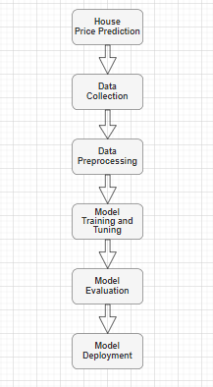

Figure 1: Flow Chart of House Price Prediction system

**CRISP DM:**

CRISP-DM stands for CRoss Industry Standard Process for Data Mining. It acts as a template to ensure all important aspects of the project are considered upfront. It is an industry standard methodology widely adopted for planning, organizing and executing data mining projects to deliver real world solutions. The life cycle consists of six phases which need not be followed in the sequence. We can reiterate over the phases as per our requirement.

• Business understanding – Define the project objectives and requirements as seen from a business perspective. Convert these into data mining goals and prepare a project charter. The idea of dissertation project is to modify simple sentiment analysis to multiclass sentiment analysis involving two additional classes of very positive and very negative along with basic classes of positive, negative and neutral. Emoji sentiment analysis will add novelty to this research.

• Data understanding – Collect and explore data to familiarize with the initial data quality issues. This includes data exploration techniques like identifying noise and outliers, null values, and other such inconsistencies to address data quality issues. Using pandas, the datasets will be explored to get basic stats like data types of each column, missing values, etc.

• Data preparation – Clean, format, transform and integrate data to prepare it for modeling. It includes addressing the issues found in previous step to ensure high quality data suitable for analysis.

• A data pre-processing pipeline will be created to handle issues.

• Modeling – Select and apply various modeling techniques like Logistic Regression, Decision Trees, Convolutional Neural Networks, etc. based on the problem characteristic. Calibrate hyper parameters and train the model to get optimal results. Numerous techniques like oversampling using SMOTE, vectorization, SVM, etc. will be used to train model.

• Evaluation – Test the model on unseen data to check its effectiveness. Compare different models using performance metrics like precision, recall and accuracy. Ensure that the business objectives are met. Model trained on above mentioned techniques will be compared for their performance. Visualizations will be drawn for better understanding of their performance.

• Deployment – Deploy the best model to production environment. It can either be integrated with an existing system or new application can be created. Plan monitoring, maintenance and retraining as required. (Schröer et al., 2021)

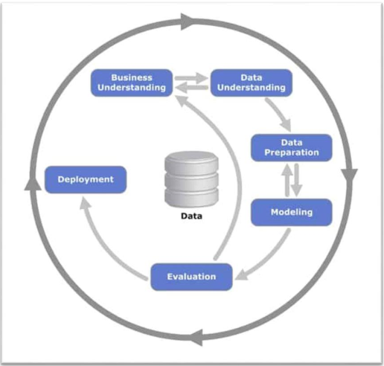

*Figure 2 CRISP-DM Methodology*

**1. Data Collection:** Acquire needed data on house prices in the United Kingdom, that may back it up with the data concerning the location, size, period and economic factors.

**2. Data Preprocessing**: Several pre-processing steps will be applied to clean the text data before analysing the collected datasets. Clean and prepare the data before analysis, so as to ensure accurate analysis. Compatibility is integration in this case so that they deal with cases of missing data, outliers, and anomalies; they also conduct feature selection, coding of categorical variables, and normalization of numerical features. The process of data cleaning includes removing the unnecessary 'URL' column from the dataset to optimize its organization and identifying and eliminating duplicates and null values to guarantee data integrity. Recognizing the distinct values in the 'Name' column (boroughs) facilitates comprehension of the data's geographic range and diversity. Target variable 'Sales volume' (y) is essential for understanding market activity, while feature selection concentrates on 'House price index All property types' (X) as it is a major indication of housing market developments. 'Sales volume' distribution analysis reveals differences in class that may affect model predictions.

The RandomOverSampler from the imblearn library is used to correct this imbalance since it works well at producing a balanced dataset by oversampling the minority class. After separating the features and target, the data is fitted and resampled using the oversampler to guarantee a balanced class distribution. To make handling simpler, the resampled data is transformed back to DataFrames. In addition to the first few rows of the resampled DataFrame being shown for verification, the updated class distribution of 'Sales volume' is provided to verify successful balancing.   
The dataset is guaranteed to be clean, balanced, and prepared for further machine learning modeling via this complete pretreatment pipeline. This process corrects imbalances and carefully prepares the data, laying a solid foundation for highly accurate and dependable housing price forecast models in the UK real estate market.

**3. Model Feature Engineering:** An essential first step in each machine learning project's data preprocessing stage is feature engineering. Adding new features or altering existing ones is necessary to increase the prediction performance of models. Various feature engineering techniques were applied to the dataset, which consist of sales volume, home price index, critical date, monthly data from 2013 to 2023,and regions.

The first step in extracting datetime features was to remove the year, month, quarter, and day of the week from the Period column These features are needed to create proper recognition for focusing on both material and regular data.

**Seasonal features** are very important as it has many options that are needed to maintain the time factors. Seasonal features play an important role in machine learning as it will help to make a proper idea of weather, holidays and business cycles.

The growth rate features are another type of function which are used to increase the sales and profit rate as per the month and this will directly affect the percentage and the records that are going to be maintained by the company for their betterment. If the growth is affected then the company can handle the loss with the proper profit.

The Moving Average Convergence Divergence or MACD is used for controlling the fame and reputation of a company by maintaining the sales and profit of the company in the market. The MACD is also used for identifying the risks for maintaining the trend.

Exponential Moving Averages are used to increase the growth of productivity so that the company is going to stay in the competition. This can be possible by gathering various types of recent data to focus on the development and maintain the trends to get new and loyal customers from the market.

Relative Strength Index is needed to handle the roles so that the company can know the position in the market and this will help them to develop or upgrade themselves to increase their sales rate and know their risks in the market.

Lastly, Trend Features is used to show the sales rate and profit rate for knowing the development processes and this will play an important role in positioning the market.

When these features are used in the machine learning approach, all types of data are accumulated and this will help to make or create new types of theories or models for the betterment of the company.

**4. Model Training and Tunning:** Machine tuning is a kind of process which are used for making various types of configurations to make certain types of parameters. These are used to control the learning process. The most important part of model tuning is that it will help to know the risk factors in the learning processes. To maximize the selected performance metric, each model will be trained on the training split, and on the validation split, hyper parameters will be iteratively changed (Raschka and S., 2018). Machine learning algorithms like Linear Regression, SVM, Random Forest and Gradient Boost will be applied on House Price Prediction algorithms. Along with classification metrics, confusion matrix will be used to identify the best performing model. As learning is an iterative process, the models will be trained for 4-5 different values of epochs to prevent overfitting and monitored using validation loss. Upon identifying the optimal hyper parameters, the final models will be trained on the entire training split from each cross-validation fold. These will then be evaluated on the respective held-out test sets to report fivefold cross-validated performance scores. Along with Evaluation metrics like Mean Absolute Error(MAE),Mean Square Error(MSE),Root Mean Square Error(RMSE), and R2 Value we will analyze hyper parameters for identifying the best model performance. The best performing models on the validation data will be selected for each dataset and ensemble construction. Before being deployed, these careful model training and tuning procedures seek to create solid sentiment classifiers (Laradji, Alshayeb, and Ghouti, 2015).

**5. Model Evaluation:** The accuracy with which machine learning models predicted the values of houses in the UK was evaluated using a number of significant metrics, such as Mean Absolute Error (MAE), Mean Squared Error (MSE), Root Mean Squared Error (RMSE), and R-squared (R²). Data preparation is the basic step to focus on the collection processes of data which are used to increase the sales and profit rate of the company, and it will also use the report of progress of the company.

Model assessment in AI is pivotal for deciding the viability and generalisability of models in different settings, including the UK. Measurements generally utilised in assessment incorporate exactness, accuracy, review, F1-score, and region under the ROC bend (AUC). In the Unified Realm, AI models are utilised in various enterprises, including medical care, money, and retail, where administrative systems oftentimes need thorough approval and understanding. For instance, in medical care, models that anticipate patient results should be surveyed for exactness as well as for their ability to convey clinically significant bits of knowledge. To do this, space-explicit models like responsiveness and particularity should be thought of. In finance, where AI is used for credit scoring or misrepresentation discovery, models are assessed on prescient execution while complying with rules like GDPR. Reasonableness markers, like segment equality and equivalent open door, are basic in guaranteeing that models do not sustain biases. Moreover, cross-approval is generally utilised in the Assembled Realm to check that the model assessment is solid. This methodology incorporates more than once isolating the information into preparing and testing puts together to quantify the model's presentation dependably. One more vital stage in model assessment is hyperparameter tuning, which includes testing different setups to further develop the model's performance. Explainability is additionally a significant figure model assessment in the Unified Realm, especially in regions, for example, banking and medical care where choices have extensive ramifications. Model forecasts are made more straightforward and interpretable by utilising procedures like SHAP (Shapley Added substance Clarifications) and LIME (Neighborhood Interpretable Model-rationalist Clarifications). These survey methods guarantee that AI models are precise, yet in addition reliable and comply with UK-explicit administrative guidelines.

**6. Model Deployment:** This type of methodology is used for facing lots of challenges which are fully based on the data collection processes for machine learning. The model deployment is very important as it will be used to make advanced things to upgrade the company and its policies. The employees have to take necessary training before using the model deployed processes. The process is generally used for solving problems that are raised in the company in any scenario. The model deployment is fully based on training, validation, deployment and monitoring. The key role of the model deployment is that it will focus on the important parts of the company which are based on security automation and many more. As per the report, 13% of the production is based on the understanding of the model deployment. This model deployment is mainly used to make instances that are based on real life. The methodology is needed to focus on the data management processes so that it will focus on the performance report. The model is also trying to focus on the integration which is based on updated computer software. Resource management is also used to maintain the memory and it will also be used to track the records through versions. Hence, model deployment methodology is used for maintaining the details of the company to upgrade themselves to face any types of risks and challenges that arise from the market.

3.3 Tools and Techniques

**Framework:** Python is the best programming language which is going to help Support Vector Machine(SVM), the basic theory of machine learning As Python does the primary job of its simplicity, numerous libraries, and a strong community's support, making it ideal for this project.

**ML Model:** One powerful machine learning method that is frequently used for predictive modeling applications, such as house price prediction, is Support Vector Machine (SVM). SVM can be modified for regression issues, but its primary purpose is to identify the appropriate hyperplane in a high-dimensional space for dividing data points of various classes. Finding a function that approximates the relationship between the dependent variable and one or more independent variables while minimizing the prediction error within a given margin is the main goal of support vector regression, or SVR. SVM is very useful in situations where the relationship between features and target values is complex and non-linear because it can handle complex, non-linear correlations between variables by employing kernel functions. Recently, Elon Musk proposed using this approach to develop a system that can analyze large datasets and potentially enhance decision-making processes in various industries (Robertson, 2023).

**Algorithm:** Robust machine learning algorithm Support Vector Machine (SVM) is applied to both regression and classification problems. SVM's main goal is to identify the ideal hyperplane for maximizing the margin between classes while effectively separating data points belonging to distinct classes. Support Vector Regression (SVR), a type of regression, aims to find a function that approximates the goal values within a given tolerance range. SVM is hugely used by the machine learning approach as it will help the user to handle two types of tasks that are linear and nonlinear classification. The kernel function is very important and it will help the machine learner to understand the transformation of high dimensional space to linear separation. The power of SVM is based on its capacity to construct a robust model by focusing on the support vectors—that is, the significant data points that are nearest to the hyperplane. It functions nicely in surroundings with several dimensions as well. SVM is robust and adaptable, but it can be very hard to manage large datasets and select the appropriate kernel functions and parameters. Overall, SVM provides a strong solution for handling challenging classification and regression problems thanks to its comprehensive boundary modification and kernel techniques (Zhang, J. and Yang, H,2024).

## 3.4 Ethical Consideration

### 3.4.1 Data Privacy and Confidentiality

At all costs, the privacy and security of the data utilized in this study should be maintained. To maintain each individual's privacy, the data should be processed according to with the guidelines set forth by data protection laws such as the General Data Protection Regulation (GDPR). Privacy and confidentiality of the data are two of the procedures.

### 3.4.2 Informed Consent

Informed consent must be sought when collecting data, especially if the data being collected is sensitive and/or personal in nature. This makes it possible for the participants to understand how their data will be used and agreeing to the use of their data under the stipulated circumstances.

### 3.4.3 Transparency and Accountability

Research is a systematic process which should be made clear hence can be checked and repeated by other researchers. This involves providing adequate information about the methods used, sources of data, and other relevant analysis procedures. Researchers also need to be responsible for the information that they produced and any effects that this information might have on people.

### 3.4.4 Avoiding Bias and Ensuring Fairness

There should be no bias in the data collection, analysis, and interpretation stages of the study as much as possible. Addressing fairness within the predictive models requires the use of non-biased data, and the integration of techniques that are used to identify and eliminate biases that may cause unfair or discriminative results.

### 3.4.5 Implications for Stakeholders

Attention should be paid to how the outcomes of the study will influence different stakeholders, such as homeowners, investors, and policy makers. There is a social justice issue in relation to the consequences of the predictions that need to be ethically assessed to avoid a skewed negative impact on any group.

### 3.4.6 Responsible Use of Technology

It is critical to be responsible in the use of machine learning models in predicting house prices because of the consequences to society. Researcher should consider the manner in which these technologies shape the market and the decisions people make and encourage use where they will benefit society.

### 3.4.7 Intellectual Property and Plagiarism

It is important to respect intellectual property rights and avoid cases of plagiarism. It is important to acknowledge sources and data used and methodologies applied in the study to ensure that the research is credible and accurate.

### 3.4.8 Conflict of Interest

It is essential to declare any and all conflicts of interest to help maintain the impartiality of the research. This may include monetary considerations, friendship or other bias, that may affect the results of the investigation.

# Chapter 04: Product/Research Design and Implementation

## 4.1 Introduction

The property market is experiencing constant evolution, it becomes necessary to apply cutting-edge analytical methods to forecast the property values properly. This chapter explains the sequential procedure that includes the data collection and preprocessing and then the feature engineering and modeling options selection. At the core of the model is its evaluation which is essential for its effectiveness. This introduce and explain several key metrics used to assess the model's performance: MAE, MSE, RMSE, and R² represent Mean Absolute Error, Mean Squared Error, Root Mean Squared Error and R-squared, respectively. Each of the given metrics offers distinct clues about the efficiency and precision of the model, assisting in its fine-tuning. This chapter will be running dynamic tests for the validation of the model's effectiveness and also to refine the precision of the prediction by ensuring the model remains amenable to the dynamic nature of the housing market.

## 4.2 Dataset Overview

This dataset provides an in-depth look into home price indexes and real estate transactions in different parts of West Yorkshire, UK, for the months of January and February 2013.The regions which are covered mainly includes Calderdale, Leeds, Bradford and along with all the regions of the entire region of West Yorkshire. The collection entry also comprises the entire collection incorporating the name of the region, information regarding that as well as the name of the distinct region namely GSS (Government Statistical Service) number that is responsible for providing authentic and reliable data referencing. Along with this URI also contributes in providing the access to in-depth data covering the region. The year and month (YYYY-MM) form plays an essential and pivotal role which helps in identifying the period of collected data , the dataset which constitutes the volume of sales ,which accounts to the total number of real estate completion in the specific region and time frame set. The alteration of changes in the data frequency is stated as monthly in the noticing period. The role of house price index(HPI) also is responsible for offering the value index which indicted the price level changes for all the variety of houses in the given area and also shares information regarding the trends in the prices which are considered to be an essential part of the dataset. Last but not the least comes the pivotal data which also gives a demonstration of the exact date of the data entry and its supply chain in the date , month and year format (DD-MM-YY).Therefore the dataset extensively is useful for examining the patterns for the real market in the estate in the region of West Yorkshire which incorporates the inclusion of shifts in the volumes of sales and fluctuations in the prices along with it the time calculated across various locations.

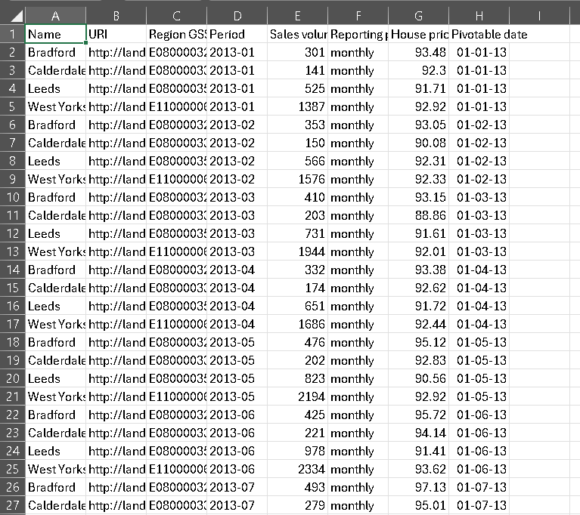

*Figure 3 Excel Sheet of Dataset*

## 4.3 Data Cleaning

The data cleaning process started with the importation of a dataset from an Excel file using the pandas data analysis library. The dataset was read into a DataFrame named df from the given path. Upon loading the data the basic exploration was done by using the head() function on the df which gave the first five rows of the dataset. This gave a general table information such as the name of the columns and the type of data that could be found in each column. In the provided dataset there were several columns, but only ‘Period’, ‘Name’ and ‘House price index: All property types’ were used for analysis and prediction.

**Step 1:** First, creates an environment in which a house price index dataset for each region of dataset, from 2013 to 2029. It imports the libraries required for machine learning, data manipulation, natural language processing, and visualization. The first setup involves obtaining the necessary NLP resources, managing any potential data imbalance, and being ready for the model evaluation. The dataset is loaded from Google Drive. With the use of different classifiers, the code seeks to provide complete data analysis and predictive modeling.

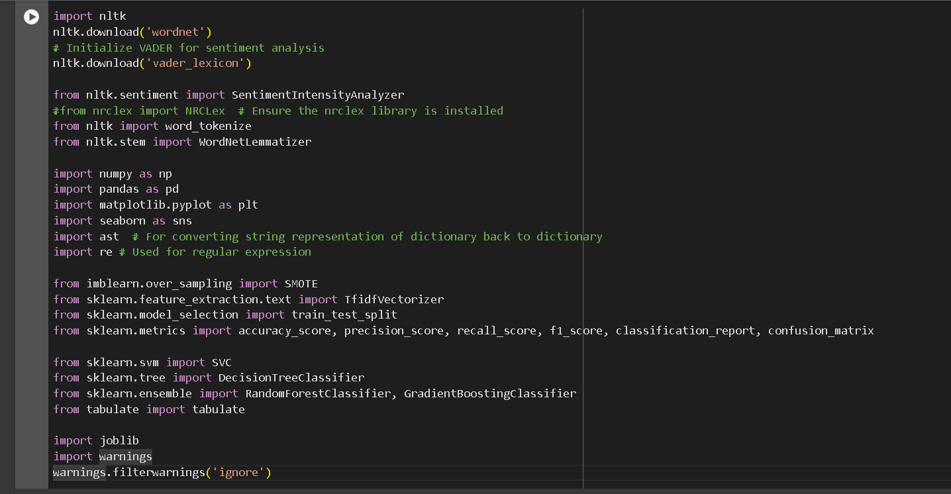

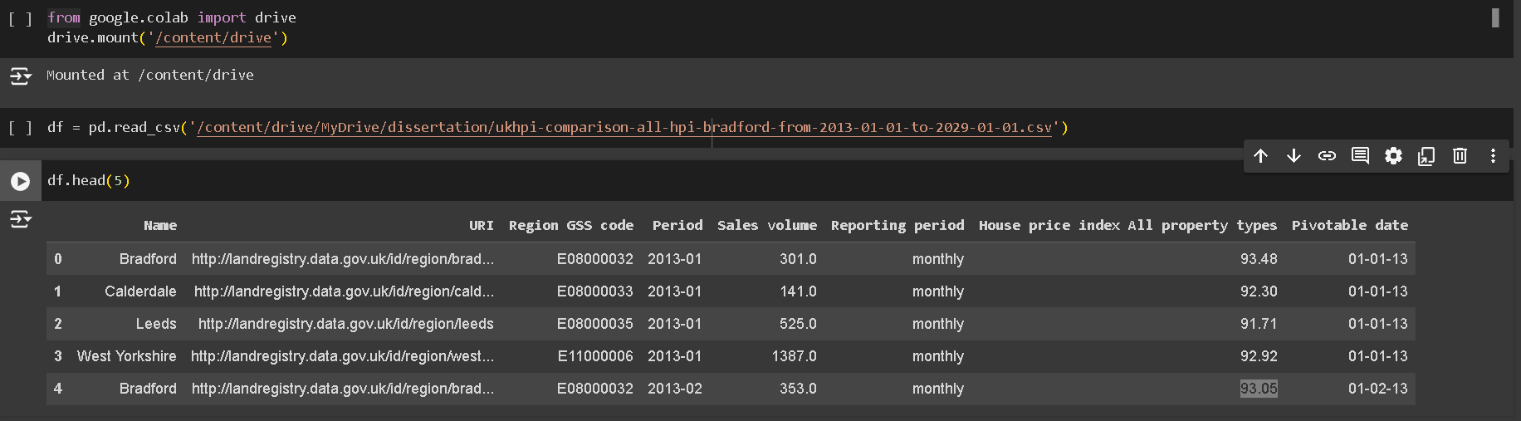

*Figure4 Import all libraries and Display Top 5 Records*

**Step 2:**

Next, retrieves and prints the dataset's dimensions, showing the number of rows and columns. Next, it uses `df.info()` to verify the dataset's information, giving a summary of the data types and non-null counts for every column. Lastly, summary statistics are produced by calling {df.describe()}, which provides information on the distribution's shape, central tendency, and dispersion of the dataset.



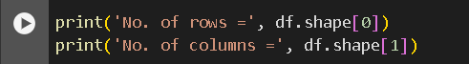





*Figure 5 code of distribution's shape, central tendency, and dispersion of the dataset.*

**Step 3:** data cleaning is performed by this code, which eliminates the 'URI' column from the dataset because it is probably not needed for analysis. The result is not directly presented as it then uses `df_clean.isnull()` to check for missing values. The code uses `dropna()` to remove rows in order to find and fix any missing values, ensuring that the dataset is lacking in null entries. Additionally, it performs a second check to make sure there are no missing values and makes use of {df_clean.duplicated().any()} to guarantee that there are not any duplicate rows in the dataset.

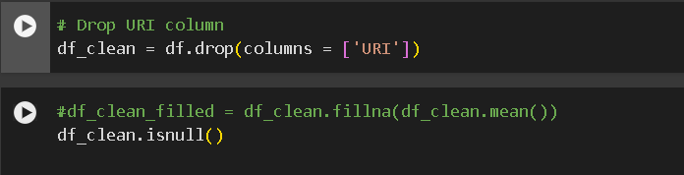

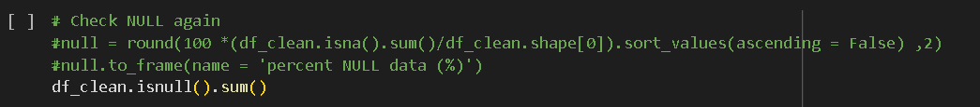

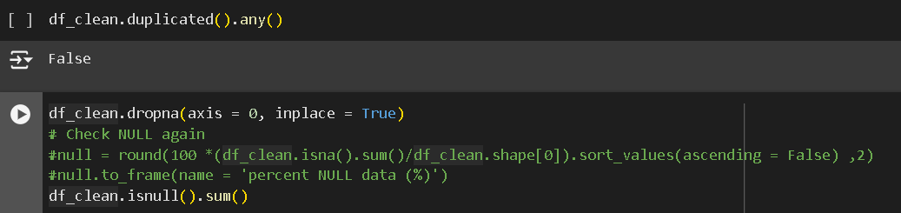

*Figure 6 code for Data Cleaning*

## 4.4 Data Preprocessing

The function of pd.to datetime therefore helps in the utilization as well as transform the column of ‘Period’ in order to determine the types of data. One of the crucial steps taken was to set the column of ‘Period’ to data frame index. The method of set index is also used in the accomplishment of the processing which also helped in the simplification as well as in the improvisation of actions done based timely in an intuitive manner as well as carefully handling the analysis. Thus via sort index the component of data frame was brought into clarification. The sort index method with the help of ‘Period’ index has also enabled the adjustments which are done subsequently in order to ensure that all the location of the temporal data are taken into account.

With the introduction of the subset of the DataFrame also often termed as Bradford of the field of the study has been reduced by generating it. The condition which states that significantly the inclusion of rows along with the value of “Bradford “provided in the foremost column titled “Name” should be provided leading to the creation of the subset. The specific analysis regarding Bradford and its forecasts are made possible only because there has been made a restriction of data only constricted to the informations of housing covering a specific region.The main agenda of this attempt put forward was to set a target to the potential groups inorder to improvise the accuracy of the predictive model.

The usage of the term ‘imblearn’library and its RandomOverSampler is finally used in the methods of balancing the data which are considered unbalanced using the method of oversampling inorder to provide rectifications to the imbalances occurring in the class mentioned in the dataset’s “Volume Sales”ensuring the imbalance is accurately checked. The term ‘Sales Volume’ is considered to be the target variable along with it the dataset is distributed equally in two categories mainly (x) constitutes categories and (y) that is the target set.The oversampling being done covering the minority class which is the ‘RandomOverSample. The objective of this class is to construct which will ensure the right fit and resampling of the data so that a class can be distributed in a balanced manner. A simplified version to be used for the management where the features of the resample and the potential target are combined together in a single Dataframe.

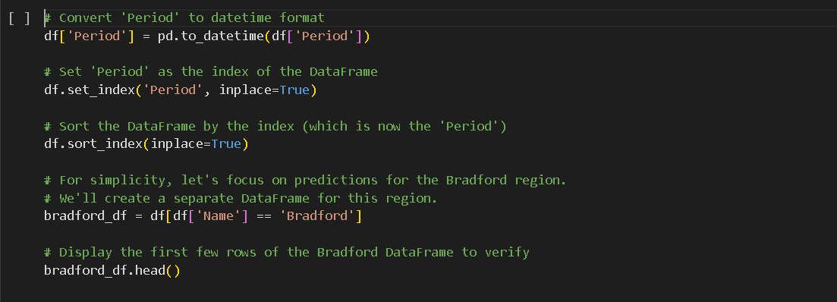

*Figure 7 Create Data Frame*

Finally, the `imblearn` library's RandomOverSampler is used in the method of balancing unbalanced data using oversampling to rectify class imbalance in the dataset's 'Sales volume' column. It first releases the initial distribution of the numbers for "Sales volume" in order to identify the imbalance. 'Sales volume' is the target variable, and the dataset is divided into characteristics (X) and target (y). By oversampling the minority class, the RandomOverSampler object is constructed and used to fit and resample the data in order to ensure a balanced class distribution. For simpler management, the resampled features and target are merged into a single DataFrame after being transformed back into DataFrames. Finally, the code prints the new 'Sales volume' distribution to verify the effectiveness of the resampling process and displays the first few rows of the balanced dataset, confirming that the dataset is now ready for further analysis or model training.



*Figure 8 value count of sale volume*

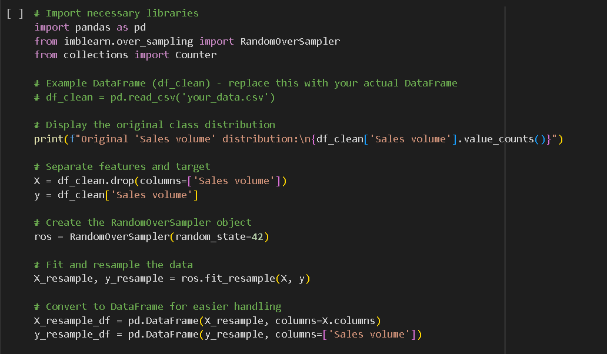

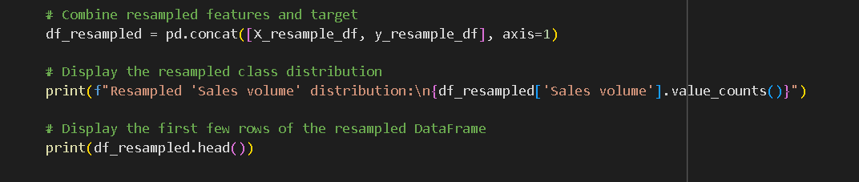

*Figure 9 Data Balancing of sale volume*

## 4.5 Feature Engineering

Feature engineering is the process of using domain knowledge to create new features or modify existing ones in a dataset to improve the performance of machine learning models. It involves techniques such as data transformation, extraction, and combination to enhance the dataset's predictive power.

**Step 1:** First,average house price index for each borough in the dataset. It groups the data by the 'Name' column, which represents different boroughs, and computes the mean of the 'House price index All property types' for each group. The resulting DataFrame, containing the borough names and their corresponding mean house price indices. The purpose of this is to provide a summary statistic that reflects the average house price trends in each borough, which can be useful for comparative analysis and understanding regional housing market dynamics.

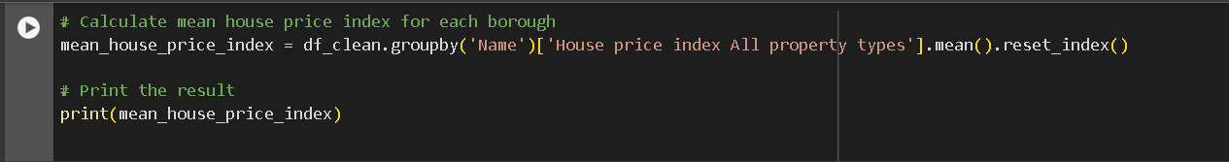

*Figure 10 Mean value for house price index*

Then,identify and visualize the top three most expensive boroughs based on their mean house price index. It first sorts the previously calculated mean house price index DataFrame in descending order. Then, it selects the top three boroughs with the highest average house price indices.

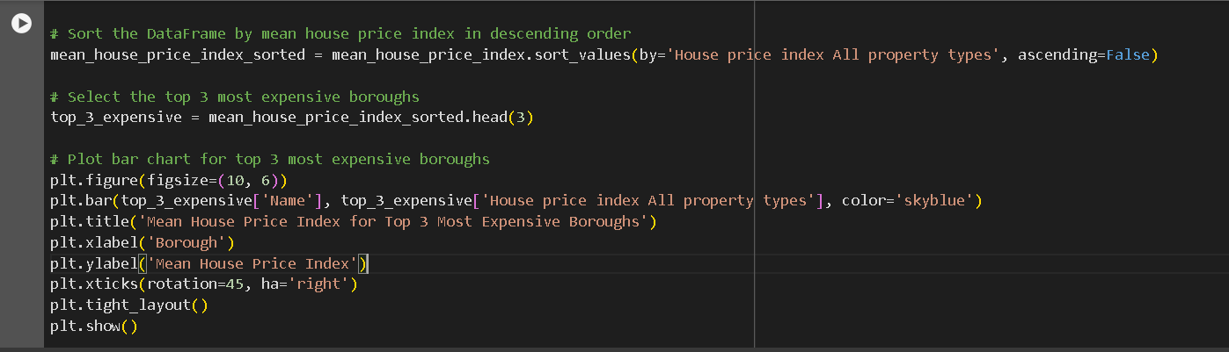

*Figure 11 plot top three boroughs with the highest average house price indices*

**Step 2:** **Seasonal Features**

These features help to identify specific seasonal impacts on sales and prices that are not captured by basic datetime features. It introduces three new columns: IsHolidaySeason, IsQuarterStart, and IsQuarterEnd from period column of original dataset. December (holiday season) is identified in the IsHolidaySeason column by allocating a value of 1 for true and 0 for false based on whether the month is December or not. Using datetime attributes, the IsQuarterStart and IsQuarterEnd columns transform the results to binary indicators to show the beginning and conclusion of fiscal quarters, respectively. For verification, the code then prints the first 525 rows of these new columns. In order to facilitate the study of seasonal trends and their possible effects on the data, it finally shows these seasonal indicators over the 'Period' column, illustrating how frequently these seasonal occurrences occur within the dataset.

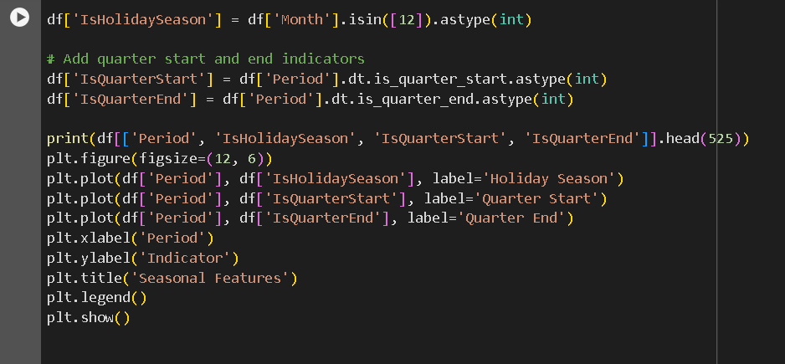

*Figure 12 code for Seasonal Feature*

**Step 3: Growth Rate Features**

The three factors mainly HPI Growth Rate, Sales Volume Growth Rate which re responsible for showing the percentage calculated during the changes made in the volumes of the sales as well as the index of the prices of home. With the introduction of the two new volumes respectively shows the changes that has been done from one period to the other. The method which is used to calculate the change in the percentage is known as the pct_change method. Ensuring that the calculations are done in an accurate setting thereafter the code takes the print of the first five rows of 525 of the columns which are newly added. The last stage is to create a plot line that represents the growth rate which been counted overtime, along with the y-axis also demonstrating the rate of growth and the axis -x which shows the period representation. The plot is accountable for providing clarity to the process. The graphical representation helps in understanding the variations and trends involved in the volumes of sales as well as the values of housing calculated throughout the time period designed.

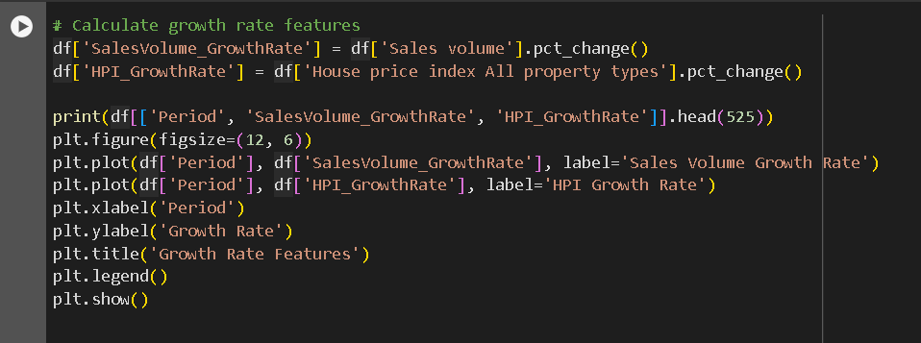

*Figure 13 Growth Rate Feature*

**Step 4: Moving Average Convergence Divergence (MACD)**

The momentum indicator also known as MACD that is used in the following of the trends which are used to verify the changes involved in the intensity, direction , growth , length of the trend and together with it also covers the Moving Average, Convergence and Divergence (MACD) and the lines used to increase the volumes in the sale. In addition to this the three parameters which are also included in the process constitutes long window (26 period), short window (12 periods), as well as the signal window (9 periods).The role of MACD works as the difference between the 12-26 periods also known as the Exponential Moving Averages (EMA) of the volumes of the sales. With the usage of 9-PERIOD EMA the line for MACD is then produced. Together with this the columns which are added newly also constitutes the produced data MACD signal and thus provides enhancement to the DataFrame. The display then shows the representation of the foremost 525 rows and column for further verification. The next step is that the values are made on the y-axis and on the x-axis. Thus the graphical representation facilitates the analysis pof te trends and alterations done in the data of volumes sales.

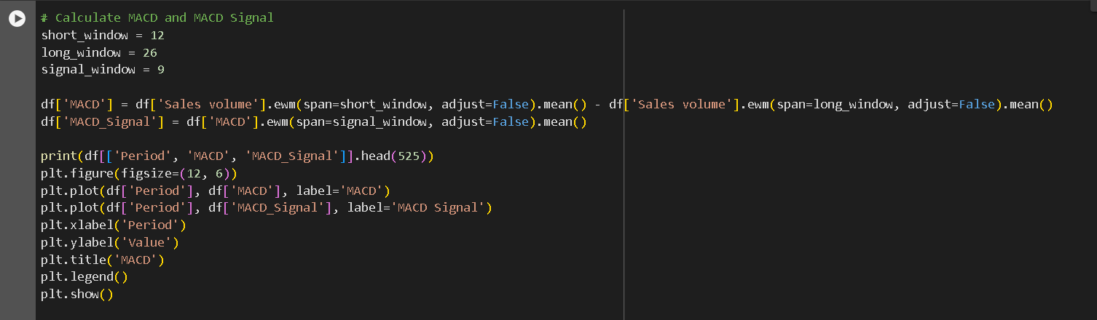

*Figure 14 Moving Average Convergence Divergence(MACD)*

**Step 5:** **Exponential Moving Average**

The recent observations are also given weightage by EMA, which also enhances the freshness of the data that can be sensitive in comparison to the simple moving average model. The simple moving average also measures the dataset and its 12- period Exponential Moving Average (EMA) which are required for the increase in the volumes of the sales as well as the index of the pricing of home (HPI) in order to provide the highlights of the trends which are going for longer term and bears the volatility of short term. The properties have the span of 12 period and the adjust set as false. The two new column which are introduced namely Sales Volume_EMA12 and HPI_EMA12 that are the results which are produced from the process. The foremost rows and column of 525 are then taken out for the process of printing which are used the code verification process. The values placed on the y-axis and x-axis, as well as the authentic value of sales volume and HPI data are on the display vear the time against the process of the respective EMA. The trends which runs smoothly and the patterns which are lying under the volumes of the sales and in the pricing of the house are demonstrated more easily with the help of this graphical representation.

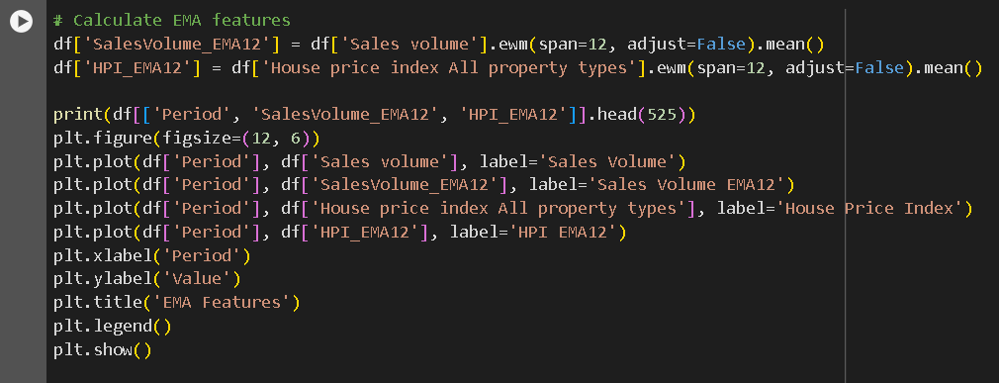

*Figure 15 Exponential Moving Average(EMA)*

**Step 6: Relative Strength Index (RSI)**

The role of RSI or the average moving oscillator is used to gauge the rate and the direction of the changes done in pricing. It also aids in the determination of the circumstances which constitutes the oversold or overbought criterias. The RSI Also is involved in translating the sales volumes as well as the price home index of the dataset into an accurate function that is responsible for calculating the Relative Strength Index. The work of RSI also ensures the determination for the size of the windows and in the case it counts upto 14 periods. There are chances of extreme profit and losses and also calculates then sizes and the nature of the windows, along with it calculates the variations which are involved in measuring the data points. RSI is then used for computing by calculating the averages. The introduction of the two new volumes which adds to the functions and represents RSI values for the increase in the sales are mainly Sales Volume RSI and HPI_RSI. The foremost rows are held for display of verifications. In addition to this RSI, a lot is created with the y-axis showing the values of RSI and the x axis refers to the period.

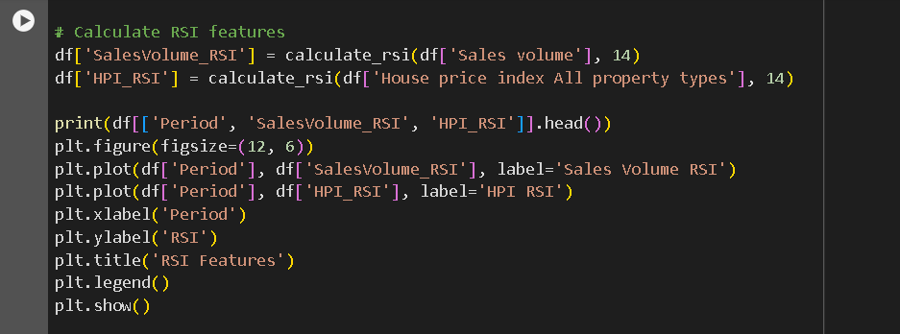

*Figure 16 Relative Strength Index (RSI)*

**Step 7:** **Trend Features**

The features of trend are enabled to identify the direction of the movement by providing a transparent picture of how much the metric is used to indicated the trigger of the rise and fall and also generating the trend used for giving the indication for the volumes in sales and the pricing of the house index (HPI) of the processes occurring in the database. In order to determine the trend setting it helps in the comparison of the value presented with the values of history with the help of methods used variedly. Therefore if the variation shows positive outcome and is exhibited in the trend upwardly the possibility to return a value of 1 is there or either way it returns a value of 0.

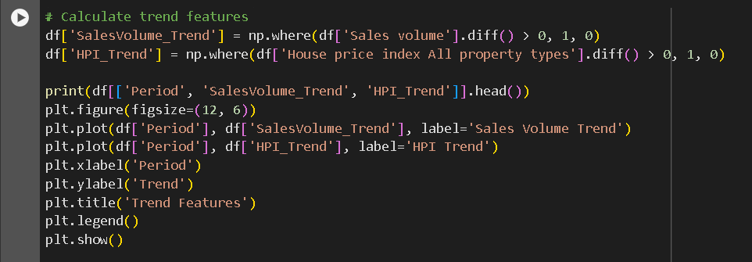

*Figure 17 Trend Feature*

## 4.6 Model Evaluation

The efficiency of the Machine Learning in the house price prediction depends on the ability of the model to predict the right price for each house by looking at the various factors. In evaluating the forecast model of virtual property prices, they use evaluation criteria that provide different perspectives on the measurement and predictive abilities of the model.

### 4.6.1 Mean Absolute Error (MAE)

MAE is the first metric, defined, in mathematical terms, as the arithmetic mean of the absolute difference between the predicted and real house price. MAE is intended to have a good level of comparative accuracy measurement by performing either the absolute difference of their prediction and then average and then divide them by the total number of cases. When the MAE is getting lower it means that the values predicted by the model is closer to the empirical value showing better performance (Huang et al. 2023).

### 4.6.2 Mean Squared Error (MSE)

The Measurement Squares Error (MSE) which is similar to MAE is utilized for computing the average of squared price differences between the actual and the predicted house prices. MSE in this way weighs the larger prediction errors more, which is beneficial for detecting the different values in the outliers, with which the model cannot cope, unlike MAE. The MSE calculates an E^2 term for each error and then averages them. The E^2 of a significant deviation between a predicted and an actual value is magnified, which helps gain a more nuanced evaluation of model performance (Landers, Armstrong and Collmus, 2022).

### 4.6.3 Root Mean Squared Error (RMSE)

The third measure, RMSE, which is analogues to the original MSE measure, is a direct interpretation of prediction accuracy, making it an easy-to-use metric. Through taking the square root, RMSE measures the dimension and reflect the scaling of MSE and target variable and therefore, facilitates the comparative understanding of the error. RMSE can be described as a tool because it focuses on the error levels that make huge impacts on the model sensitivity. The tool helps better evaluation of model prediction (Ahmed et al. 2020).

### 4.6.4 Rsquared (R2) Score

R2 (Rsquared) is a convenient tool that shows a complete assessment of a proposed model, including how well it can predict house prices. More specifically, R2 measures the proportion of total variance in the target variable that can be explained by the model. Values between 0 and 1 can show the degree of fit of the model to the data: the higher the model efficiency, the closer R2 is to 1. R2 stands for the coefficient of determination, and it actually measures the percentage of fluctuations of the target variable that the model explains. It signifies the goodness-of-fit of the model in respect to a baseline model that predicts the mean of the target variable. In this scenario, R2 provides the basic line of demarcation for assessing how advanced the house price prediction model being proposed (Chen, 2023).

R2 or the coefficient of determination alone determines the final performance of the predictive machine models where they apply in an area such as house price prediction. It is the relationship between this sum of squared residuals and the total sum of squares of the target variable. This number varies in values from 0 to 1. A high R² signifies a greater extent to which the model’s structure fits the data, inferring a stronger correlation between the features and the outcomes that are being predicted. And, of course, R2 should be understand as a part of the approach which includes the indicators to help recognize the problems like over fitting or biased predictions. With respect to house price prediction, realizing aspects like location, dwellings nuances and market dynamics is essential. This is necessary for achieving a high R2 score and also ensuring the model's forecasts are consistent with the day-to-day trends in the local real estate scene.

**Finally, These all model evaluation methods(MAE,MSE,RMSE,R2) use on each models(Gradient Boosting Classifier, Linear Regression, Support Vector Machine(SVM), Random Forest Regression) to identify for which model is more efficient and give more accurate predition for the dataset.**

## 4.7 Modeling

**1.** The outcome of the final results stored in the dictionary are set on display for the areas specified.The main agenda is to show a comparison between the outcomes of the results across domains scattered in multiple areas and assess the accuracy anticipated for the locations set for the model.

**1.1: MAE:** Mean Absolute Error evaluates the performance of a Gradient Boosting Regressor model in predicting sales volume based on the house price index for different regions. It calculates the Mean Absolute Error (MAE) to assess the model's performance using the GradientBoostingRegressor from sklearn. The algorithm divides the data into training and test sets, prepares the features and target variable, filters the dataset, trains the model, and computes the MAE for each designated region. The results are stored in a dictionary and displayed for each area. The objective is to compare the outcomes across multiple domains and assess the model's anticipated accuracy for each location.

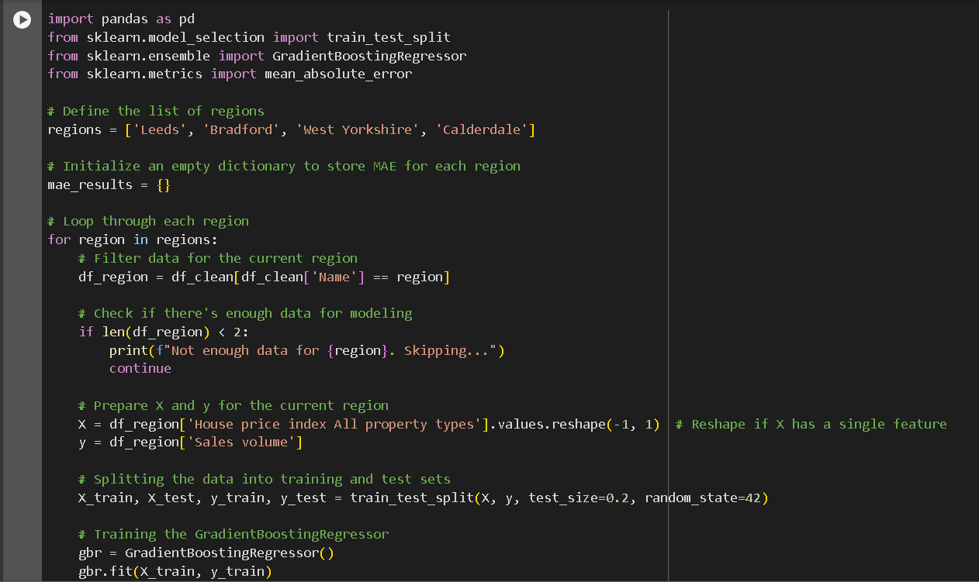

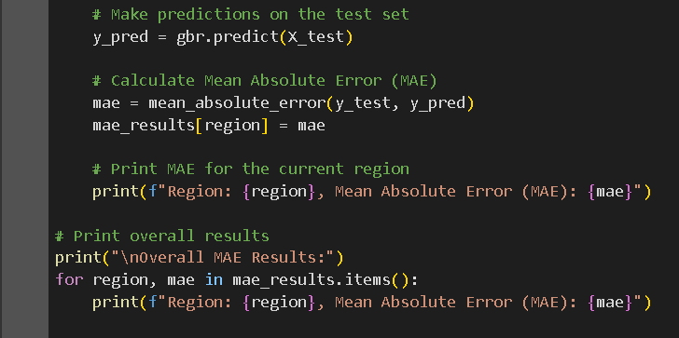

*Figure 18 Finding MAE for GradientBoostingRegressor*

**1.2 MSE:** The (MSE), which can also be considered as the Mean Squared Error, is mainly used in terms of assessing the satin accuracy of the models. It can be stated that the codes that are created in terms of setting the tests and training, filtering the data sets and producing target variables and features in terms of training the models are considered as the estimation of the MSE for a particular region. Additionally, it can be mentioned that the results of MSE involving the region are printed after keeping in a dictionary. It can be mentioned that the main objective of this process is to evaluate the effectiveness of the models that predict the volume of the cells in each region and compare the accuracy of the predictiveness for various regions.

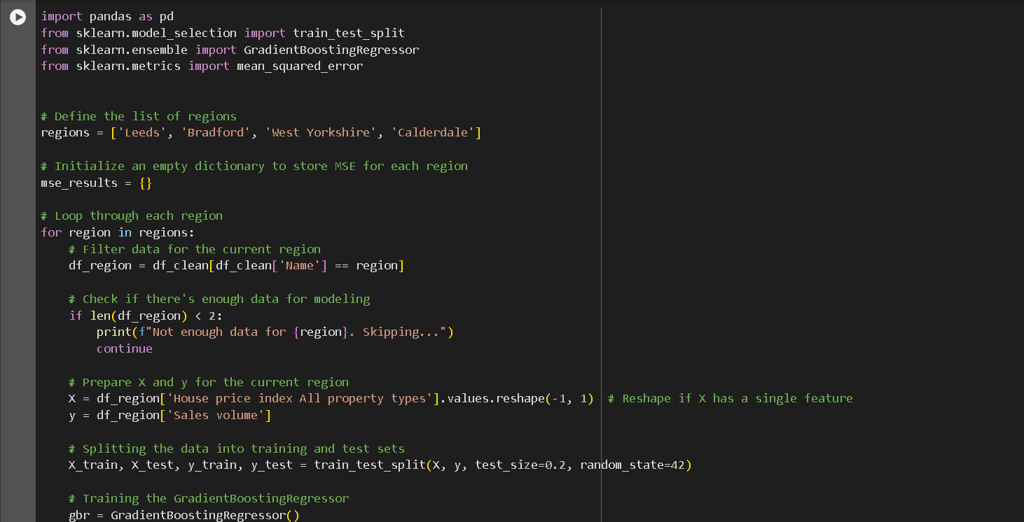

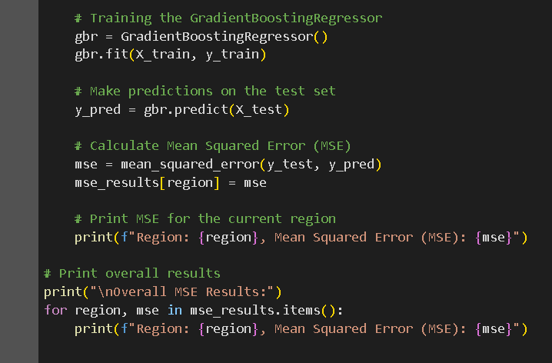

*Figure 19 Finding MSE For Gradient Boosting Regressor*

**1.3 RMSE:** It can be stated that the capacity of a model is to estimate the volume of the sales that are creating pressure over different regions by using the price index of housing. This is measured by the Root Mean Squared Error. Additionally, this RMSE belongs to the Gradient Boosting Regression process that involves the features and target variables of prepping. This process also includes the division of data into sets of tests and training and is also responsible for filtering the data sets in terms of extracting the details from the regions according to the lists. It can be mentioned that the root mean square error is mainly used in terms of measuring the prediction accuracy of the models which is also followed by the evaluation and training. On the other hand, the entire results are printed in terms of storing in the dictionary and comparing. This shows that RMSE is responsible for valuing the places and the functions are responsible for providing proper insights in terms of understanding how impactfully the models of regression are predicting the future and evaluating or comparing the accuracy in different and multiple places.

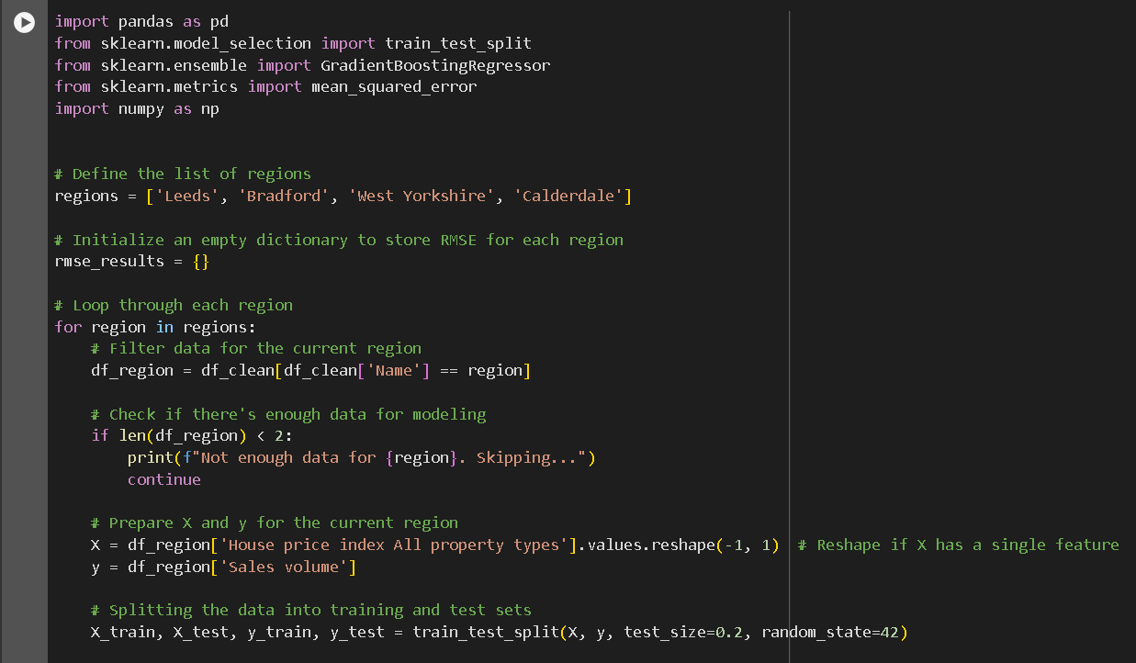

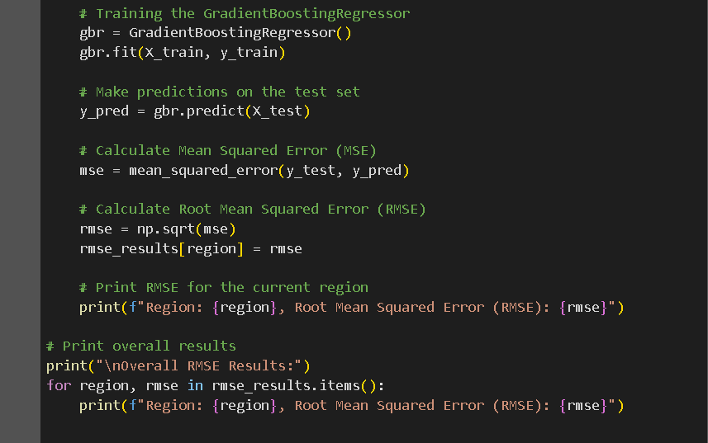

*Figure 20 Finding RMSE For Gradient Boosting Regressor*

**1.4 R2 Value:** In terms of evaluating the understanding of a successful Gradient Boosting Regression model, it is important to understand the forecasting of sales values that are crossing in different parts of the region. In addition to this, it is important to understand the model in terms of identifying the index of the housewife and also computing the method that leads to an R2 score. It can be stated that the responsibility of the code is filtering The delta set and separating the data in two sets of tests and understanding of the training. It also helps in terms of generating the features and the variables of targets for each selected region. In addition to this, in order to find out the variations in the volume of cells it is important to understand the basis of the index of house pricing and how the model has been trained. It can be stated that the R2 score can be calculated easily and it helps in terms of generating the test set. It is understood that the values of R2 for a particular domain are entered and generated in terms of providing a proper insight into the ability of the model and explaining the prediction with the help of proper accuracy and understanding the range of the wide domains.

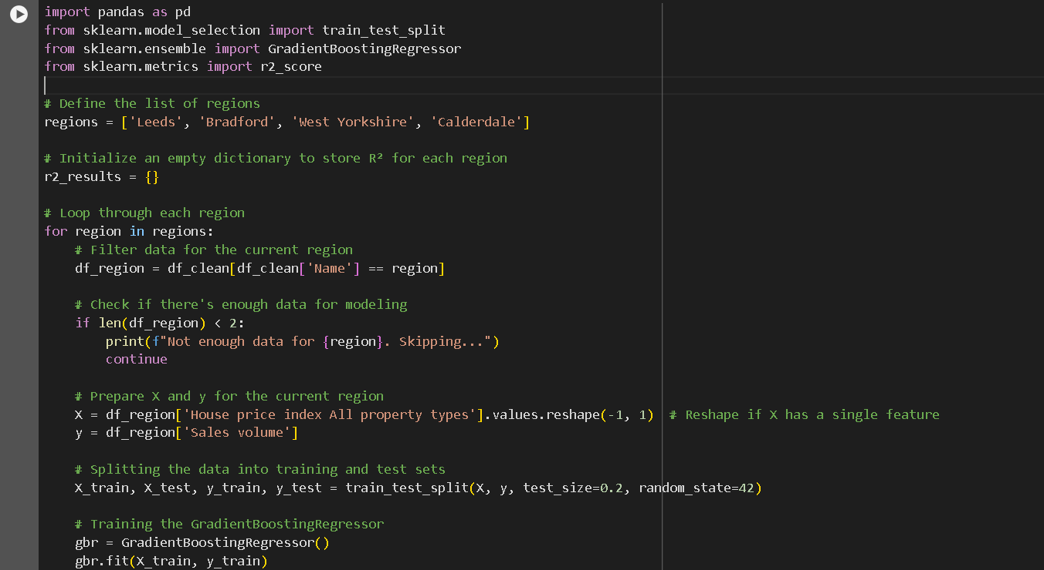

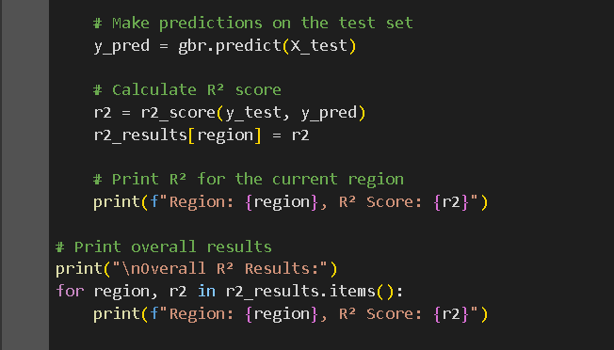

*Figure 21 Finding R2 For Gradient Boosting Regressor*

1. **Linear Regression:**

Linear regression can be considered as the fundamental statistics and techniques for learning machines that help the model in terms of creating a connection between the independent and dependent variables. It can be stated that the main objective of linear regression is to understand and identify the best-suited linear equation that helps in terms of predicting the independent and dependent variables. The formulas and the understanding of the statistics help in identifying the independent dependent variables and it is also allowing in terms of fulfilling the goals of regression. Ordinary Least Squares are helpful in terms of understanding the common methods and also reducing the summation of actual values and squared variances as the nature of the method is coefficient.

**2.1 MAE:** House price index and the sales volume at the features that are prepared in terms of providing a proper process of modelling. This is done just after the filter has been set on the data set and in terms of isolating the particular regions. Additionally, the data are divided into the steps and training in terms of using the ratio of 80 to 20. It can be stated that the linear regression model has been trained and understood as the predictions. It can be stated that there is a certain accuracy of the models that are responsible for evaluating the Mean Absolute Error. This is again determining the actual data and the avoided size of the errors that have been predicted.

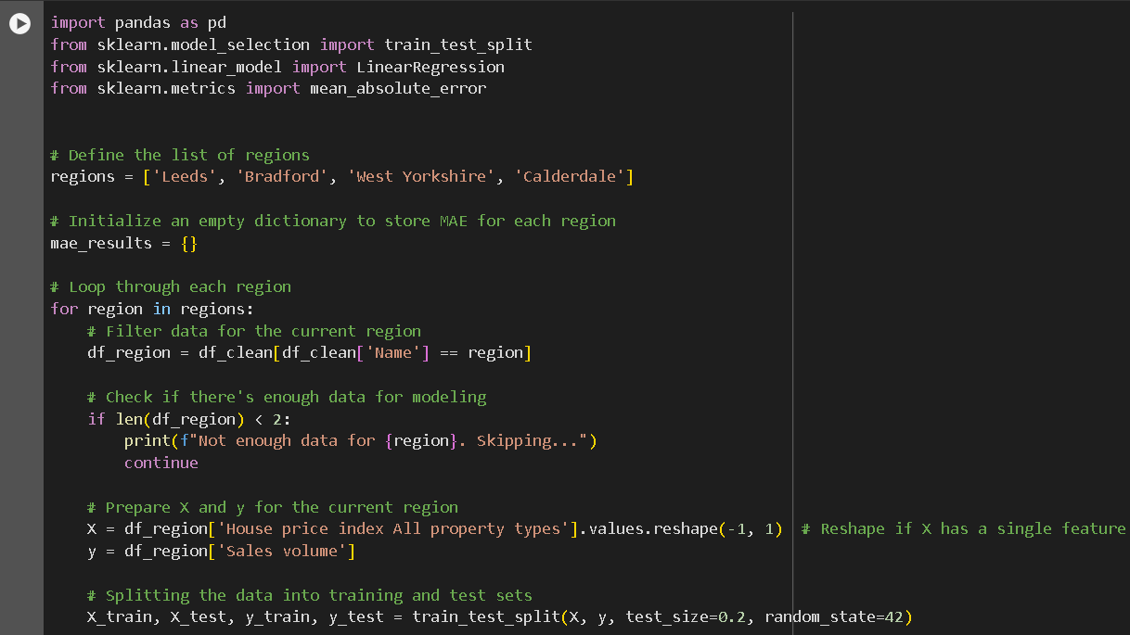

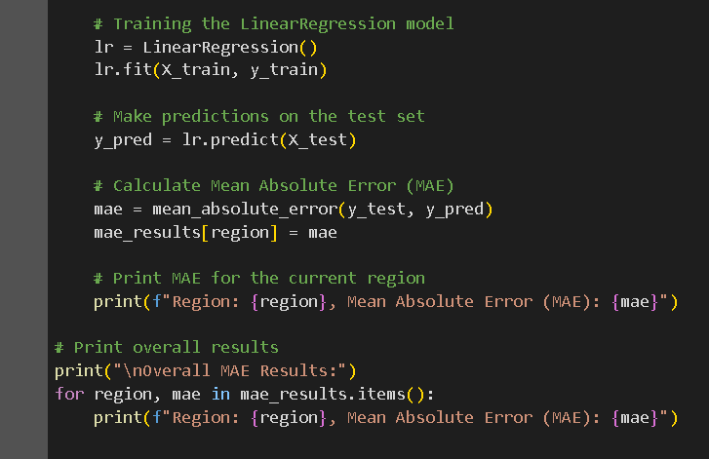

*Figure 22 Finding MAE For Linear Regression*

**2.2 MSE:** It can be stated that the models that are helping in terms of understanding the performances are computed and predicted in terms of understanding the actual data. Additionally, each site of MSE is printed and calculated in terms of helping to understand how properly they are allowing competitiveness. It also shows certain changes in the findings that display the assessments and volumes that are estimated in the price of housing index.

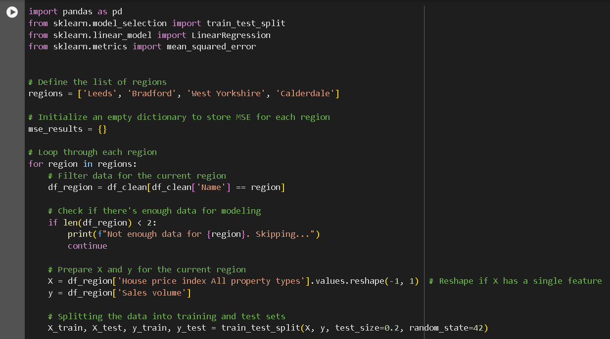

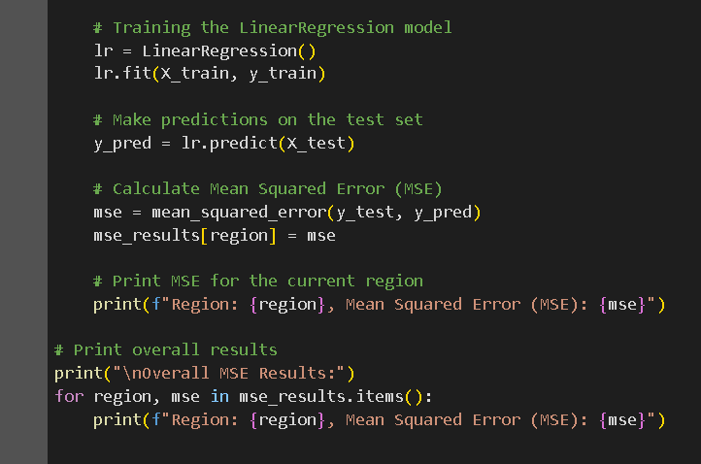

*Figure 23 Finding MSE For Linear Regression*

2.3 **RMSE:** It is understood that the performances of the models are identified or evaluated in terms of determining the data by using the RMSE. It can be stated that they are helping by providing insights into predictive models and understanding the nature of values that are used for RMSE. It can be stated that the values help to analyse the model and understand the nature of the same according to the value of the price of the housing.

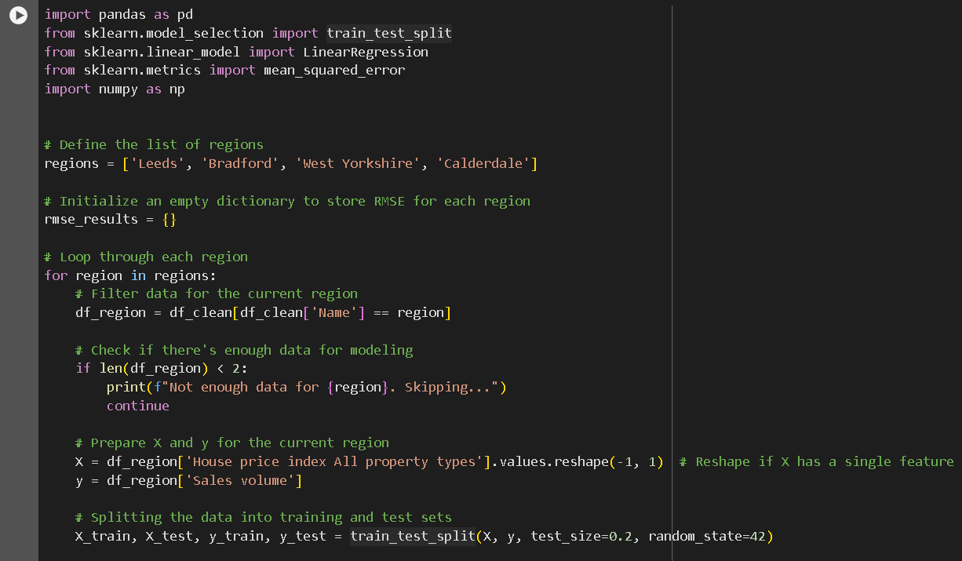

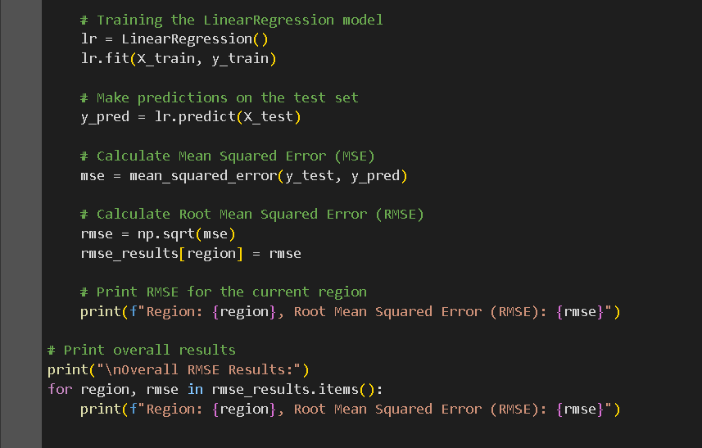

*Figure 24 Finding RMSE For Linear Regression*

**2.4** **R2 Score:** The score of R2 helps in terms of evaluating the achievement of the models. It can be considered as the variables that are dependent on the sales volume and home price index. Additionally, it helps in terms of accounting for the models for the evaluation and calculating the exact volume of the sales. It can be concluded that the results of the same are used in terms of displaying the comparisons.

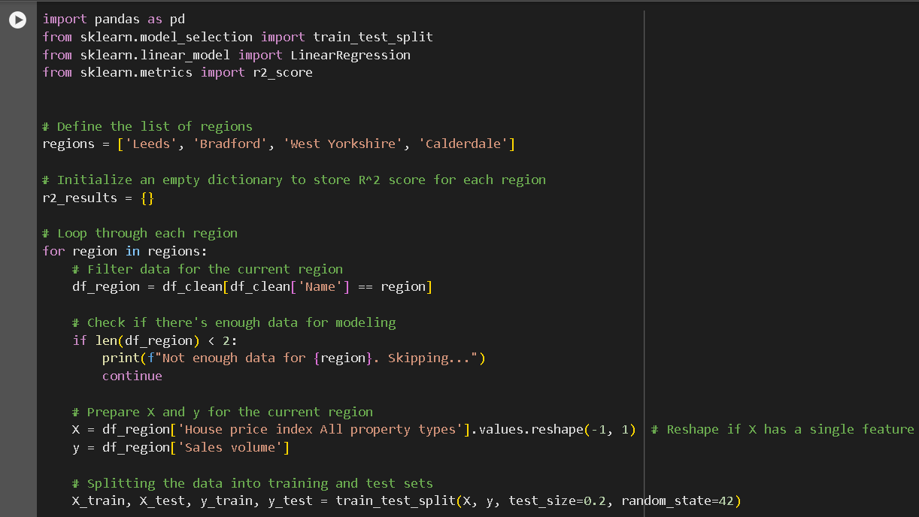

**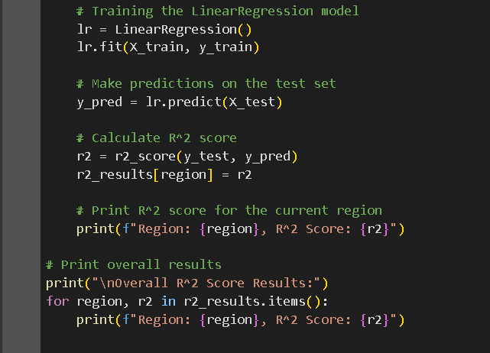***Figure 25 Finding R2 For Linear Regression*

**3. Support Vector Machine**

Support vector machines can be considered as the sets that help in terms of understanding the process of supervised learning. It can be stated that the methods of the same are used in order to classify the outliers of the detections and for regression. There are certain advantages of support vector machines that involve the effectiveness of high dimensional spaces which helps to effectively handle the cases and increases the numbers of the samples that can be used. SVMS is used in terms of technically understanding the hyperplane and primary objectives that can help segregate the points of data.

**3.1 MAE:** In terms of understanding the process of Mean Absolute Error, it is important to understand the process of the anti-dictionary and how they are initialised and terms of targeting the regions. It can be stated that the index of the price of housing is responsible for predicting and understanding the responses of the sales volume variable. It can be stated that this process is responsible for the accuracy of the projection and evaluation of the models of SVR that predict the findings and the origin of the model.

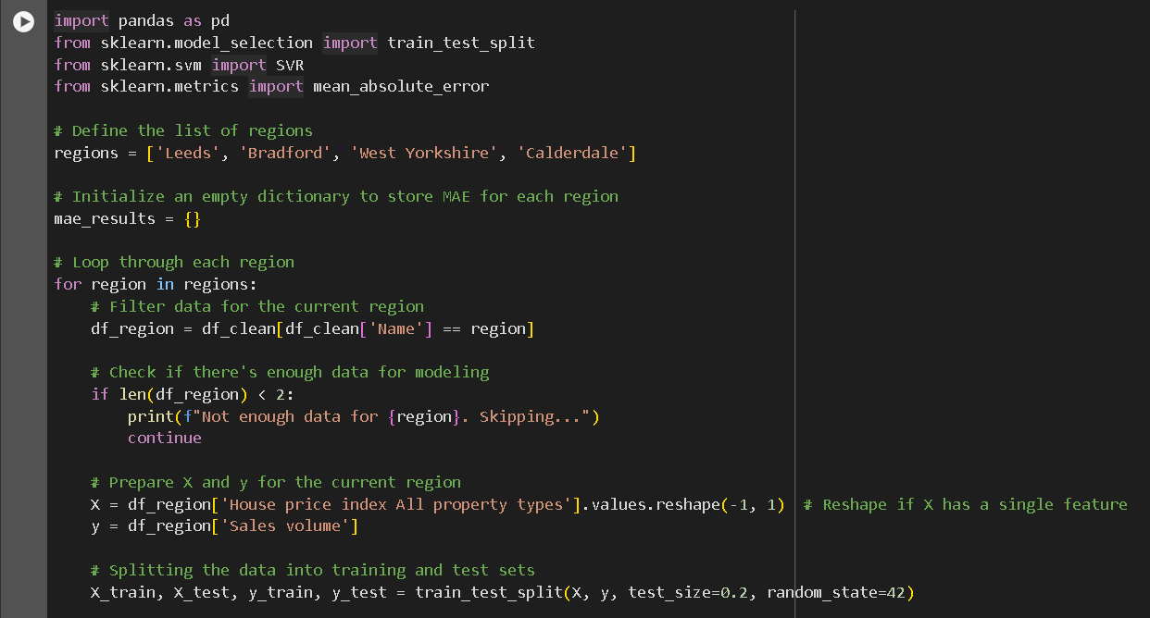

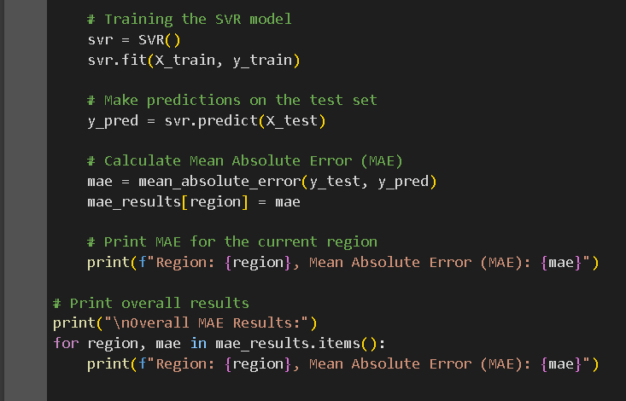

*Figure 26 Finding MAE For SVM*

**3.2 MSE:** In the first place it is understood that a setup of the dictionary in terms of listing the targeted regions and the target regions of MSE. After the process, the filters of the algorithm and the data are processed in terms of understanding the responses and the variables of the predictor that are setting up and reshaping the sets. The prediction process and then transforming it into the printings, would help the targeted regions and understand the ability of the sales volume. It also helps in terms of enabling the comparisons between the models and understanding the process of performances of SVR predictive models**.**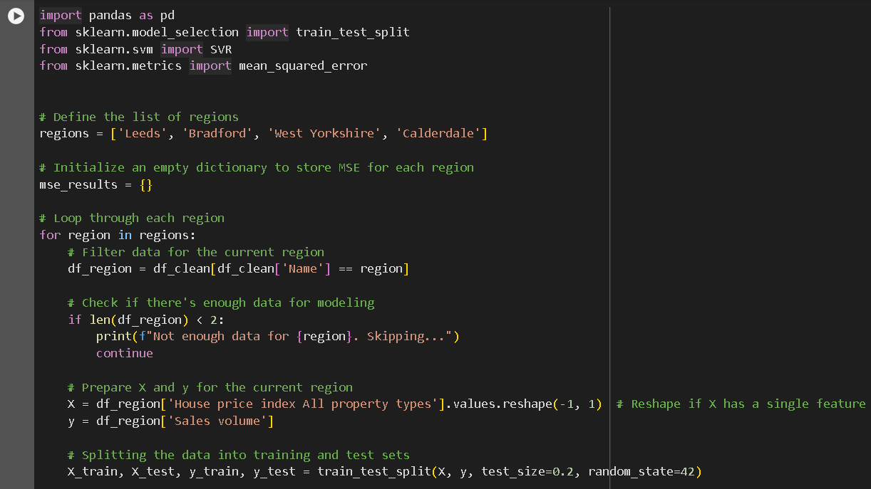

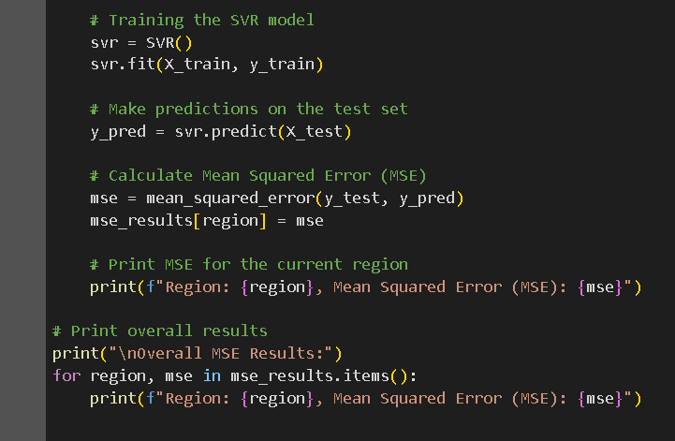

*Figure 27 Finding MSE For SVM*

**3.3 RMSE:** The process starts with the understanding of definitions that help to understand the nature of the countries. It can be stated that The RMS is initialised within the dictionaries in terms of understanding the particular regions. On the other hand, it is helpful in terms of understanding the relevant data that are used for the algorithm of the data. Additionally, the main objective of this variable is to understand the process of variable preparation and receiving the training sets by using certain processes. After entering the separated data in the training and test sets, the training set operates the SVR model.

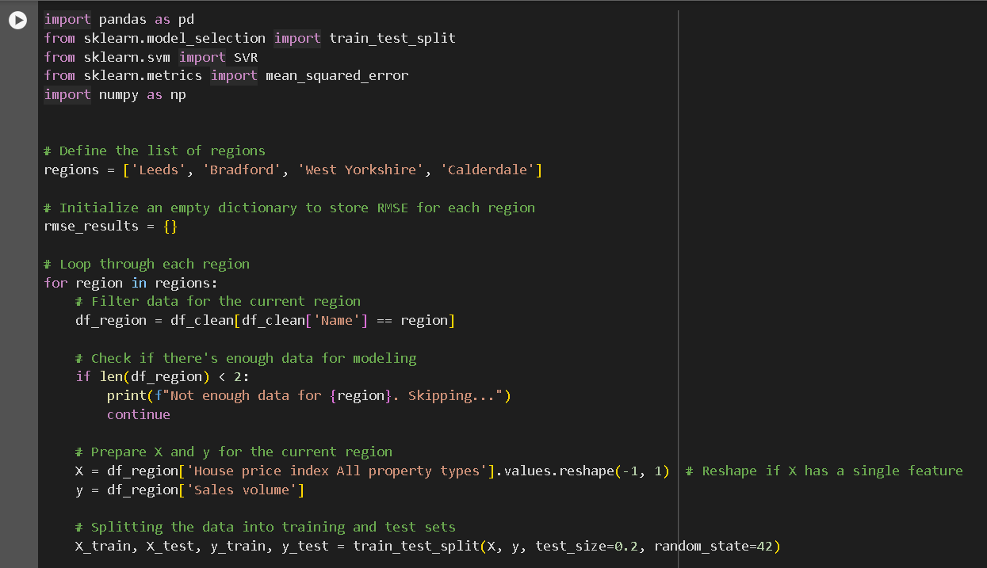

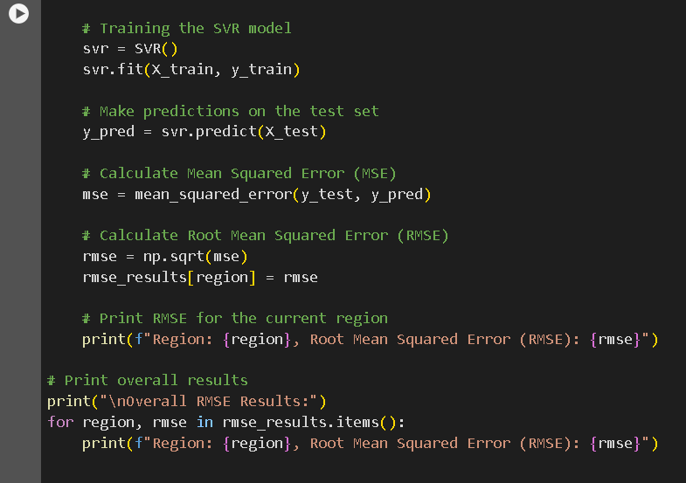

*Figure 28 Finding RMSE For SVM*

**3.4 score of R2:** Establishment of the dictionary which contains the R-squared (R²) scores for Bradford, Leeds, West Yorkshire, and Calderdale on the first part. By monitoring the significant information within the dataset through various aspects including improving the approaches to ensure that there is enough data for each place. After that, it targets all the features in the process for targeting all the variables by the usage of sales volume which helps to modify the various prices of the houses. After entering the data as the separated version in the training and test sets, the SVR model is operated by the training set. All the required predictions are being created by the test set, and the goodness of the model’s fit are being evaluated in order to calculate the R-squared score. All the results, which have been shown in the R2 score in each region, are being provided in a dictionary and provide all the significant details to monitor the level of accuracy and the performance of each model to check its significance.

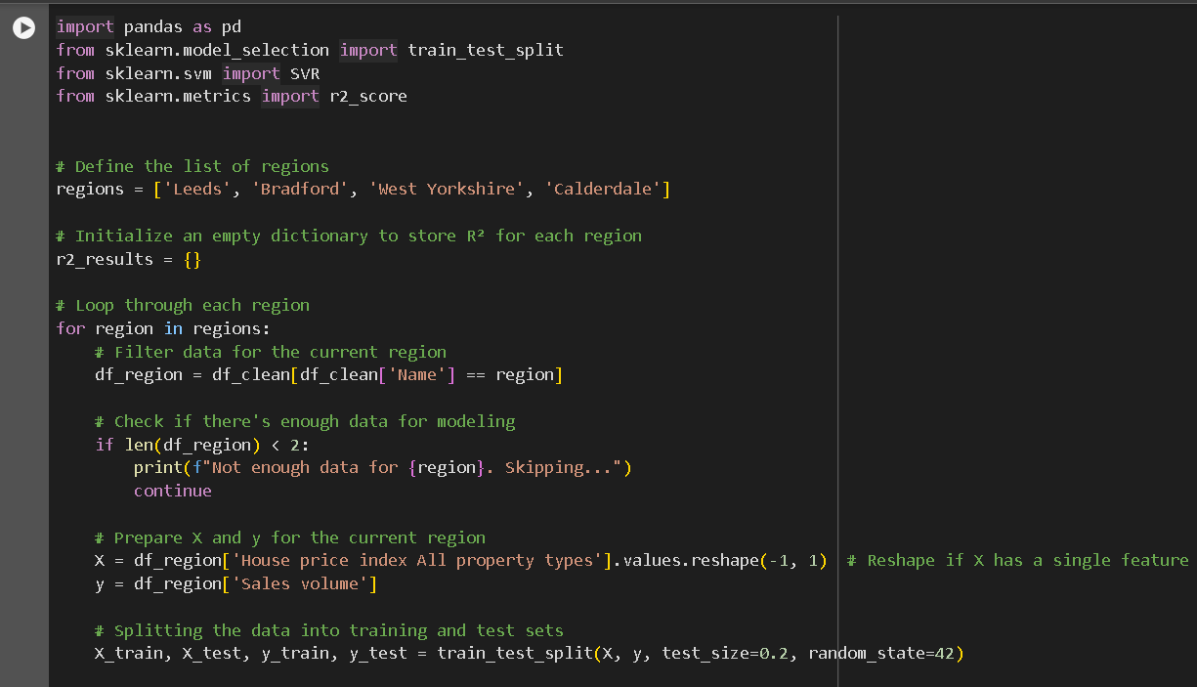

**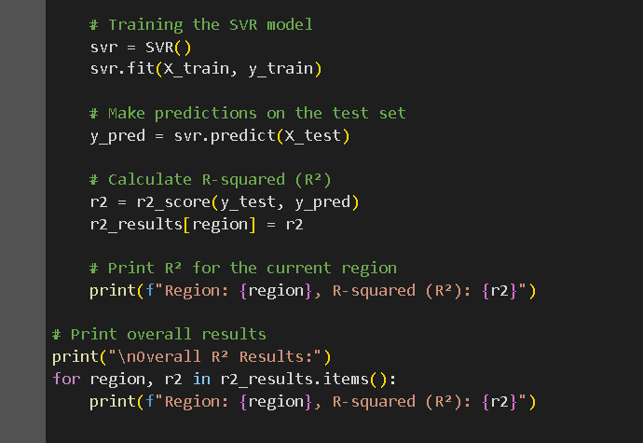***Figure 29 Finding R2 For SVM*

**4. Random Forest Regression**

Random forest regression refers to the improved system which is combined with the learning tool and techniques for constantly targeting the desired variable of the forecasting. It helps to create a huge number of trees in that particular training phase which is used by the different subset features and various data. This specific unpredictability gives the facility to each decision tree for collecting various elements of various data which reduces the overfitting likelihood which is basically affected by the individual trees. The trained trees produce various individual predictions which often make the final outcome very average. With the process of combining all the multiple various trees, it helps to advance the process of enhancement of the accuracy level which gives stability to the model. After that, Random Forest Regression can be helpful in order to assess all the features and its importance which can be helpful in the process of identifying several variables that are affected by the different predictions. However, this particular method and technique provide robust information to the problems of the regression by covering all the required knowledge in the decision trees.

**4.1 MAE:** here the first code which builds several lists of the specific areas which creates a dictionary in which the values of Mean Absolute Error (MAE) of each region are contained. By establishing the process of filtering all the inputs for each of the sites, here all the programs ensure that there is enough data present in order to make the program successful. After that, the feature and all the target variables create the testing and training sets.

The model of Random Forest Regressor is being trained by the training data, on the other hand, test data creates all the predictions. In the process of evaluating predictions models which show the volume of the sales are being measured by the mean absolute error for each region.

This particular code print of mean absolute error provides all the findings of the summary for each region. This particular technique helps in the process of evaluating all the performances of the models and it also gives various insights about the predictable accuracy.

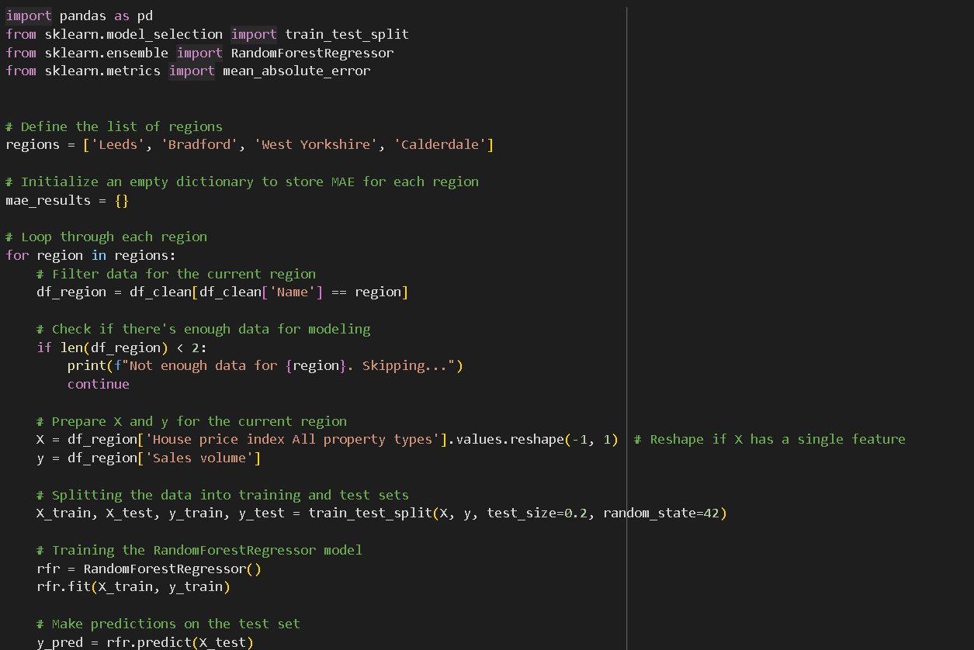

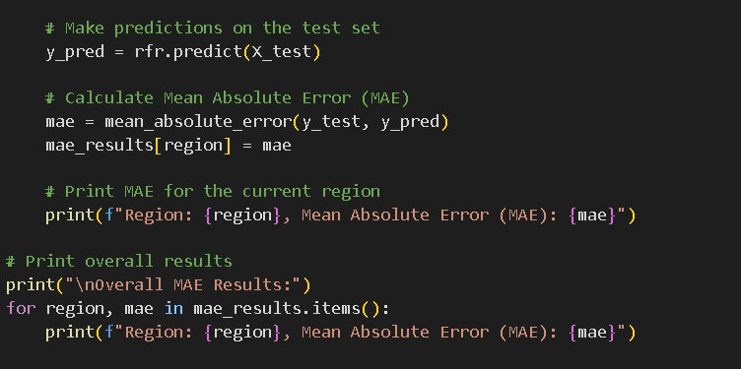

*Figure 30 Finding MAE for Random Forest*

**4.2 MSE:** MSE specifies the list of regions in the process of building all the dictionaries to store all the outcomes of each region around the world.

The feature and the target variables are being divided by the test and training sets. It also helps in order to train the model of random regression forest. The predicted and the actual insights are being computed in order to test all the various predictions.

Lastly, overview of the performance of the model around the region are being produced by all the approaches which provide findings of MSE. This brings a specific distinction between the predictable and the actual values of the sales.

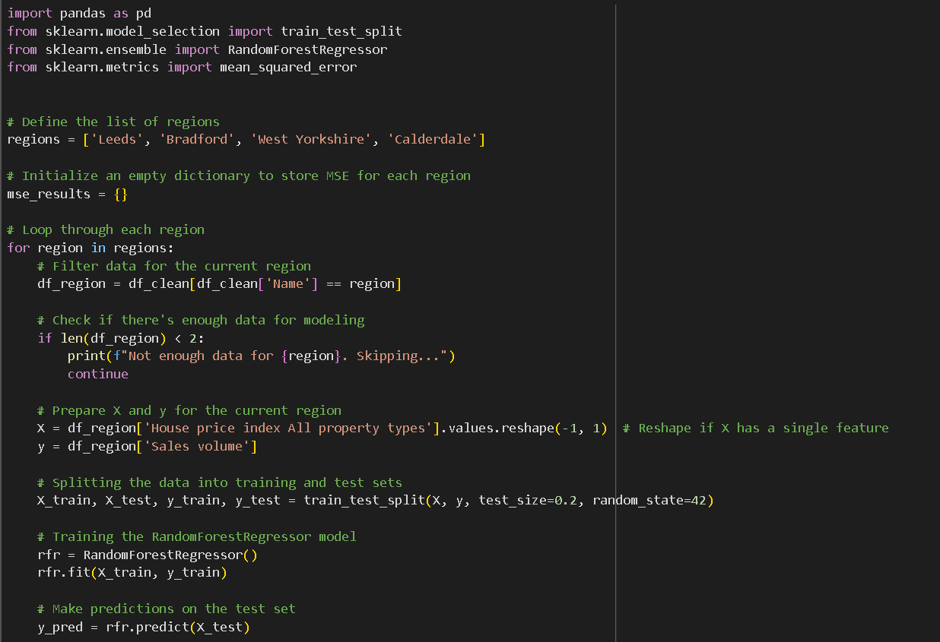

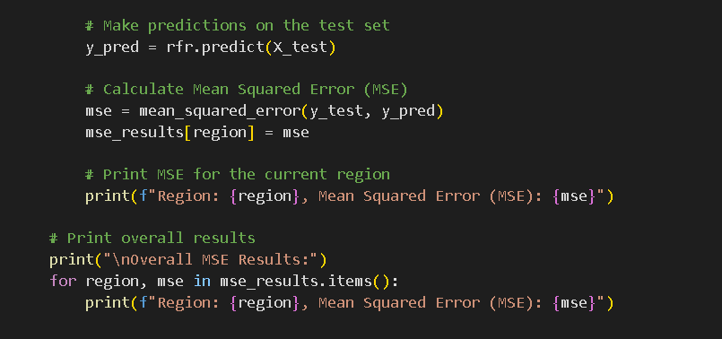

*Figure 31 Finding MSE for Random Forest*

**4.3 RMSE:** By creating a chart of lists of the areas this helps to store all the values of the RMSE. After that, the separated data helps to determine the analysis of that particular sufficient data. The model of the random forest is being trained for the regions around the world. The RMSE monitors the predictions which are being made to monitor the rate of accuracy level. The results of the regions are being printed in order to follow all the insight summary of the RMSE.

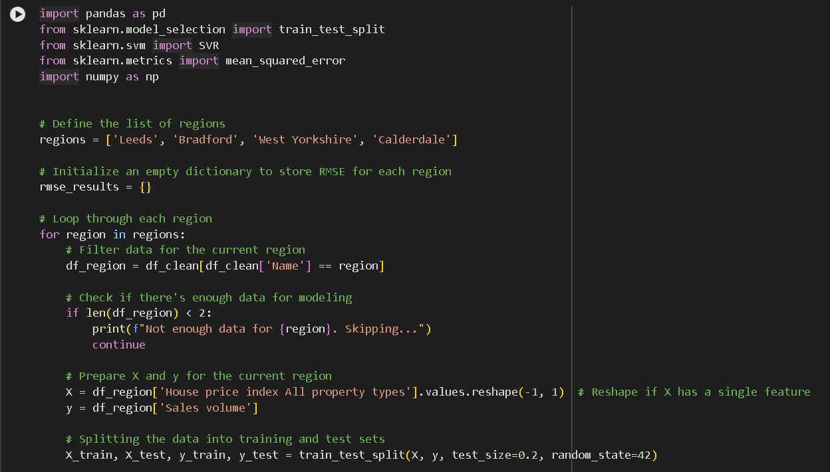

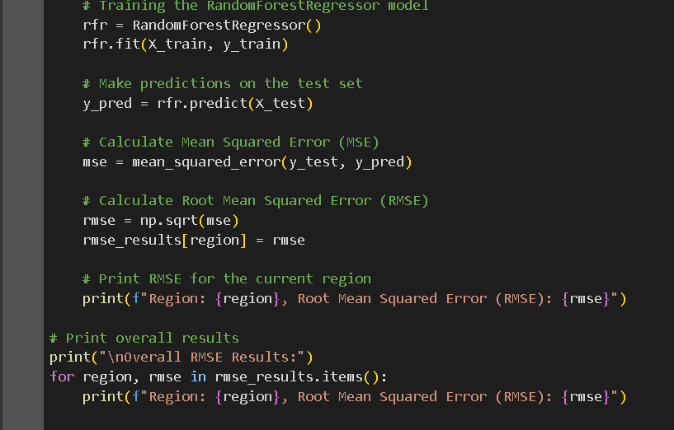

*Figure 32 Finding RMSE for Random Forest*

**4.4 R2 Score:** In order to store the scores of R2 for the different regions a dictionary is being made to define the specific areas.in helps in the process of filtering all the data of the regions in order to store the relevant data to ensure the sufficient data for the models. Thereafter, the training and the test set data are being divided, and all the target variables are being created in order to train the random forest regression. The scores of R2 which are presented in the house price index can be predicted by the sales volume. All the findings of R2 of every region are generated by the evaluation of the performance of the models of each region.

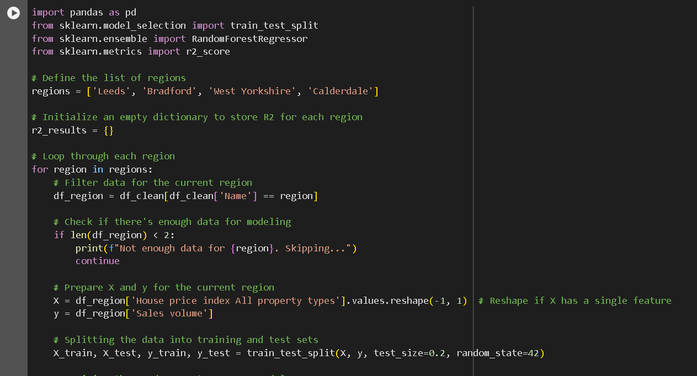

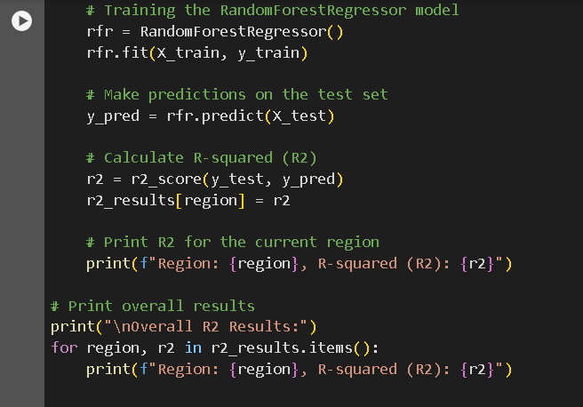

*Figure 33 Finding R2 for Random Forest*

The mean absolute error indicates the least average prediction which has the comparison with the other models. The mean squared error can be considered as the higher version of linear regression, and it is also displayed that it is lower than the random forest. In order to support all the vector machines (SVM) Root Mean Squared Error (RMSE) is higher than that of Linear Regression but lower than that of Random Forest and Gradient Boosting.

In the negative R2 value no one made the process of performing the prediction of mean-based prediction. In order to measure the better performance, it shows that SVM performs better than MSE and MAE. Here it shows that SVM helps in the process of generating accurate predictions in the evaluation of the strategies.

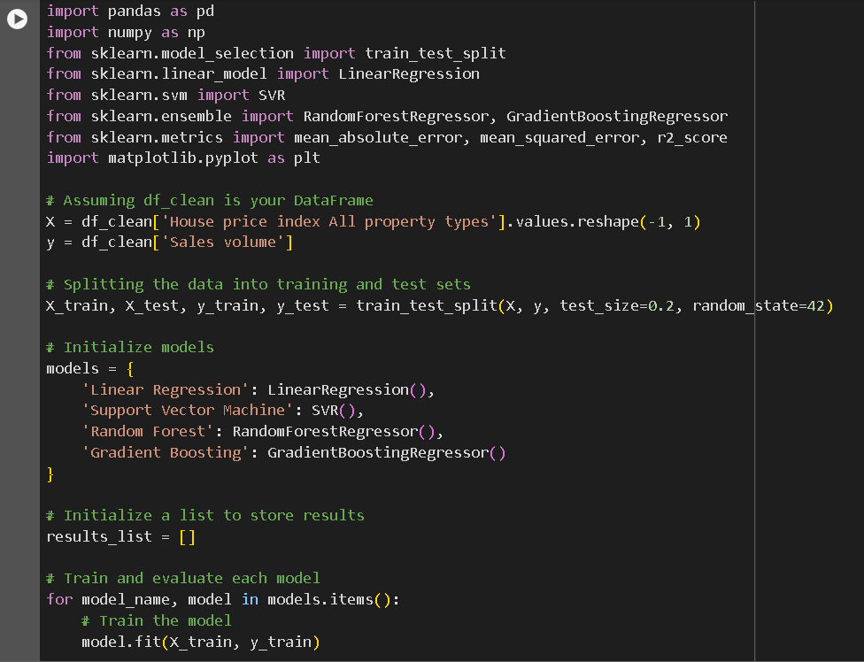

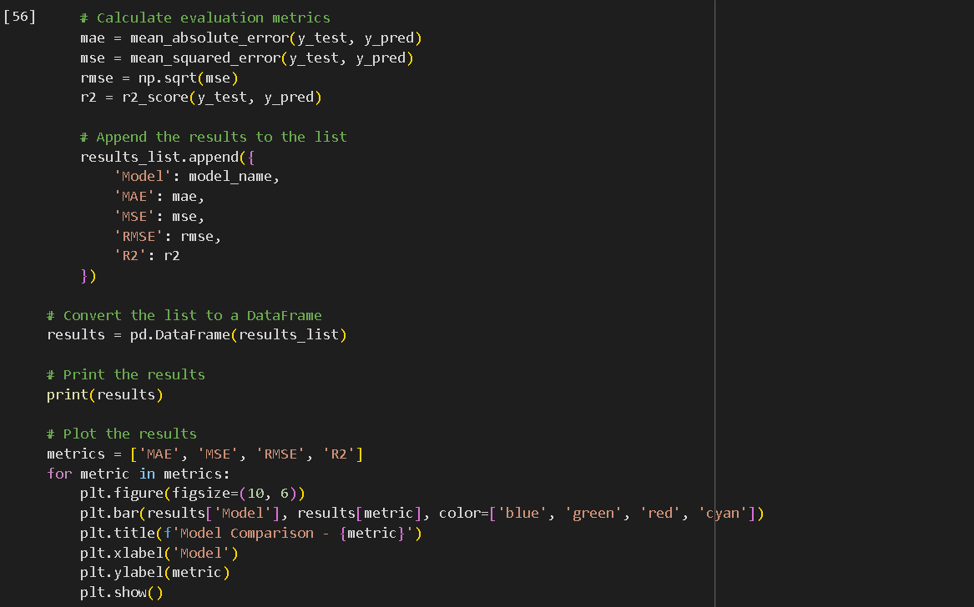

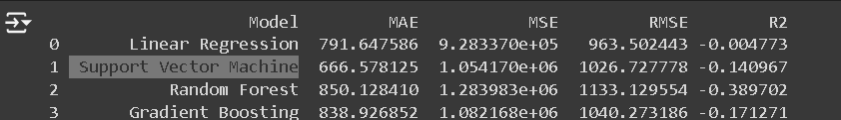

## 4.8 Model Prediction

The Support Vector Regression (SVR) model is used by this code to forecast future house price indexes for various regions. Here the SVR model is basically used by this particular code in order to monitor the house price indexes for the different regions. At first the dataset needs to be changed in order to determine the format in allowing the analysis of the time-based analysis.

The system then projects results over the next five years using the past data. These future projections are compiled into a DataFrame to create a pivot table that summarizes the expected house price indices for each region. This table is saved in a CSV file for reporting or analysis at a later time. A bar graph is created to better visually represent the projected home price indices for each of the five regions over the ensuing five years. The graph makes it simpler to compare the anticipated trends across locations and provides an easy-to-understand way to see the anticipated changes in property prices.

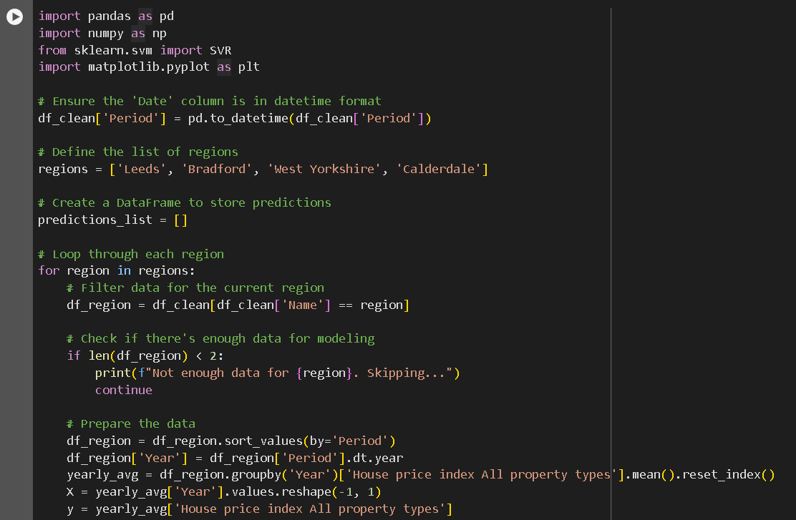

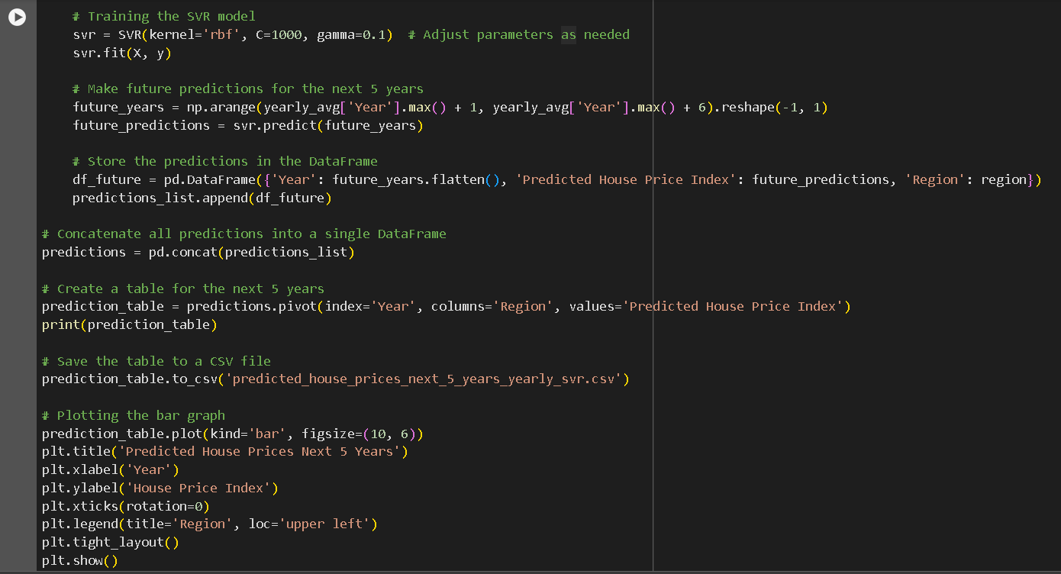

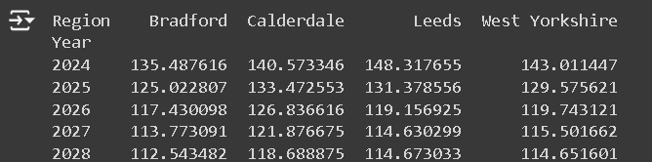

*Figure 34 Model Prediction*

## 4.9 Visualization and Analysis

Finally,Visualize the house price indices for the various regions to display the place with the greatest index for each year. It initially determines which region has the highest predicted house price index for each year using the {idxmax} and max functions. The information is then organized into a DataFrame that displays the year, the region with the highest index, and the corresponding index value.

these indices with matplotlib over time. The house price index for each region is shown as a separate line, making it easy to compare trends between them. To highlight these peaks, red dots are used to indicate the regions with the highest index values for each year. Labels, a title, a legend, and a grid are added to the plot to enhance readability and add additional information to the visualization. This graphical illustration makes it easier to comprehend how regional variations in house price trends occur and shows which region leads the country in terms of annual house price indices.

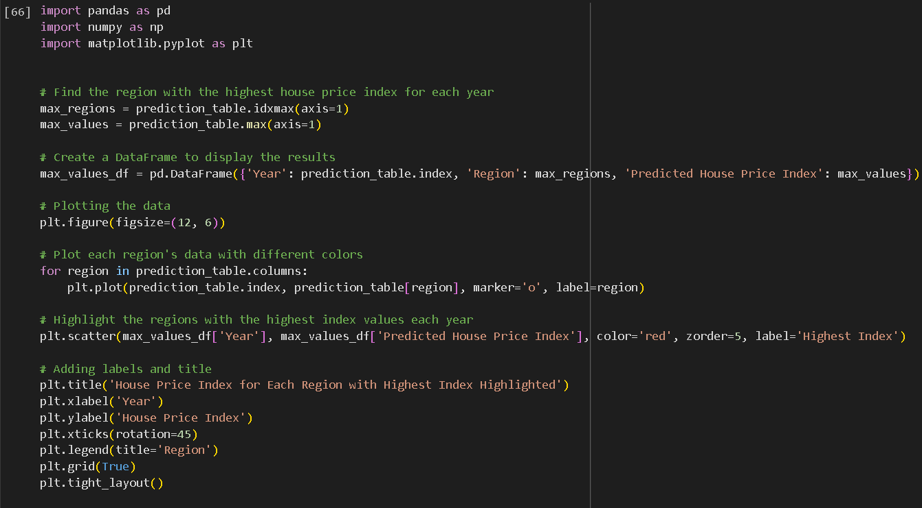

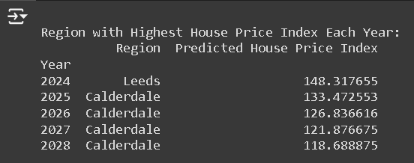

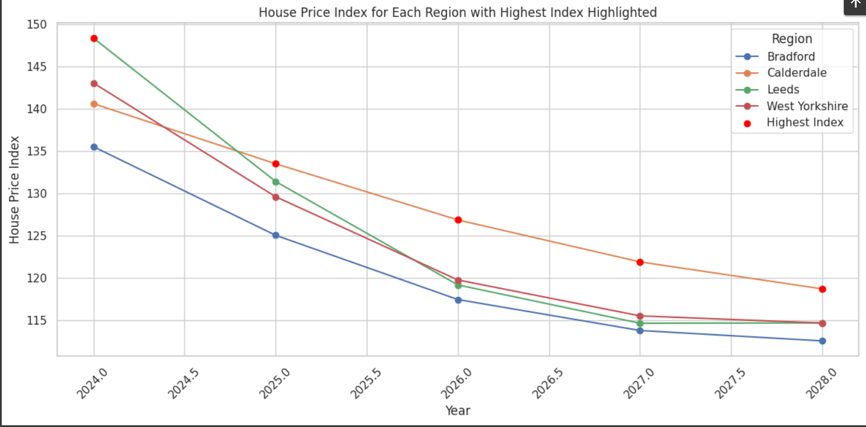

*Figure 35 Max values of Prediction*

## 4.10 Deep Learning

Artificial neural networks, the building blocks of deep learning, are algorithms that draw inspiration from the structure and operations of the human brain. Layers of connected nodes, or neurons, that process and learn from data make up these neural networks. Since neural networks utilize numerous layers to simulate intricate patterns and representations in data, the name "deep" in deep learning relates to this feature.

Deep learning algorithms are specific machine learning techniques that leverage multi-layered neural networks. The following are some important deep learning algorithms and architecture Feedforward Neural Networks (FNN), Convolutional Neural Networks (CNN), Recurrent Neural Networks (RNN), Long Short-Term Memory Networks (LSTM), Gated Recurrent Unit (GRU).

Deep learning is essential in the present AI era because it allows us to address complex, data-intensive problems that are above the scope of traditional algorithms. Because of its ability to automatically learn features and model complex relationships in data, it is a powerful instrument that has greatly advanced industry and technology.

**Long Short-Term Memory Networks (LSTM):** One type of recurrent neural network (RNN) that is particularly useful for effectively extracting long-term dependencies from sequential input is the long short-term memory (LSTM) RNN. This is considered to be accurate due to the exceptional architecture that it supports. This amalgamates with the combination of memory cells followed by gates which grants access for having a systematic control over the amount of data that is being opted out. At the same time, these two memory networks  have  the capabilities in getting a unique design which are posed to be effective in detecting problems such as gradients. This entails in personifying them to mitigate critical issues in a proactive manner which are intended to be sustainable along with long-term context. This, it is evident that language modeling and time series are preferred as there two widely accepted applications that stands to be effective for LSTMs.

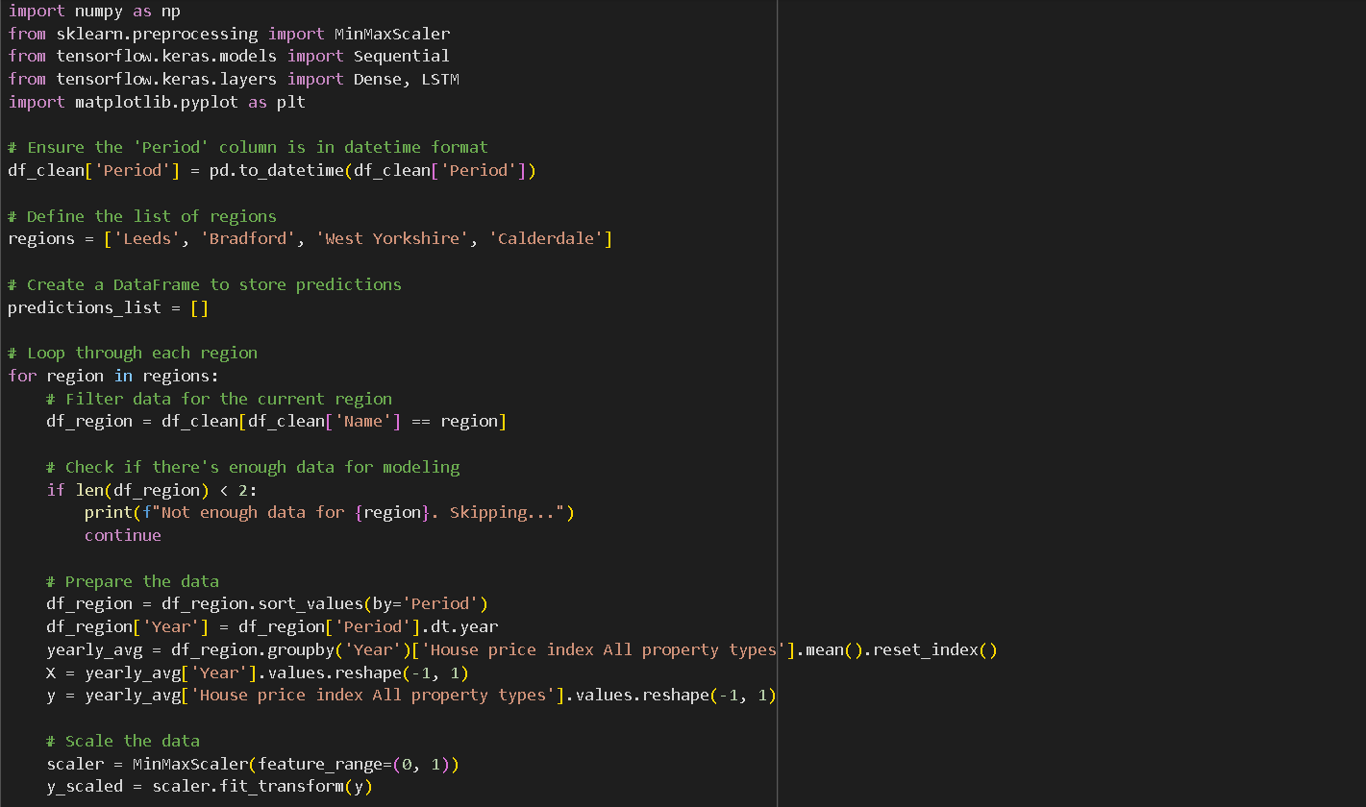

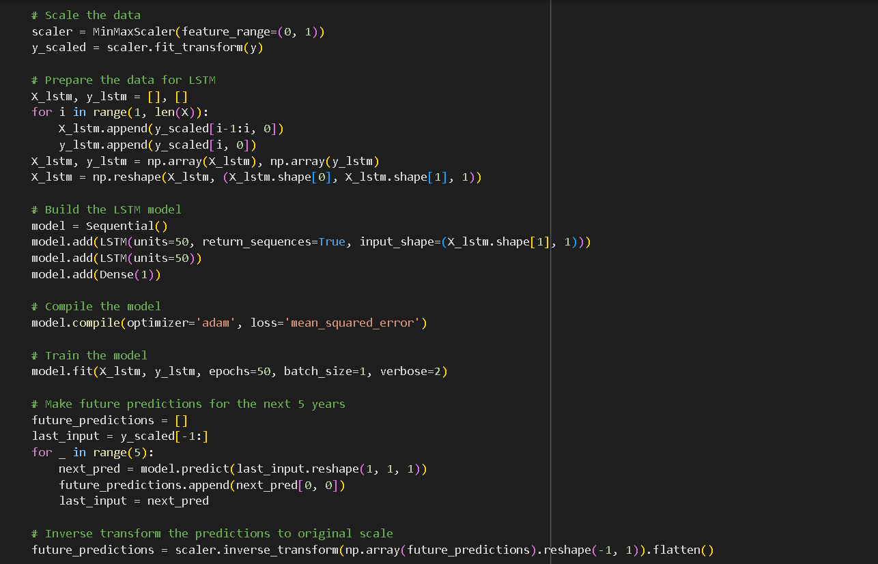

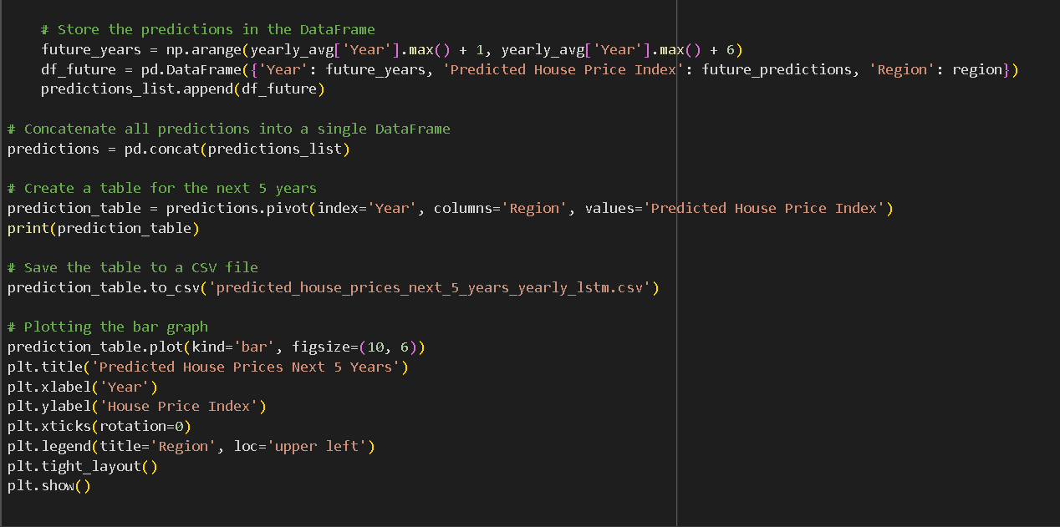

*Figure 36 LSTM Algorithm*

It is observed that having a primary mindset in achieving the goals of safeguarding the project houses is termed to be a vital aspect that cannot be ignored. Here, it is viewed that with the utilization of project future house price indices requests for various weaker sections that are identified by the utilization of  the “LSTMs” which allows it to stand as a neutral network. At the same time, this neutral network is considered to be a superior tool for showing power during  the time of accuraste series prediction applications. Moreover, within the next five years in particular the domain which is West Yorkshire with Bradford Calderdale allows the fetching of relevant historical data  and work upon it accordingly. The code enables a comparison examination of potential price changes for houses across various places by utilizing a machine learning model that recognizes patterns and trends over time. On the other hand, this entails capturing crucial information that are terms to be vital for the urban planning along with economic forrcasts  and within the field of real-estate investment. It is observed that the mechanism of this lies behind the structure of preparing the data followed by processing it meticulously  and executing it sequentially to get optimum results. This proved to be fruitful as it sustains with the sequences that are intended to prepare the LSTM model  and get valuable insights from it after the data has been executed. Thus, once the data is fetched then it is transferred with the next two layers of the model that intrigues with successful prediction with the use of Keras. Additionally, after  the successful completion of the training phase, it guides with proactive outcomes for the next five years which augments into a successful Data Frame. Therefore, these forecasts are saved as a CSV file for which a bar graph is needed for portraying the execution and getting upgraded with the latest trends within the house prices. This algorithm is crucial because it uses sophisticated machine learning techniques to make more accurate forecasts, automates the laborious process of projecting future home prices, and produces understandable visuals to aid in strategic analysis and decision-making.

**Gated Recurrent Unit (GRU):**Similar to Long Short-Term Memory (LSTM) networks, a Gated Recurrent Unit (GRU) is a complex variety of recurrent neural network (RNN) intended to handle sequential input. GRUs are especially useful for tasks like speech recognition, natural language processing, and time series forecasting that require temporal dependencies and patterns. In contrast to traditional RNNs, which struggle with long-term dependencies due to disappearing or exploding gradients, GRUs manage the information flow by using gating techniques. The three main components of a GRU are the update gate, which regulates the amount of historical data to be maintained and the amount of new data to incorporate, the reset gate, which regulates the amount of historical data to be deleted, and the candidate activation, which stands for a possible new state. The enhancement of this recurrent neural network is poised to be of immense importance as it successfully leverages in utilizing proper training functions and monitors in a comprehensive manner. This indicates with the support of the discrete cells that are impound to be ignoring  the input gates by the advancement of a single gate  and upgrading it with the latest trends. As this type of network contains minimum hyperparameters than LSTMs that  serves it to be much more superior in terms of architectural structure and adjustment. However, in some cases, fostering with simpler infrastructure has the possibilities of limiting the training time thereby fueling their overall performance. This however is not needed because of its complexity. Therefore, this comes to be beneficial with respect to many circumstances for getting a nuanced understanding  and anticipating the temporal trends That pose to be advantageous in harnessing sustainable results.

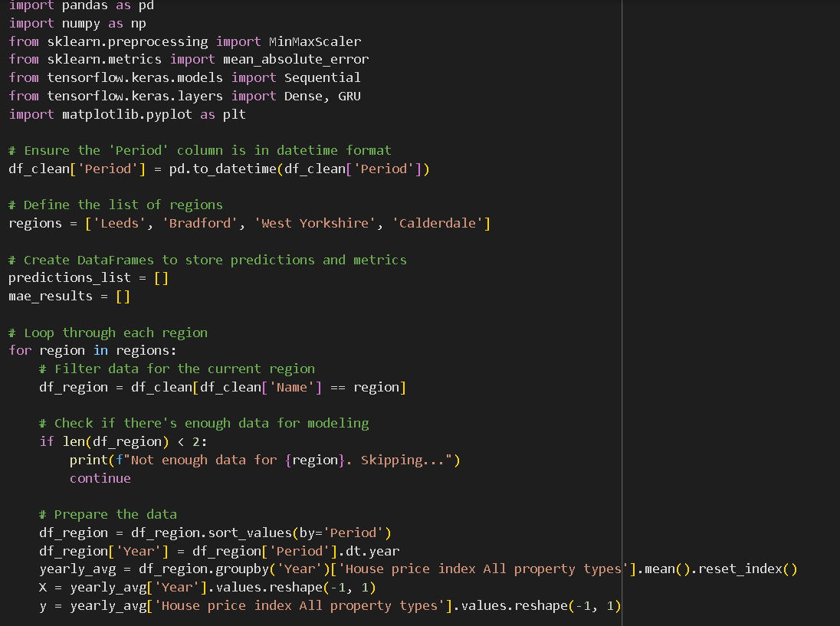

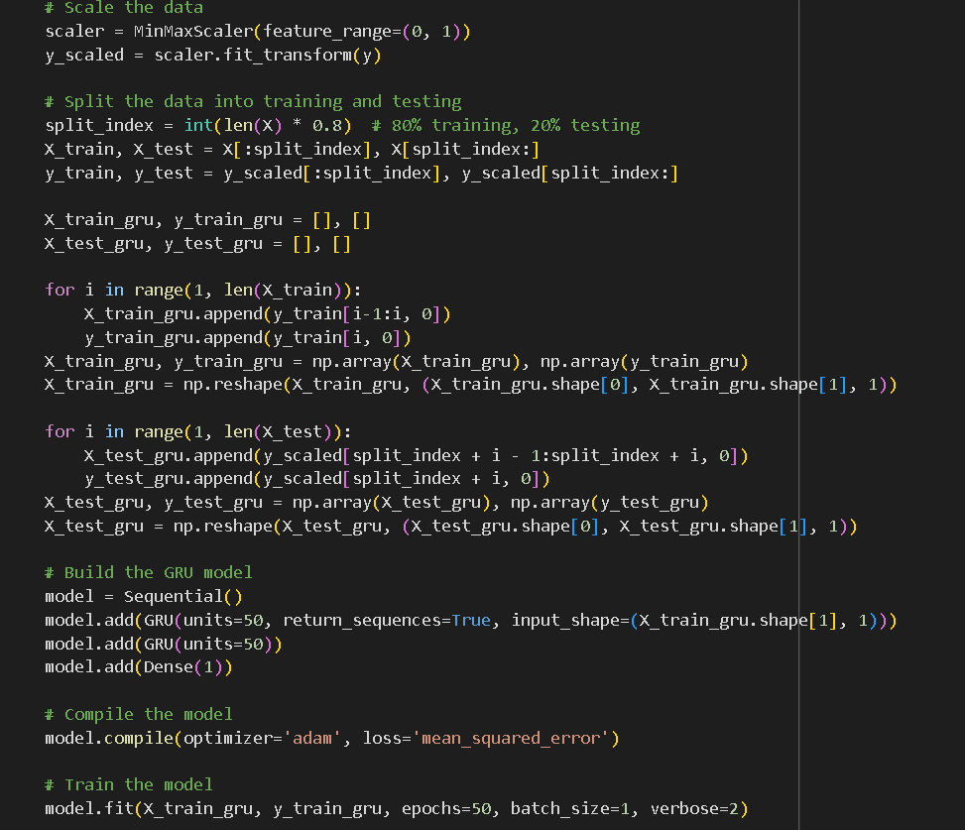 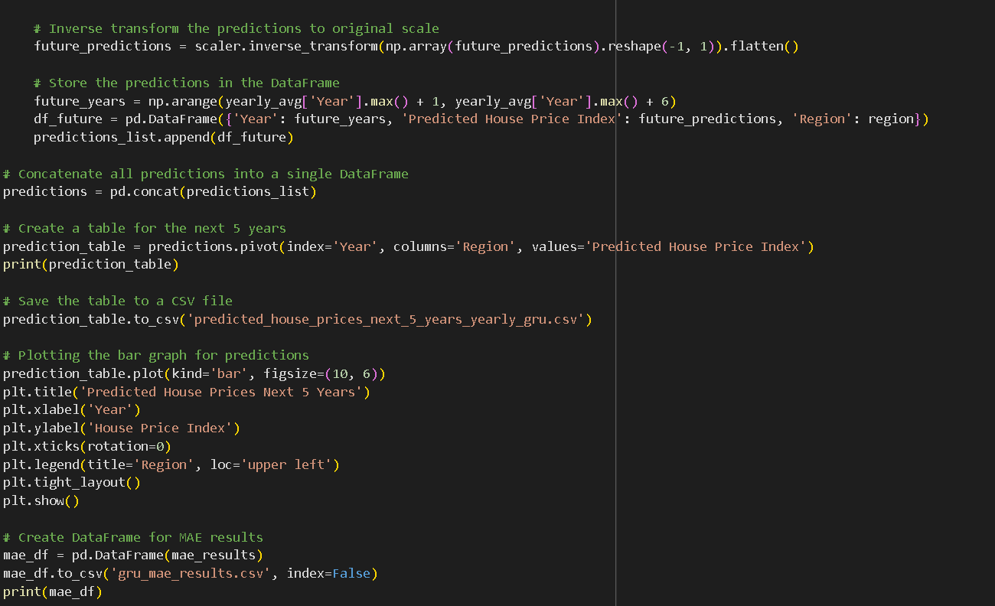

*Figue 37 GRU Algorithm*

It is obvious that the application of the Project house price indices comes with many prolific variations like for example utilization  of the “GRU’ model. This embraces in getting structured orientation of the data that are contained within  the dat  and time format of the Period column. At the same time, it also serves with holistic filtering of the data getting appropriate calculations regarding the annual averages. It is noted that within the first code, there is a chance of a significant portion which is operated in a meticulous manner. Additionally, after scaling up the data with the tool “MinMaxScaler”, the data is then distributed within training and testing sets. Here, it is chalked out that data is collected in more than  the testing cases. Following this,  the data is transferred to the model which converts it into a serial observation. The importance of  the model is that it has the tendency to generate these projections that are fully based on the data provided. Moreover, this is also utilized for Mean Absolute Error also abbreviated as “MAE” apart from forecasting which contrasts the estimated values to the actual values. Furthermore, it is obvious that the mechanism implemented in this process opts out to be an exceptional one due to its cohesive analysis patterns.From the above image, it is found that more than fifty epochs are found in order to modify the model for enabling to execute the test in a streamlined manner. This proved to be scalable with the initial values that set the stage in determining the MAE. The automation of the forecasting process that helps to facilitate informed decision  and granting for fostering definite geographical data. Quantitative data is allowed in this case alongside  their geographical data with full effectiveness. However, this code served them with distinctive values that gained from the DataFrame  and the MAE results to CSV files which in-turn allows systematic generation of a graph in predicting complete precision. Thus, the model helps to analyze the overall understanding with the dissemination of the vital data that are developed for  the upcoming  days with full endeavors. 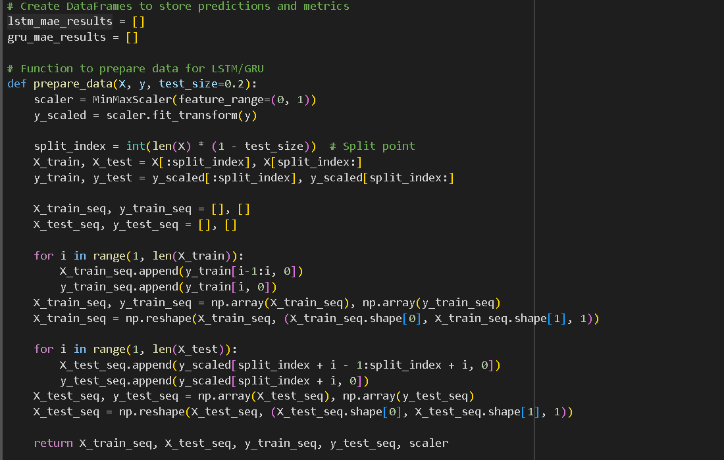 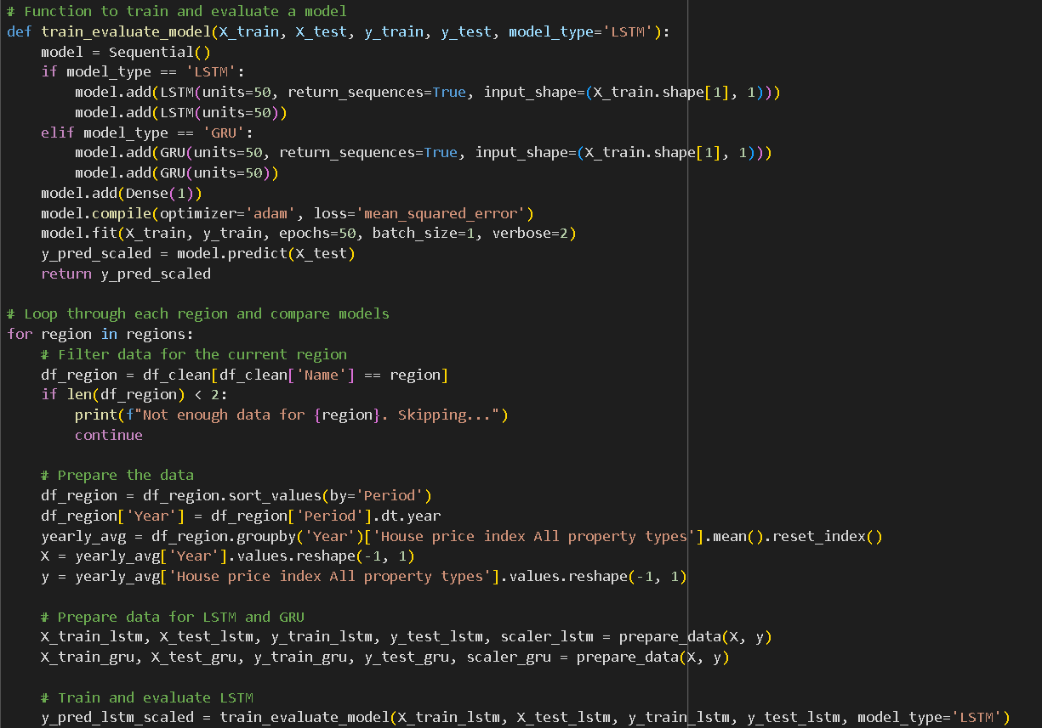

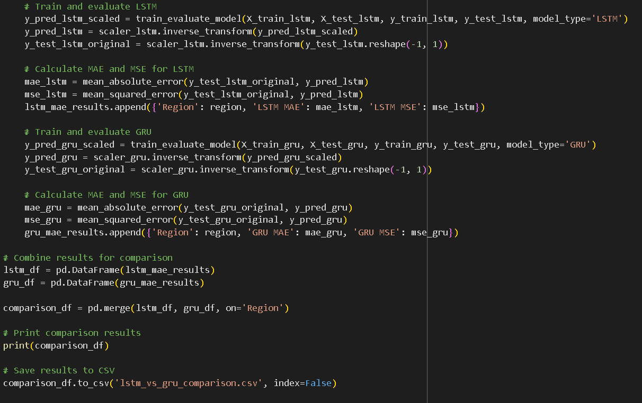

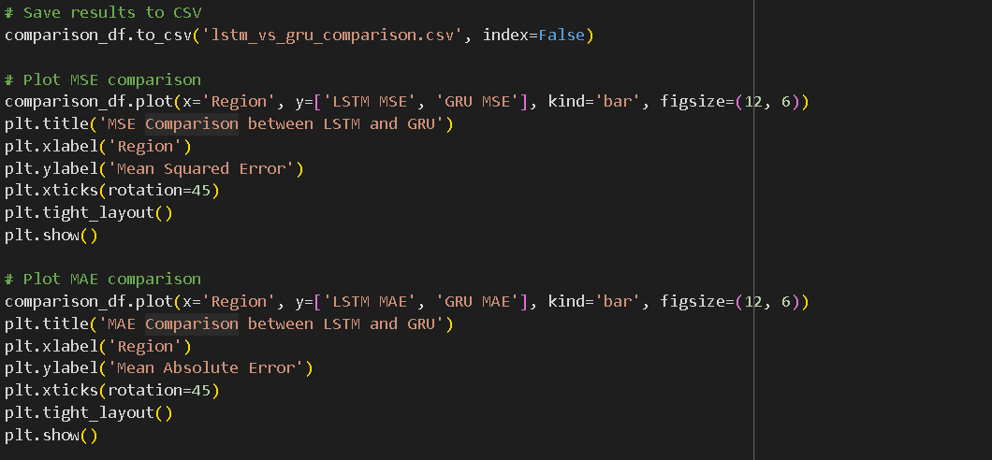

*Figure 38 compare LSTM and GRU Algorithm*

The following code is meant for the application of getting proper access with which both “LSTM”  and “GRU” are benefited by producing efficient project house pricing indices within several topographical regions. It is found that the main motive behind this is to get a systematic overview to allow complete evaluation and comparison within these types of neural networks. These terms are of immense relevance that are used for the prediction of the upcoming values which are estimates for the historical data. Consequently, thus code aids to assess the two models for having a streamlined performance. The comprehensive determination of the overall performance of the model suits in generating the code with respect to the involvement of  bar charts that allows to have  contrast within MAE and MSE for both the models. It is noted that the amalgamation of “MAE” and “MSE” supports portraying positive results to both models with unique results. This results in comparison of each model in a systematic way. Initially, the code prepares the data and then it is followed by a separation process into two parts namely; testing and training sets. This is then reorganized in such a manner that the prediction is produced to be evaluated with full precision in accordance with each and every model. On the other hand, the facilitation of the process generated the exact forecasts which in-turn amalgamated with the sustained decision-making process. Here, the results are achieved by granting with collective information and this fosters with valuable insights regarding the functioning of each model and benefiting in opting for the best model which is used for gaining effective  outcomes. 

# Chapter 05: Results and Analysis

## 5.1 Introduction

This chapter has properly discussed different outcomes on the machine learning model on house pricing. The chapter has further evaluated the relevance of the model to achieve the research objectives. It involves the definition of various aspects such as measures of variation, graphs and charts alongside a description of the nature of the information between the variables of interest. Finally, the chapter reflects on the implications of these findings to the real estate market characteristics and policy matters.

## 5.2 Data Preparation and Feature Engineering

### 5.2.1 Data Collection

The data used in this study was collected from an Excel file containing house price indices and sales volumes of different regions, with a focus on the Bradford region. They were ‘Period’, ‘Name’, ‘Sales volume’ and ‘House price index all property types’. The ‘Period’ column was also changed into the datetime format in order to perform time series analysis.



*Figure 39 Dataset*

### 5.2.2 Data Cleaning

Step1: When a DataFrame is run through the `df.info()` method prepare and clean the data effectively before performing more detailed analysis. its structure, data types, and completeness are simply summarized. This DataFrame contains 8 columns and 524 elements that are indexed from 0 to 523. The following rows are available: "Name," "URI," "Region GSS code," "Period," "Sales volume," "Reporting period," "House price index All property types," along with "Pivotable date." All other columns have 524 non-null data, with the exception of "Sales volume," which has 516 non-null entries, suggesting 8 missing numbers. The data types are different: "House price index All property types" and "Sales volume" are {float64}, whereas the remaining data types are {object}.This shows  determining the memory use, identifying the data types of each column, identifying any missing values, and understanding the structure of the DataFrame. The information needs to be retrieved in a proper manner. It helps to improve the data for further processing and analysis.

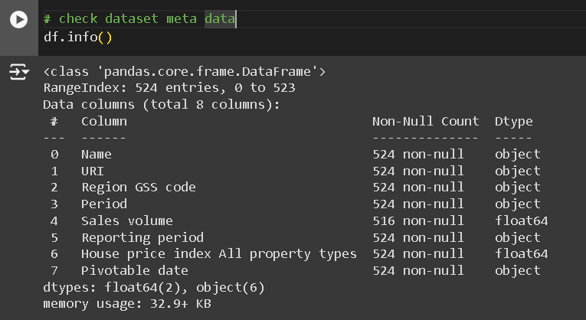

*Figure 40 Display Meta Data*

Step 2: In this step, it becomes extremely important to obtain and summarise key knowledge from the statistical measures in the study. This is particularly helpful to make the insights dependable and accurate. The derived summary of the statistical calculations present a proper understanding of the “Sales Volume” and “House price index All property types” columns. The “Sales volume” column gives a standard deviation of 999.38 with an average of 1129.54. This column also has 516 non-null values. These measures are important for understanding the relevance of the “Sales volume” column. There is a great degree of variation of data in the column. 97 is the smallest and 4664 is the largest sales volume. While the median is 702.50, the 75th percentile is 1528.75, and the 25th percentile is 352.25. These numbers indicate that the data is very variable but rather symmetrically distributed.

The "House price index All property types" column, on the other hand, shows less variability than sales volume with an average value of 118.50 and a standard deviation of 18.43 for the 524 non-null entries. There is a minimum of 88.86 and a maximum of 165.10 for the house price index. A more uniform distribution is indicated by the 25th percentile of 104.43, the median of 115.04, and the 75th percentile of 132.38. Overall, this overview shows that although home prices are generally steady, sales volumes differ significantly, offering crucial information for more research and judgment.

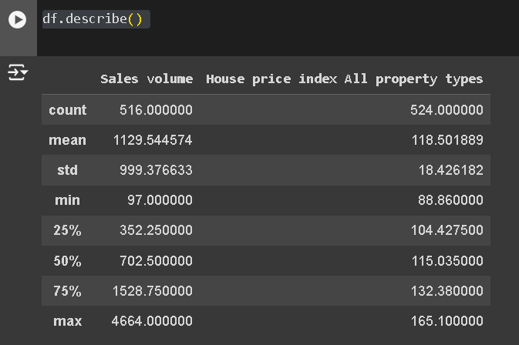

*Figure 41 overall Information of sales volumes and House Price Index*

Step 3: The "URI" column contains URLs or identifiers that do not contribute to the analysis, statistical models, or insights you are aiming to derive, it may be considered irrelevant. Sometimes, the information in the "URI" column might be redundant or can be derived from other columns. In such cases, keeping it would add unnecessary complexity. Also, Dropping unnecessary columns can reduce the size of the dataset, making data handling and processing more efficient. By removing columns that are not needed, you can streamline your DataFrame, making it easier to focus on the relevant features for analysis. In order to check for any missing values in the DataFrame {df_clean}, `df_clean.isnull()} command can be used. This commented-out line is instrumental in filling out the missing values in the DataFrame. They are mainly filled using the column mean. This particular approach is very effective in eliminating irrelevant columns from the created DataFrame. Data can be better analysed, since the entire DataFrame becomes more streamlined using this approach.

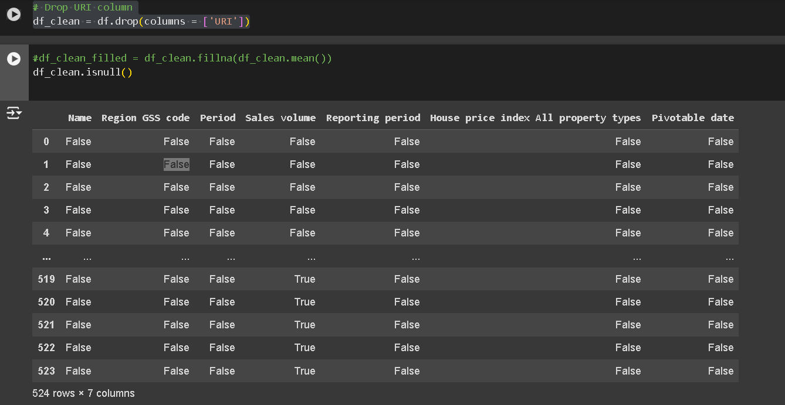

*Figure 42 Clean Data*

Step 4: This step is really important since it helps to ascertain that the data is of the highest quality. With the help of df_clean.isnull().sum() command, we are able to identify missing values in each column of the created DataFrame. On top of that, this step helps to formulate a proper plan to tackle the missing values. Important techniques for handling the missing values include imputation, removal and similar methods. The missing values need to be effectively managed, so that the research can be conducted ethically. We have found 8 null values in the Sales Volume column.

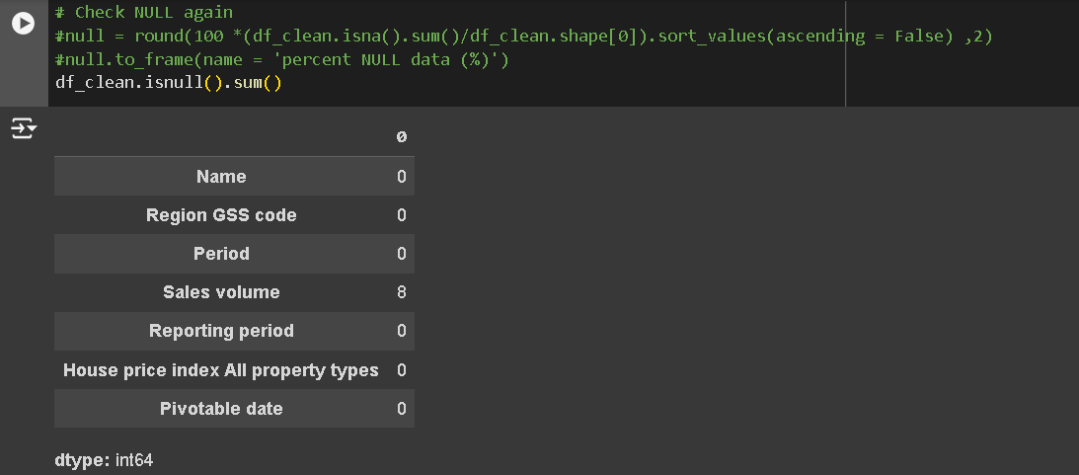

*Figure 43 Finding Null values*

Now, we need to clean all Null values for preparing the DataFrame for reliable analysis. First, df_clean can be used to examine duplicates.repeated(). The entire analysis and statistical results can be disrupted if there are duplicate rows. Subsequently, df_clean command can be used to remove rows that have missing values. Given that many analytical techniques need complete datasets, dropna(axis = 0, inplace = True) handles any data gaps. Finally, using df_clean.isnull() to recheck for missing values.sum() verifies that every gap has been properly filled. Together, these actions increase the correctness and completeness of the dataset, making it appropriate for additional study.After this step there is no null values in dataset.

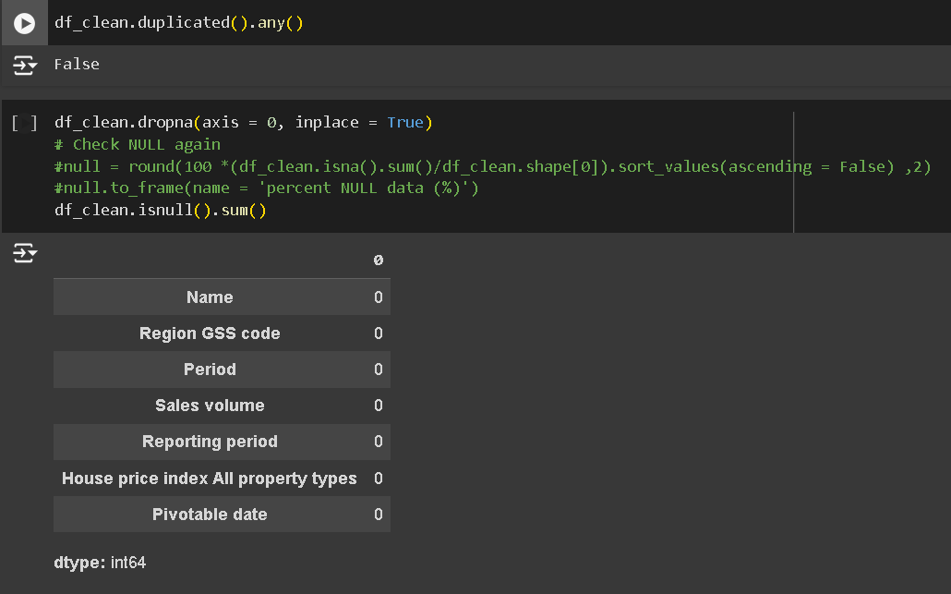

*Figure 44 Clean Null Value*

### 5.2.3 Data Preprocessing

To make the cleaning of the data easier for analysis, the ‘Period’ column was used to set a new index for the DataFrame. This step was required for time-based operations and analysis to take place. The created DataFrame was then sorted by the ‘Period’ index to ensure that all the subsequent operations adhered to time series sequencing. To focus on the desired area, the new subset of the DataFrame was created and named as bradford_df. This subset only included the rows in which the contents of the ‘Name’ cells were the same as the word ‘Bradford’. In this way, the analysis and predictions made on the data were relevant strictly to Bradford housing market tendencies only.

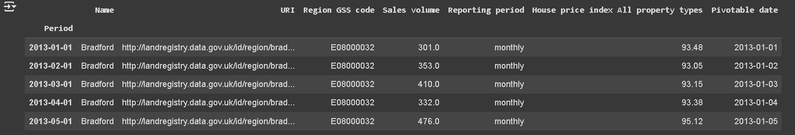

For a number of reasons, maintaining data balance is essential in statistical analysis and machine learning. It primarily affects model performance because unbalanced datasets can cause models to predict the majority class more accurately than the minority class, resulting in misleadingly high accuracy. This may lead to biased models that perform poorly in crucial situations like fraud detection or medical diagnosis. The dataset shows that the frequencies of sales volume vary significantly. A number of sales volumes are repeated, with the count of three for a few particular volumes, 683.0, 1078.0, and 280.0, having the most frequency. Numerous sales volumes had two occurrences, suggesting a moderate degree of dataset recurrence. On the other hand, a significant percentage of sales volumes only show up once, indicating a long tail of unusual or infrequent sales statistics. This disparity suggests that while certain sales volumes are typical, a large number of them are not, which may have an effect on any modeling or analysis done on this data. Redressing this imbalance might be necessary to guarantee a fair and accurate analysis, particularly if the less frequent sales volumes are highly significant in the context of the firm.

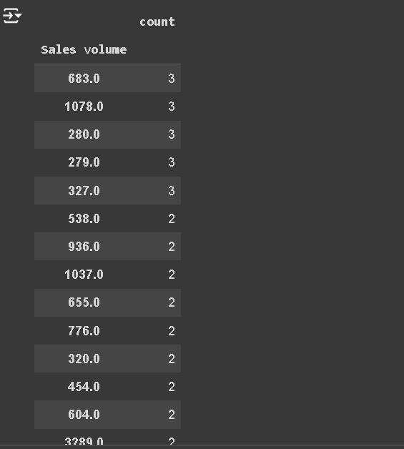

There was a notable disparity in the sales volumes of the original dataset; some numbers, including 683.0, 1078.0, and 280.0, appeared three times, while many other values just once. Inaccurate model training and biased analysis may result from this imbalance. However, following resampling, every sales volume now displays three times in a consistent way, ensuring a balanced distribution. By reducing the impact of class imbalance, this adjustment enhances the dataset's potential for precise and unbiased analysis. To cover a broader range of locations and time periods, the dataset has been resampled. Since the sales quantities are uniformly distributed, it helps to conduct the analysis in a comprehensive manner. For instance, in January 2013, sales volumes in Bradford and West Yorkshire are presented in a concise manner. It has properly illustrated how resampling has helped to achieve a balance in data.

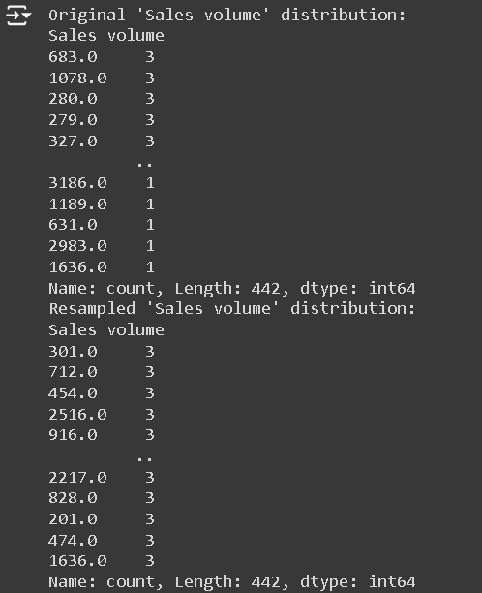

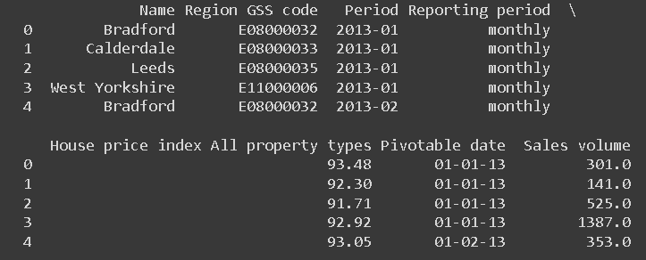

*Figure 45 Data Balancing*

**Box Plot**: Box plots are one of the primary visualization tools used for analysing large data sets. The visualisation tool presents a holistic picture of the data present in the data set. This overview can further give insight on the spread of the data, tendency and range. It helps one to understand the pattern in which data is present in the data set. The box plot of the sales volume is absolutely important to analyse the data present there. A central tendency can be seen from the central line preset in the box. The margins of the box represent the 25th (Q1) and 75th (Q3) percentiles. They are helpful for illustrating the interquartile range (IQR), which represents the central 50% of the entire data. It helps to exhibit the middle portion of data distribution. The whiskers range from the box to 1.5 times the IQR. It continues over the 75th percentile and under the 25th percentile. This is the range in which most of the data points lie. Outliers are points that fall outside of these whiskers; in this example, they represent many greater sales volumes above the top whisker, suggesting notable variations from the remaining data. This points to a few examples of unusually high sales volumes that could need more research to determine the underlying causes, which could include odd sales trends or data entry mistakes. Overall, the box plot provides a clear and succinct visual summary for study by highlighting the sales volume data's central tendency, variability, and outlier presence.

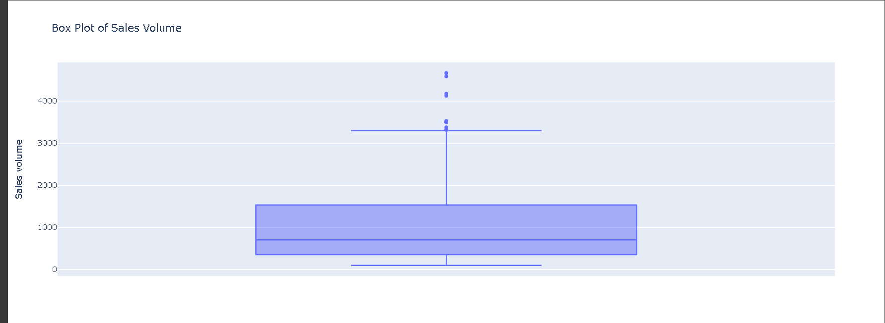

*Figure 46 Box plot of Sale Volume*

**Histogram**: Histograms are a crucial tool in data analysis and visualization because they provide a clear visual representation of the distribution of numerical data. Since they offer a clear visual depiction of the distribution of numerical data, histograms are an essential tool in data analysis and visualization. Histograms display the distribution of data points across various intervals, which helps identify patterns like skewness, central tendency, and general distribution shape.

Two histograms showing the distributions of sales volume and the house price index for all different kinds of properties. Most sales volumes are concentrated at the lower end of the scale, specifically between 0 and 1000 units, as the first histogram on the left illustrates. The frequency is highest in this region, suggesting that lower sales volumes are involved in the majority of transactions. There are very few occasions where the frequency surpasses 3000 units; instead, it declines significantly as sales volume grows.   
  
The distribution of the house price index across all property categories is shown in the second histogram, which is located on the right. According to the statistics, home prices typically cluster between 100 and 120 on the index, with a peak occurring between 110 and 120. A minor right skew is present in the distribution, with fewer properties indexed above 140. This suggests that even in cases when the majority of properties are properly priced, a lower proportion of high-value residences contribute to a higher index. The data on the sales volume suggests that there is a tendency for smaller transactions. This insight can be derived when the data is compared with the home price index. The home price index exhibits properties with mid price range with sporadic outliers in the higher range.

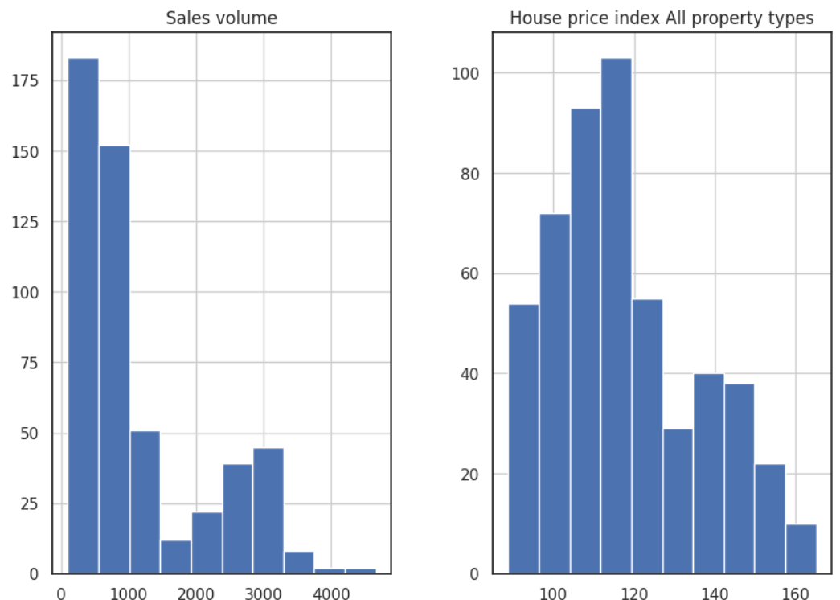

*Figure 47 Histogram of Sale Volume And House Price Index*

### 5.2.4 Feature Engineering

**1. Mean Values:** The mean house pricing index is extremely significant for analysing the housing market. This tool provides a holistic summary of the various patterns in real estate prices. Therefore, it helps to understand if the prices are rising or falling. Considering the insights gained from this tool, buyers, sellers and investors can make informed decisions. The bar chart exhibits the mean housing price index for three valuable boroughs, such as West Yorkshire, Bradford and Leeds. Moreover, West Yorkshire and Leeds present the highest mean house price index. The values come close to 120. Bradford is another costly area, which presents a mean housing price index of approximately 120. The graph is instrumental in showing that the three boroughs have high home price indices. Moreover, there is very little discrepancy between the three areas. Hence, it is evident that they are one of the costliest areas to buy a property in.

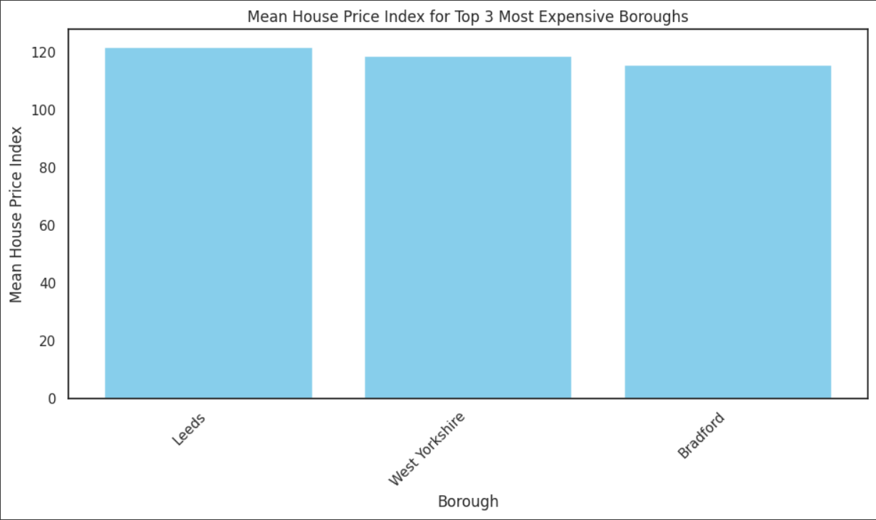

*Figure 48 Mean House Price Index*

**2. Seasonal Features:** These features help to identify specific seasonal impacts on sales and prices that are not captured by basic datetime features. The Holiday Season, Quarter Start, and Quarter End are the three seasonal aspects that are shown on the graph from 2012 to 2024. In contrast to the other aspects, the Holiday Season—represented by the blue lines—occurs intermittently, suggesting that holidays are dispersed and irregular. The Quarter Start, represented by orange lines, shows up at regular intervals to emphasize how regular and predictable quarterly starts are throughout the year. The Quarter End, denoted by a green line, is less regularly and consistently shown in the data, which could indicate that it was plotted differently or is not as prominently displayed. Overall, with a distinct pattern of quarter starts and more erratic vacation seasons, the graph successfully illustrates the cyclical structure of business periods.

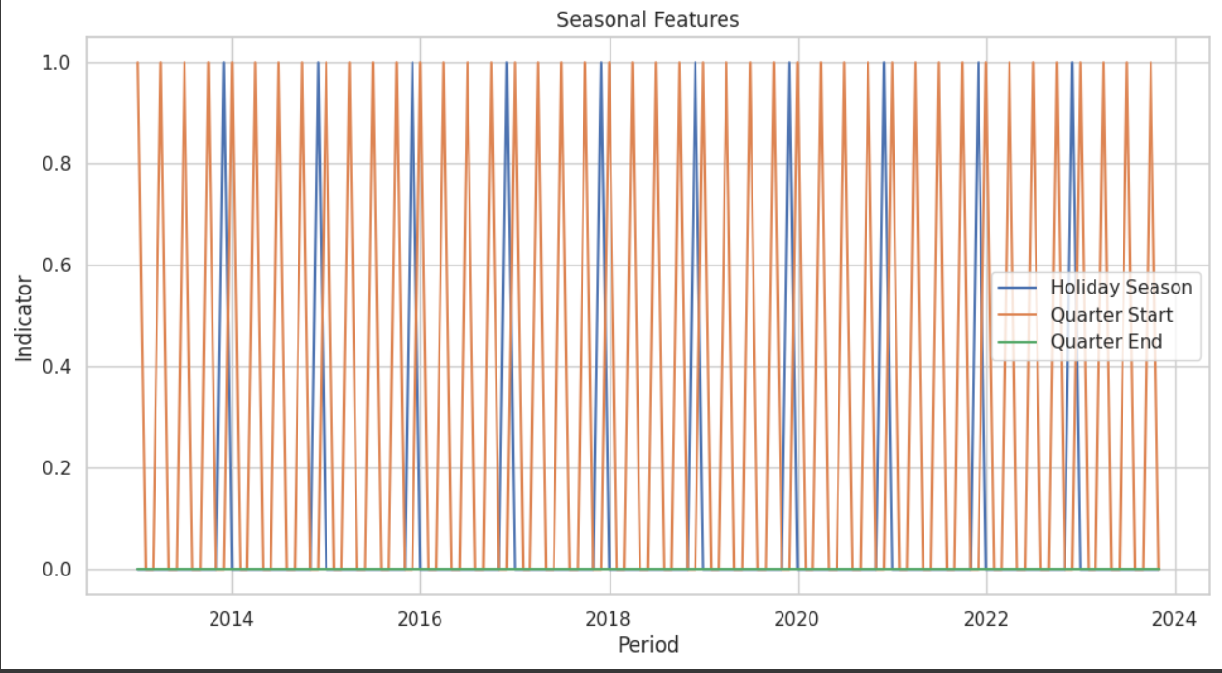

*Figure 49 Graphical representation of Seasonal Feature*

1. **Growth Rate Features:** Growth rate features help to capture the rate of change and can indicate acceleration or deceleration trends. The "Growth Rate Features" figure shows a comparison between the growth rates of the Sales Volume and the Housing Price Index (HPI) from 2012 to 2024. The blue bars depicting the Sales Volume Growth Rate exhibit significant volatility, ranging from values slightly below -1 to above 4. It is evident that there are noticeable variations in the sales volumes. These fluctuations are primarily influenced by changes in the seasons, economic problems and other market aspects. The data clearly shows ups and downs with no clear indication of a long-term pattern. The sporadic shifts in the market can cause the sales volume to change over a period of time.

On an alternative note, the HPI Growth Rate exhibits a steady pattern without much fluctuation. This is represented by the orange line presented in the graph. It can be seen that the HPI Growth Rate shows a downward trend before 2020. However, afterwards, it exhibits an upward trend. Therefore, it can be inferred that housing prices gradually increase over time. It reflects the steady market conditions.

There is no association between the two indicators in the graph, since the HPI Growth Rate remains more or less the same. The growth rate remains constant even during high sales volume. Therefore, it is evident that the property sales and sales volumes share no proper association. As a concluding statement, the picture is important for getting insights about real estates. It helps different stakeholders to understand the market dynamics and formulate effective strategies.

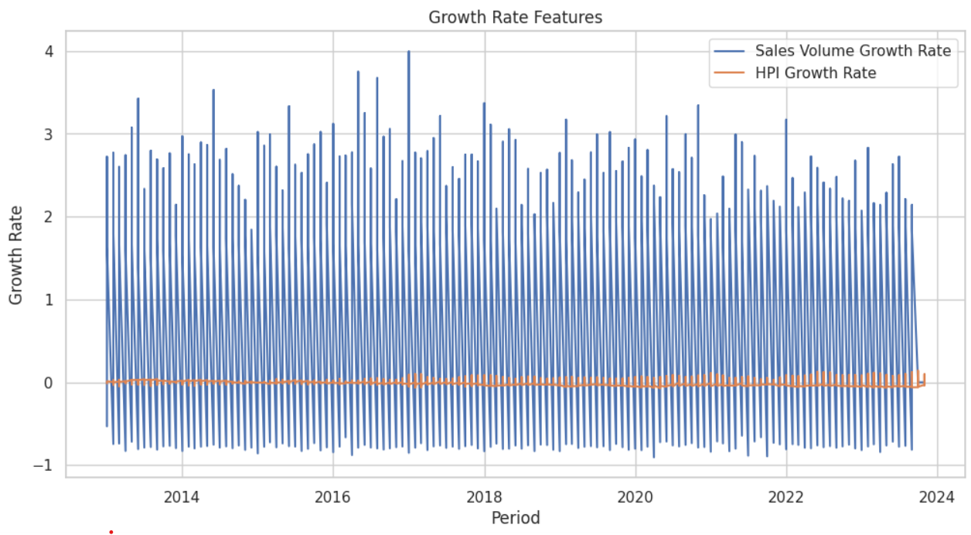

*Figure 50 Graphical Representation of Growth Rate Feature*

**4. Moving Average Convergence Divergence (MACD):** MACD is an effective indicator, which helps to identify changes in a trend’s intensity, momentum, length and direction. This visualisation is helpful for representing the sales volumes from 2012 to 2024. There is a juxtaposition between the MACD black and blue line. If the data is technically analysed, patterns in sales volume can be identified. The MACD line ranges from -200 and 200, which shows instability in the sales volumes. However, MACD exhibits a smooth tendency. When the crossover is present above the signal line, then there is an upward trend. Alternatively, if the crossover is situated under the signal line, it presents a downward trend. The place where MACD and the signal line converge with one another, shows changes in trends. The places where crossovers happen help to identify possible buying and selling opportunities. These are important for understanding shifts in momentum in the market.

The MACD indicator displays a circular trend with highs and lows in the sales volumes. These variations are a result of the changes in seasons in the market. However, the variations in the short-term patterns do not lead to an instability in the long term. Moreover, there is no clear upwards or downward trend in MACD. Sales volume can be described as a dynamic concept that is influenced by high volatility and shifts in market conditions. The long-term trend shows that the sales volume balances out over a period of time. The research is particularly important to provide meaningful insights to the stakeholders. Therefore, they are able to understand the dynamics in sales volumes, market entry and exit strategies. They can also forecast future changes in sales trends.

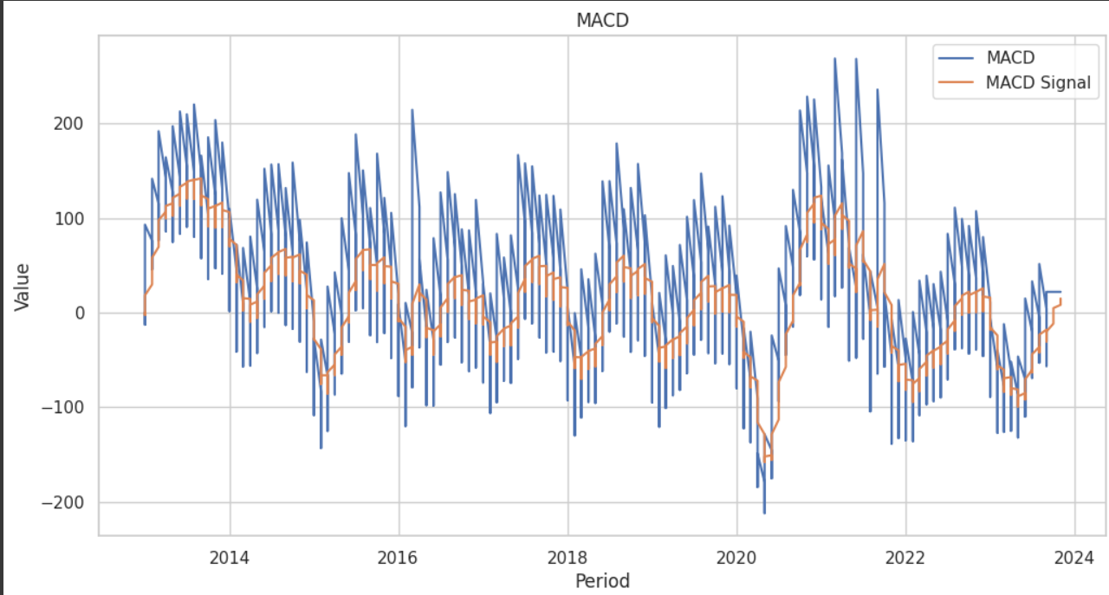

*Figure 51 Graphical Representation of MACD*

**5. Exponential Moving Average (EMA):** Considering the influence of the latest observations on EMA, it helps in simple traffic movement with the allowance of fresh observations. There is evidence of four data series which are compared with the help of graphical representation. The green line represents the house price index while the orange line represents sales volume EMA12. On the other hand, the blue bars and the red line represent sales volume and HPIEMA12 respectively. The analysis of the housing price index or done over the years 2012 to 2024 with the help of an exponential moving average. The unpredictability of market conditions has been represented with the help of sales volume that shows significant vulnerability from 0 to above 4000. In addition to this with the help of sales volume EMA12, the market fluctuations of short-term are captured with cyclical patterns which indicates period-wise variation and other types of patterns based on the state of the economy.

Additionally, the researcher has been able to analyse the House Price Index, which is measured between 0 to 1000 explaining that the housing values are becoming more predictable and consistent. This data has been represented with the green line and the regulated increase in house price helps to understand sales volume concerning cyclical patterns and long-term stability. Additionally, the stable residential market is supported by consistent Price value and upward mobility.

The fluctuation in sales volume data highlighted in the chart represents the influence of external market factors and the significance of stakeholders. In this regard, it is important for the stakeholders to incorporate the impact of these turbulences while maintaining the market position. The predictability in the housing price index provides the investors and the wires relative peace given the consistency in valuation in the long-term. Ultimately based on the graphical representation the researcher is able to hypothesise that despite turbulence in the market place the relative price of housing has remained stable and consistent. Therefore it is easier for investors and buyers to understand the market dynamics.

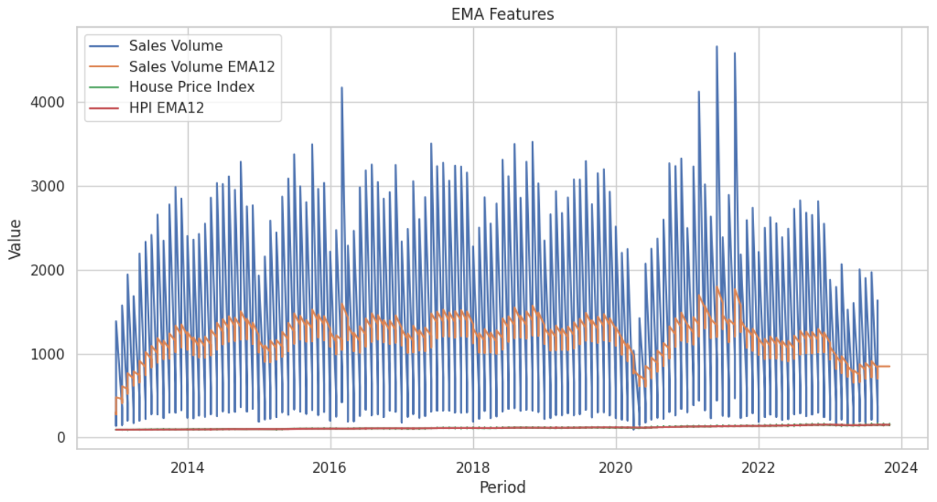

*Figure 52 Graphical Representation of EMA*

**6. Relative Strength Index (RSI):** The RSI parameter measures the direction and rate of price turbulence. It further determines the level of buying or selling under the market dynamics. The researcher needs to integrate these values to understand the house price index and relative strength index. These values help not only the researcher but also the buyers and investors to understand the market credibility based on the turbulent foreign exchange situation.

The graph display represents the relative strength index as well as the house price index for the sales value in the years 2013 to 2024. The turbulence can be Northeast in the blue line. However, it can also be the same that the relative strength index is almost stable with a range of 40 to 60. Despite stability, the cyclical pattern implies that the most notable turbulence occurred between mid-2015 and early 2023. Following this, the orange line depicts the fluctuations between the 30 and 70 range with a higher vulnerability index and noticeable mobility between 2015 and 2017. The researcher has heavily relied on cyclical patterns in order to represent the house price in the end relative strength index to identify the ups and downs in more rapid outcomes. The cyclical pattern also helps to understand the recurring dynamic variations in the marketplace.

The researcher has explained that the sales volume RSI is more persistent and less vulnerable than the house price index RSI. Ultimately the overall graphical representation depicts that despite the cyclic preferability in sales volume and house price index the HPI denotes higher vulnerability and sensitivity to market changes.

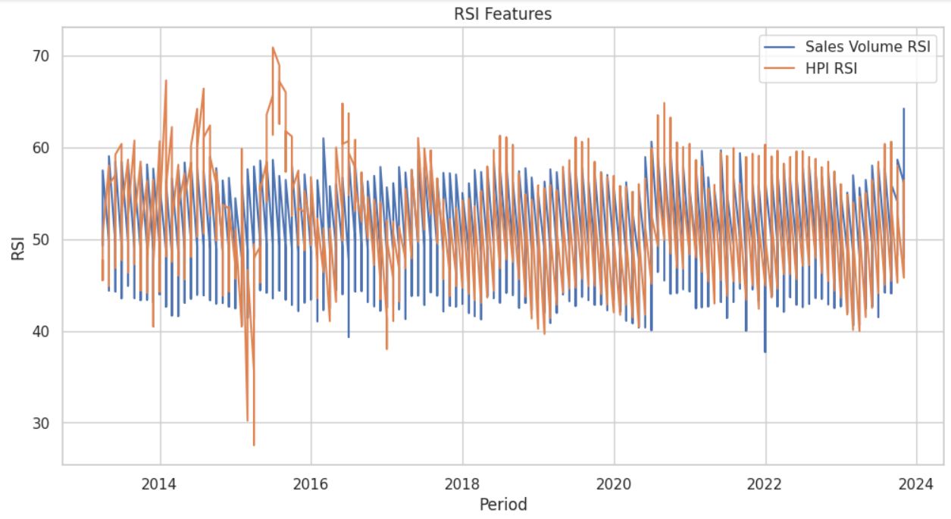

*Figure 53 Graphical Representation of RSI*

**7. Trend Features:** The implementation of trend features in understanding the market movement helps the policymakers, developers and investors to understand the general characteristics of sales volume and house price index. The consistency in trends explains a healthy and growing real estate market. It also gives beneficial investment opportunities and market potential for capital growth. According to the researcher, it is important for the stakeholders to understand the peak and lean times in the market. Therefore trend features help in explaining the market direction by providing a clarified dimension of metrics. Understanding the market position is important for policymakers to integrate the characteristics of sales volume and house price index to ensure market stability and potential growth. The consistency helps in expanding the real estate market and it also sends a healthy signal to potential investors.

The graphical representation of trend features represents the house price index from 2013 to 2024. It has been noticed that both the Trends of sales volume and house price index have paid consistent and close to 1.0. This explains the consistency in market growth and dynamics. Between 2016 and 2018 the parameter of sales volume trend has occasionally decreased making the success short-lived and rebound. After this, the graphical representation shows the lean parts of the house price index while the other areas are studiedly moving on an upward track. The recurrent drops present in the picture of a connection between the differences in home affordability during these times.

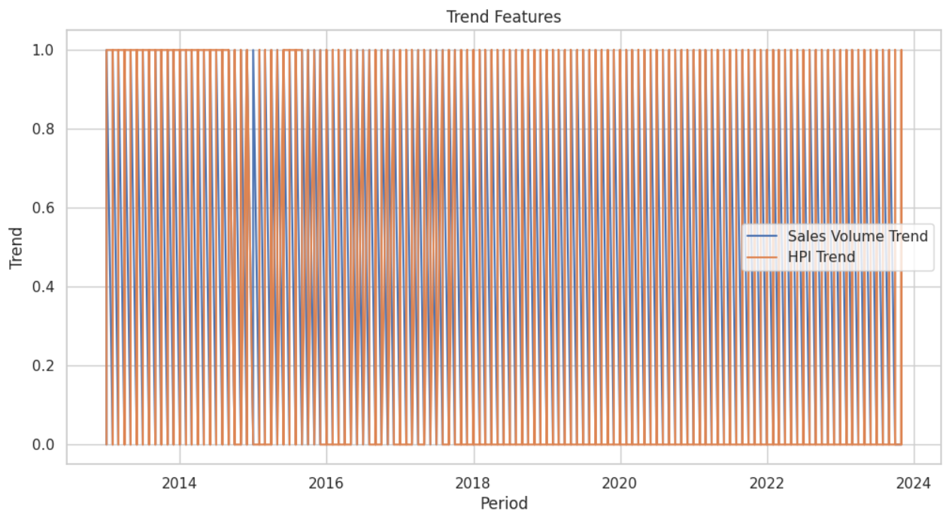

*Figure 54 Graphical Representation of Trend Features*

## 5.3 Model Evaluation

During the time of using Mean Absolute Error (MAE), R-squared (R²),  Root Mean Squared Error (RMSE) and Mean Squared Error (MSE), the utilization of model evaluation becomes of paramount importance for the selection of the most optimum technique for any particular dataset. A detailed understanding of the certainty of the performance levels can be obtained with the use of these specific metrics. The mathematical implication which displaces two with the help of mean absolute error also explains the size of mistakes without maintaining the direction of the mistakes. It has also been noted that the bigger mistakes are penalized by mean square error and root mean squared error. Root mean square error also held the research cell by providing real data and simple analysis techniques. This method of mathematical implication is important because it decentralizes the parameters and explains the overselling and underselling algorithm. The biggest advantage that these types of mathematical operations provide to the researchers is accurate answers to make certified hypotheses.

### 5.3.1 Gradient Boosting Classifier

The biggest advantage that gradient routing classification provides to machine learning is accuracy and good performance. It also helps in merging the data according to the research variables to create a good prediction method. By managing complicated relationships that more simplistic models can overlook and offering meaningful information about feature relevance, this method aids in feature selection and interpretation. Although boosting is prone to overfitting, this risk can be reduced by including regularization methods like contraction and tree pruning, as well as by adapting the methodology to other loss functions and data sources. An effective method that performs particularly well with small to medium-sized datasets is gradient boosting. In practical scenarios, it can yield dependable and accurate categorization results.

**MAE:** The results of mean absolute error depict the analysis and the differences in the significance of market value. Calderdale has the lowest MAE (47.47) of all the regions examined, signifying the most precise projections. Based on the effective graphical representation it can be stated that Bradford is not as accurate as Calderdale in forecasting the results of mean absolute error of 90.06. The city of Leeds has a higher mean absolute error of 163.69. In other words, the cities of Bradford and Calderdale also have listed correct representations while West Yorkshire has the main accuracy that is highest among all these regions.

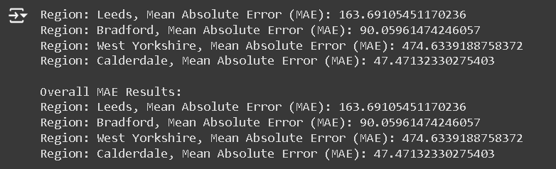

*Figure 55 MAE Values for Gradient Boosting Classifier*

**MSE:** Certain variations are usually formed within the performance of the particular model which is particularly denoted by regional Mean Squared Error or MSE. The lowest MSE is often found in Calderdale, as well as the most accurate forecast, estimated at a margin of 2,936.41. A higher extent of MSE accounting for several 12,954.96 for Bradford can be said to be more precise than the estimate of Caldereale. In terms of MSE, both Bradford and Calderdale posed an estimate of a lower MSE margin (e.g., 64,304.85), as compared to Leeds. On the other hand, West Yorkshire has the highest MSE of all, figured at 343,815.11. Based on the results of these MSEs, it can be entailed that the accuracy of the model is comprehensively dependable on the nature of the region along with its contemporary parameters.

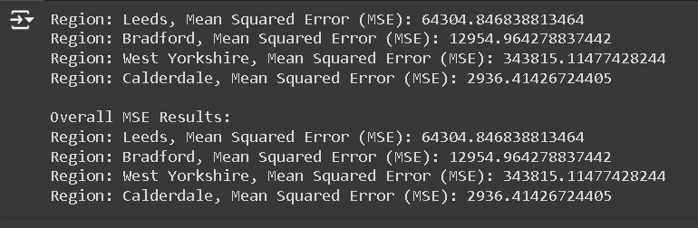

*Figure 56 MSE Values for Gradient Boosting Classifier*

**RMSE:** The route mean square error indicates the results of regional differences in the modern. Calderdale has the lowest magnitude but the highest accuracy with a root mean square error of 54.99. On the other hand, Bradford comes second with a root mean squared error of 13.82. Based on the regional discrepancies West Yorkshire has the highest error in forecast with 586.34. These results depict the predictive accuracy against the significance of location.

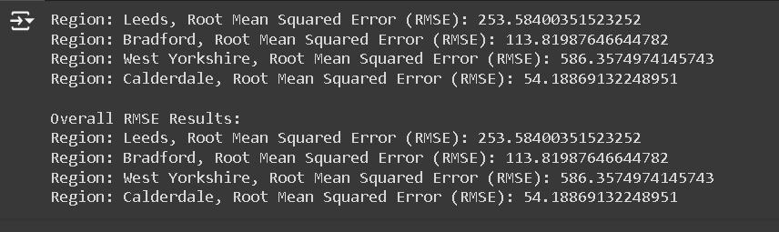

*Figure 57 RMSE Values for Gradient Boosting Classifier*

**R2 Score:** The performance of the model has several differences across the board based on the results of R2. Calderdale has the best art to score with -0.02 which indicates the accuracy of the model despite the relative negativity. The second rank of R2 score with -0.57 comes from Bradford which indicates mediocrity in the performance of the model. The model explains that the score of Leeds is significantly lower than the other two cities. It has also been noticed that the score of West Yorkshire suggests poor performance but it is not as good as Leeds.

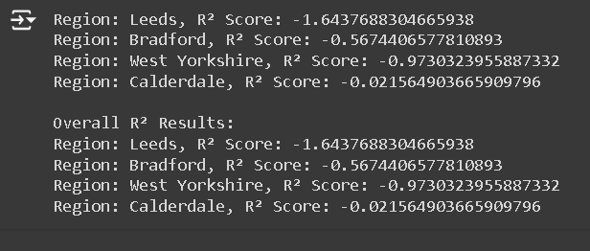

*Figure 58 R2 Values for Gradient Boosting Classifier*

### 5.3.2 Linear Regression

Linear regression is one of the most important techniques in statistics and machine learning considering its simple usage techniques and easy-to-grasp methodology. The benefits of the independence factors on dependent variables impact the forecasting and interrelationship highly. Considering the simple technique of usage linear regression gives accurate predictive analysis when the interrelationship helps the baseline model in the evaluation of the algorithm. Linear decoration also helps in the decision-making of various fields like healthcare economic engineering as well as the significance of predictors in hypothesising interrelationships between research variables. The advantage that linear regression provides to applications and large data sets is also helpful in maintaining efficiency. Also, linear regression is the base for complex techniques like polynomial regression and regularisation processes.

**MAE:** Mean Absolute Error during the linear regression analysis usually exhibit noticeable geographical differences. The lowest MAE is noticed in Calderdale, estimated at 46.88 which has the least number of average forecast errors along with the most accurate outcome. In this aspect, Bradford falls at the second rank as its MAE is 78.64. It denotes that Bradford has an optimal level of performance. However, it is less accurate from Calderdale. Leeds has a higher extent of MAE (124.28) compared to Bradford and Calderdale. Within this particular domain, West Yorkshire has an MAE score of 345.97. The results from the linear regression analysis, demonstrate a profound influence of regional traits on the accuracy of the model.

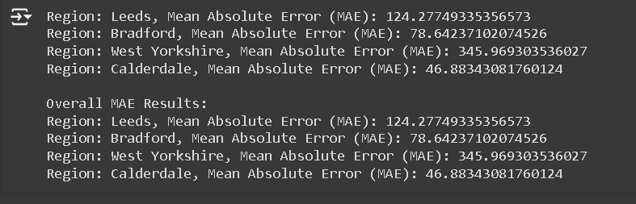

*Figure 59 MAE Values for Linear Regression*

**MSE:** The Mean Squared Error (MSE) facilitates a model’s capability to provide relatable regional variability. The most appropriate Mean Squared Error has been provided with Calderdale with the lowest value of 2,894.65. The second prominence of Bradford can be reflected in a comparison of Calderdale with the greatest MSE is supposed to be 8,917.94, although with greater error, with an MSE of 8,917.94. In comparison to both Calderdale and Bradford, Leed owns the highest MSE figured at 22,202.47. The minimal accurate regional projections and the highest average squared error were possessed by West Yorkshire, with an MSE of 175,890.56. The outcomes are suggestive towards highlighting the responsive regional variations with the accuracy of the linear progression mode, indicating West Yorkshire to possess the least and Calderdale to own the highest performance metrics.

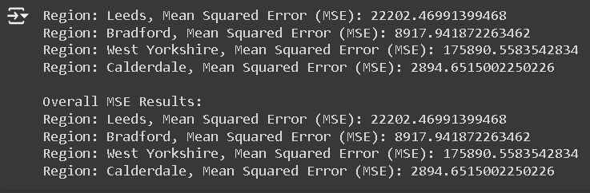

*Figure 60 MSE Values for Linear Regression*

**RMSE:** The significance of the variability owned by the performance metrics model is reflective of showcasing the Root Mean Squared Error (RMSE) as a part of the linear regression analysis. The greatest accuracy and minimum mean error magnitude is possessed by Calderdale which is designated as 53.80. The second position is acquired by Bradford with an RMSE of 94.43, significantly highlighting a comparatively better performance but with less accuracy than Calderdale. Leeds surpassed both Bradford and Calderdale with an RMSE of 149.00, presenting a pre4cise forecasting feasibility. The least accuracy and minimal forecasting ability is possessed by West Yorkshire, with an RMSE of 419.39, with the results depicting a domitable regional difference with the accuracy metrics of the linear regression model. It further highlights that best performance and least performance capability bis possessed by Calderdale and West Yorkshire respectively.

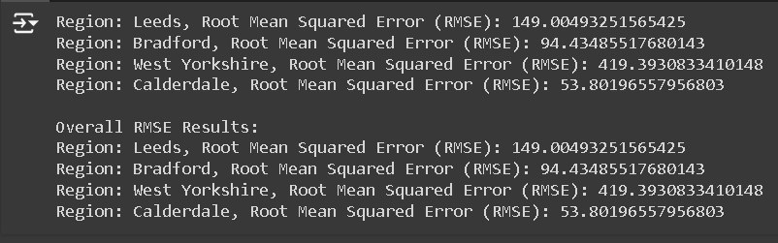

*Figure 60 RMSE Values for Linear Regression*

**R2:** The R2 value derived from the linear regression analysis shows how well the model describes the variance in the data across various locations. Leeds performs better than other places despite the fact that the model only partially describes the variance in the data, with the highest R2 value of 0.09. Bradford's R2 value of -0.08 indicates a poor fit, meaning the model does not outperform a simple mean-based prediction. West Yorkshire shows a similar level of poor model performance and low explanation power, with an R2 score of -0.01. Calderdale is the model that does the worst job of describing the variance in the data, with the lowest R2 score of -0.01. Overall, these findings imply that the linear regression model has difficulty fitting the data in all regions; Leeds performs the least poorly overall but still suggests that the model's predictive power is constrained.

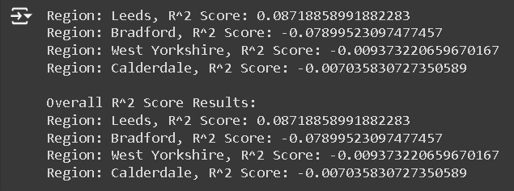

*Figure 61 R2 Values for Linear Regression*

### 5.3.3 Support Vector Machine(SVM)

Strong and versatile machine learning techniques, Support Vector Machines (SVM) can be used for regression and classification applications. Their expertise in handling high-dimensional data—where the number of characteristics significantly exceeds the number of observations—makes them particularly useful in fields like biology and text classification. SVMs are resistant to overfitting because of their regularization parameter, helping to balance the complexity of the model and performance. The impact of hyperplane maximisation is the margin between the classes which results in the efficiency of the model's ability to generalise. In addition to this, the functions of radial basis function or polynomial kernel enable the management method of non-linear relationship which converts the feature to facilitate linear separation. Support vector machines are helpful for arranging from small searches to complex parts. There are different types of kernels or adjustable classes that are used to maintain the balance in imbalanced data. The efficiency of support vector machines helps in adaptability and makes support vector machines a vital tool in the resilience of machine learning

**MAE:** The main absolute error explains the finding of support vector machines from the model performance based on the regional differences. The lowest MAE which is also the best in the least average error analysis. Calderdale has the lowest MAE considering its numeric value of 46.49. The score of Leeds is higher in MAE of 125.58. This is higher than Bradford and Calderdale. These results depict a less accurate version of the counteraction. Thus, SVM's accuracy picturised the score paradigm between Calderdale and West Yorkshire

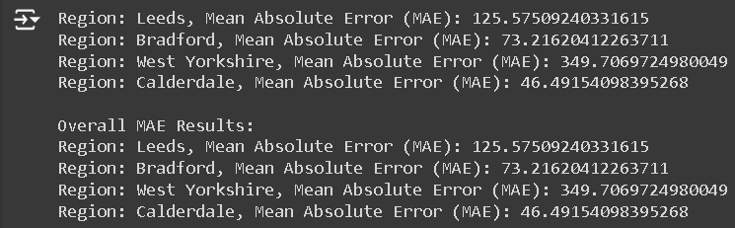

*Figure 62 MAE Values for SVM*

**MSE:** Mean Squared Error or MSE can be expressed through the performance variation which is clearly distinguished across multiple locations in the dataset. 2,809.41 is the estimated MSE of Calderdale. A better performance is noticed in Bradford while having an MSE of the margin of 8,024.83. The projections of Leeds can be termed as less precise compared to others, which makes the MSE value 24,033.75. The highest average of MSE is exhibited for West Yorkshire, which is 177,635.79. Through these results, it is evident that the SVM model performs with variance across different regions.

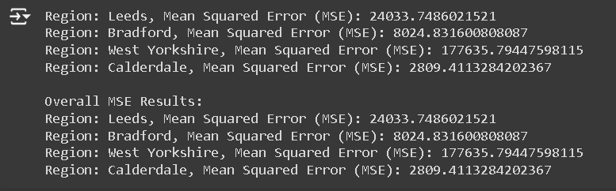

*Figure 63 MSE Values for SVM*

**RMSE:** In the model performance, the root mean squared error but reflector larger average error than of the SVM show a significant variance of regional change. With an RMSE of 53.00, Calderdale is showing the highest percentage if being accurate forecasts and the lowest error magnitude. Bandfont has taken the second place with the RMS of 89.58 showing a good performance but reflecting a larger average error than Calderdale. Additionally, Leeds shows are higher RMSE of 155.03 than the others indicating the projection accuracy is less. Furthermore, it can be stated that W Yorkshire shows the highest average accuracy in the forecasting of all other regions with an RMSE of 421.47. As a result, it can be stated that the notable difference is shown in regional prediction accuracy in the case of West Yorkshire with the help of SVM model performance.

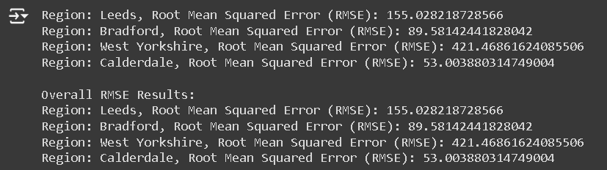

*Figure 64 RMSE Values for SVM*

**R2:** The R-squared (R²) values of the SVM study demonstrate how well the model explains the differences in the data among geographic regions. Bradford has the greatest R2 score (0.03), indicating that the model explains a small but positive portion of the variation in the data. Calderdale ranks second with an R2 score of 0.02, suggesting a slightly restricted ability to clarify variance. Leeds has a R² score of 0.01, suggesting extremely low explanatory power, while West Yorkshire has a negative R² score of -0.02, indicating that the model performs worse than a simple mean-based prediction. In summary, the findings indicate that the SVM model is not very good at describing the variance in the data; Bradford performed the best out of all the regions, but it was still not very good at providing an explanation.

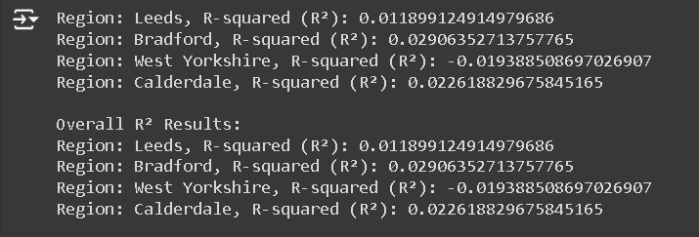

*Figure 65 R2Values for SVM*

### 5.3.4. Random Forest Regression

A powerful and flexible merging learning technique which is used for predicting modelling is known as Random Forest Regression. It is particularly used to deal with the complex and non-linear relationships between target variables and data. There are two ways such as reducing overfitting and increasing generalisation into new data for combining the output of multiple decision trees to enhance the performance of prediction. As a result, the combined technique not only helps to reduce the fitting noise but also provides information which is useful regarding the importance of features, selection and guiding features engine. Random forest regression is suitable for a real-world data set which is more resistant to the missing value and outliner as well as often contains irregularities or incomplete information. The ability to handle the data set which are large number with a variety of variables. It is completely easy to set up and adjust the contribution to the efficiency. Therefore considering all the things which is being discussed it can be stated that Random Forest Regression provides excellence and accurate performance which leads to the use of tools for a variety of tasks for prediction in disciples.

**MAE:** Mean Absolute Error which is a result of Random Forest Regression analysis shows the difference based on the location. The least mean absolute error of Calderdale indicates the forecasting which is highly accurate and shows 48.73 data. In the case of Bradford, an average error of 88.65 is shown outperforming Calderdale having an average error. However, an MAE of 149.36 is shown in the case of Leeds higher than Bradford and Calderdale. With an MAE of 464.31, West Yorkshire has the largest mean Errors and the precise is being forecast for all the regions. The result shows the significant variations in the regions in the accuracy of prediction with the model of Random Forest exhibiting the performance which is optimal in Calderdale and difficult in the case of West Yorkshire.

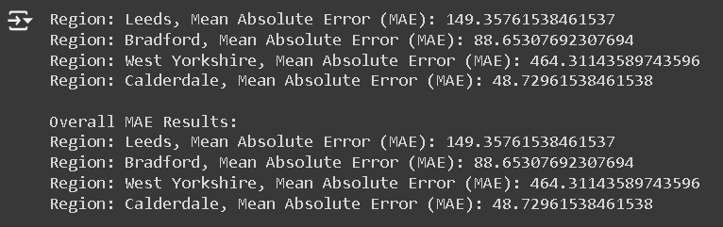

*Figure 66 MAE Values for Random Forest*

**MSE:** The result of Random Forest Regression which is the Mean Squared Error study shows the geographical differences that are distinct in the performance. The lowest average squared error which is MSE shows 3111.33 in the case of Calderdale is being reflected and indicating the most accurate projection. However, Brandford performed better than Calderdale which average shows a higher 12982.96. MSE of 47623.50 hs being seen in the case of Leeds than Calderdale and Bradford suggesting predictions which are corrected. The least precise being forecasted in the case of West Yorkshire which has the highest mean squared eros is 357982.28 compared to another region which is being tested. Therefore, the analysis suggests that the regional variation has a significant anticipation in the case of Random Forest Model accuracy. This is due to West Yorkshire posing problems being significant and Calderdale performing well.

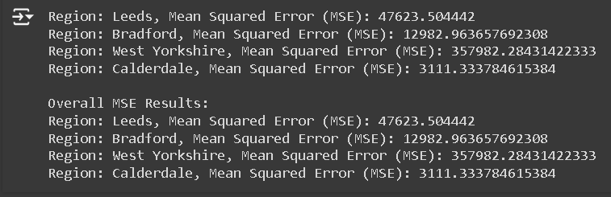

*Figure 67 MSE Values for Random Forest*

**RMSE:** Root Mean Squared Error which is also known as RMSE in the Random Forest Regression model shows a notable difference in the regional-based performance. Calderdale has shown the highest forecasts which are accurate and have the least error magnitude, hence the RMSE is 58.21. Bradford achieved the second palace with an RMSE of 110.24 showing excellent performance but average error which is higher than Calderdale. In the context of Leeds, RMSE has been estimated at 225.60 which is higher than  Bradford and Calderdale. This reflects the less projection being accurate. All of the above, West Yorkshire has been forecast with the RMSE of 593.38 which is not very accurate and precise having the highest average error. These results highlight the significant regional variation in prediction accuracy and demonstrate that, although the Random Forest model performs best in Calderdale, it has significant difficulties in West Yorkshire.

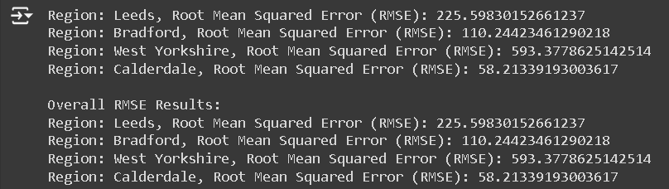

*Figure 68 RMSE Values for Random Forest*

**R2:** The R-squared (R²) values of the Random Forest Regression study demonstrate how effectively the model functions to clarify the variance in data across different geographic regions. Calderdale is the least badly suited region, but it's still not ideal, with the highest R2 score of -0.04 of any region. Bradford comes in second, with an R2 of -0.49, suggesting that the model performs under average, greater than Calderdale but below average overall. R2 values of -0.89 for Leeds and West Yorkshire both indicate very low model performance with large projected mistakes.

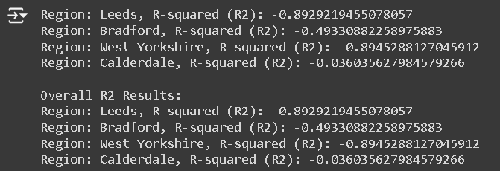

*Figure 69 R2 Values for Random Forest*

**Finally,** **When comparing several regression algorithms applied to different locations, the Support Vector Machine (SVM) emerges as the most successful model for predicting sales volume based on performance indicators. Metric analysis reveals that SVM consistently outperforms alternative models, including Gradient Boosting, Random Forest, and Linear Regression And model is under fitted because record are limited(525records), for perfect prediction its need few thousands of data record.**

SVM is competitive and shows comparatively low average prediction errors for Leeds, with Mean Absolute Error (MAE) of 125.58 and Mean Squared Error (MSE) of 24,033.75, somewhat poorer than the Linear Regression model. With the lowest MAE of 73.22 and MSE of 8,024.83 in Bradford, SVM demonstrates its excellent accuracy and error minimization in this area. This pattern is maintained in Calderdale, where SVM is the most accurate model among those examined, with an MAE of 46.49 and an MSE of 2,809.41. SVM, on the other hand, does not fare as well in West Yorkshire; its MAE of 349.71 and MSE of 177,635.79 are still lower than those of Random Forest and Gradient Boosting.

SVM performs competitively when looking at Root Mean Squared mistake (RMSE), which indicates the extent of the mistake in the model. SVM’s RMSE for Leeds is 155.03, but Random Forest’s RMSE is higher at 214.50. SVM had a lower RMSE in Bradford than the other models, at 89.58. With the lowest average prediction error of all the models, SVM has the best RMSE of 53.00 in Calderdale.

While all models have negative R-squared (R²) values, meaning that none of the models fits the data well, SVM performs somewhat better, with the greatest R² values among the models in Bradford and Calderdale. This implies that, in comparison to the other methods, SVM is more adept at capturing the variance in the data.

In summary, although no model fits the data perfectly, SVM stands out for its superior performance in minimizing prediction errors and achieving better overall metrics in most regions. This makes it the most reliable choice for accurate and consistent sales volume predictions across the regions tested.

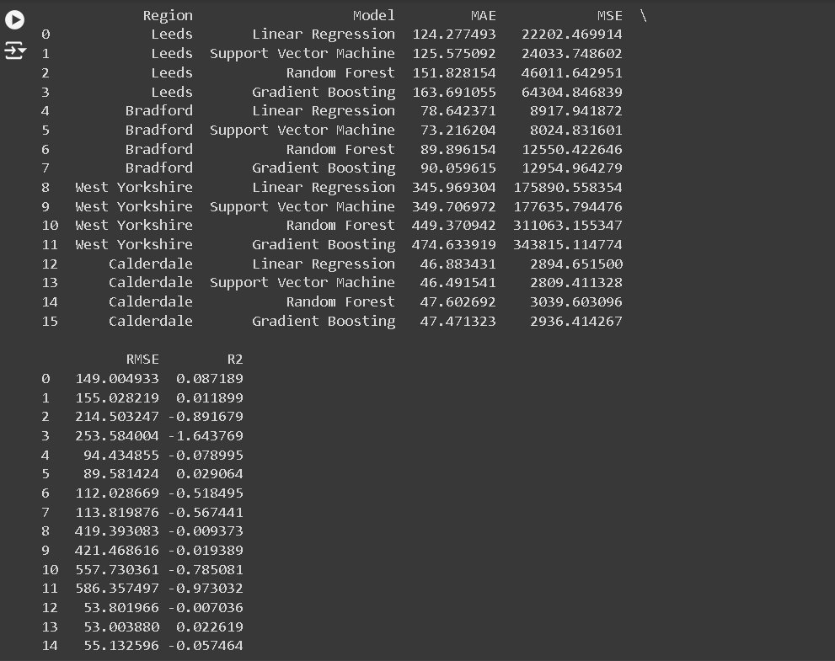

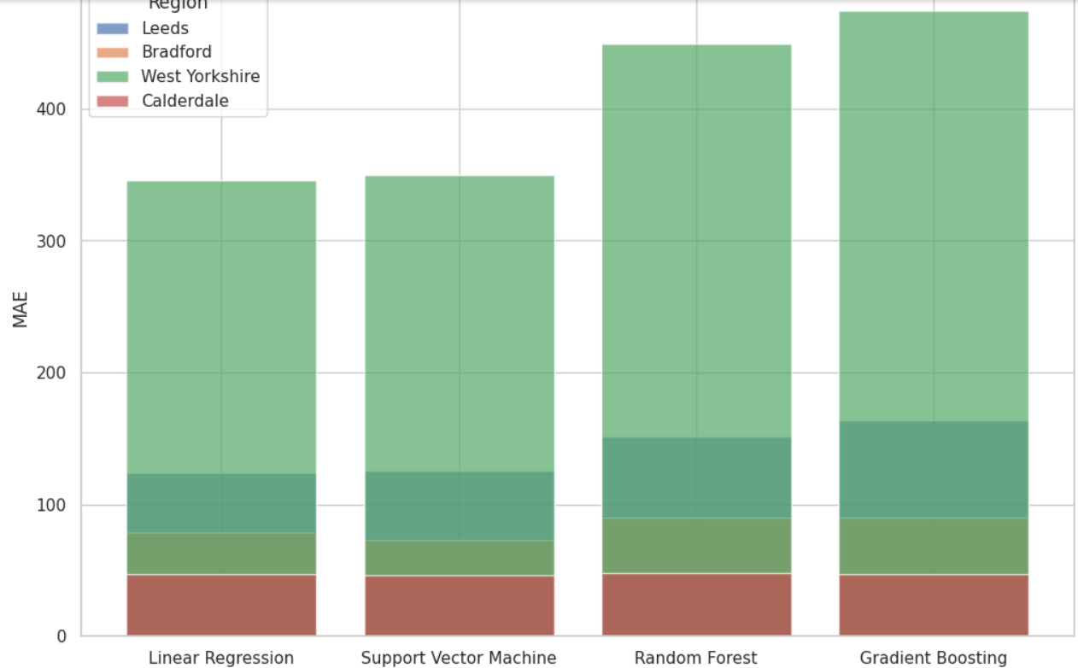

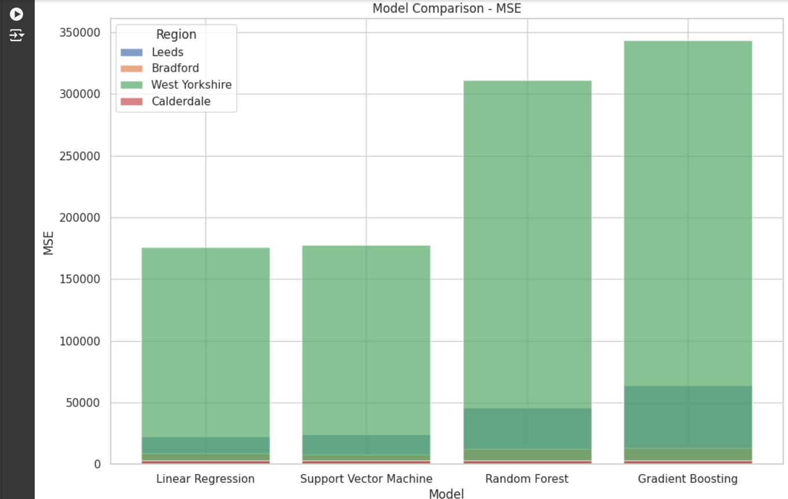

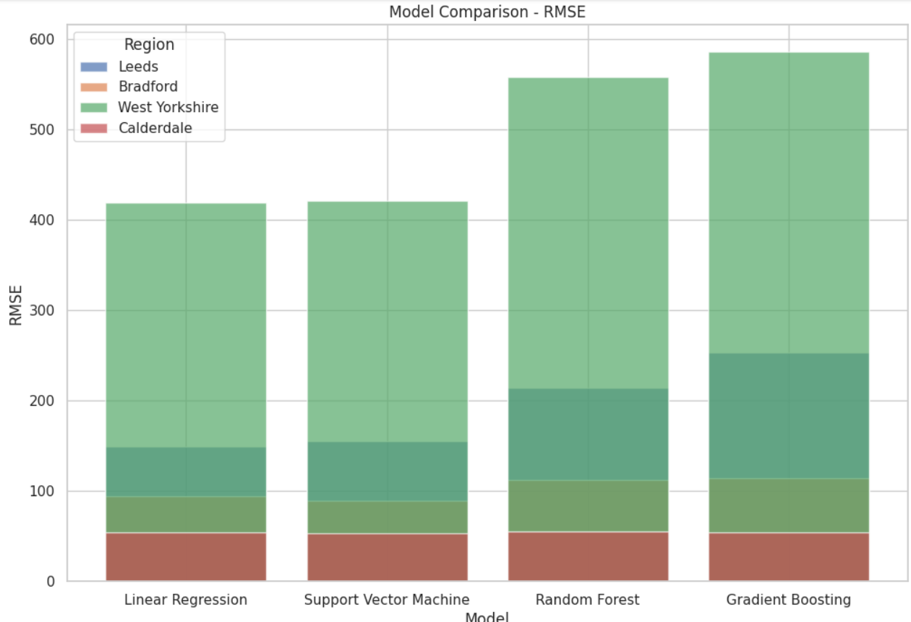

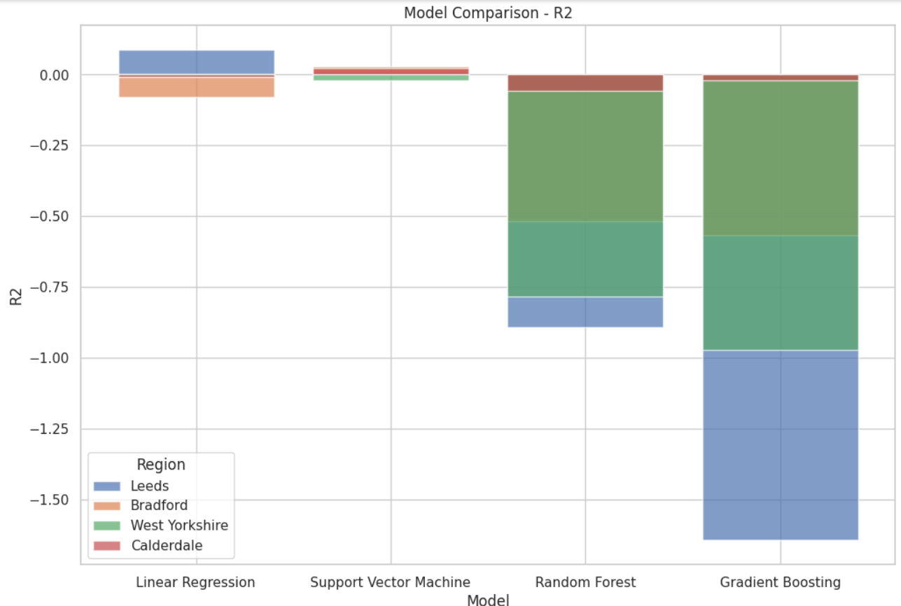

*Figure 70 Model Evaluation*

### 5.4 Predictions

#### 5.4.1 Predicting Future House Prices

Afterwards, the model was employed effectively to predict future events which were the purpose of creating the model in the first place. The projections were made for the years subsequent to the current year up to the year when the forecast was made, as well as for the year 2024. The years for prediction were created as numpy array with values between 2024 and 2029 and then a two dimensional array named prediction_years. With the help of the trained model, the house price index for these future years was predicted using the predict() method. These predicted values were then organized into a new DataFrame, prediction_df, which contained two columns: The two columns on the right side are ‘Year’ and ‘Predicted House Price Index’.

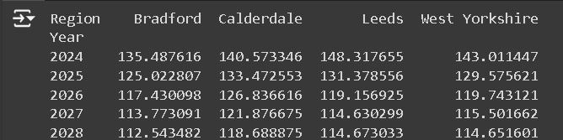

*Figure 71 Model Prediction*

From 2024 to 2028, the given data tracks a particular statistic for Bradford, Calderdale, Leeds, and the entire West Yorkshire region. It shows a distinct and steady downward tendency for all of these places.

Bradford's values begin at 135.49 in 2024 and follow a consistent downward trend every year, peaking at 112.54 by 2028. This indicates a five-year drop that was steady yet gradual. In Calderdale, values begin at 140.57 in 2024 and decrease to 118.69 in 2028; similar patterns may be observed. This steady decrease suggests that the area is seeing an annual falling trend.

Leeds, which begins the region with the highest value—148.32 in 2024—also undergoes a sharp decline, falling to 114.67 by 2028. Leeds has experienced the most price reduction all over the years, as shown by the significant drop in the region. These patterns are also seen in the West Yorkshire region as a whole, which fell from 143.01 in 2024 to 114.65 by 2028. This implies that the whole region is experiencing the same downward trend.

The consistency and severity of the decrease in every region point to a widespread issue or combination of variables having a detrimental effect on these areas. Leeds experiences the most decline in values over the time, even though it began from a higher basis. This steady downturn in Bradford, Calderdale, Leeds, and West Yorkshire as a whole suggests a potentially alarming pattern that needs more research.

It is essential to comprehend the fundamental causes of this deterioration. Possible research topics include regional characteristics that may be contributing to the declining trend, policy consequences, demographic shifts, and economic situations. It will be crucial to create plans to deal with these problems if we want to reverse the current downward trend and encourage stability and development in these areas.

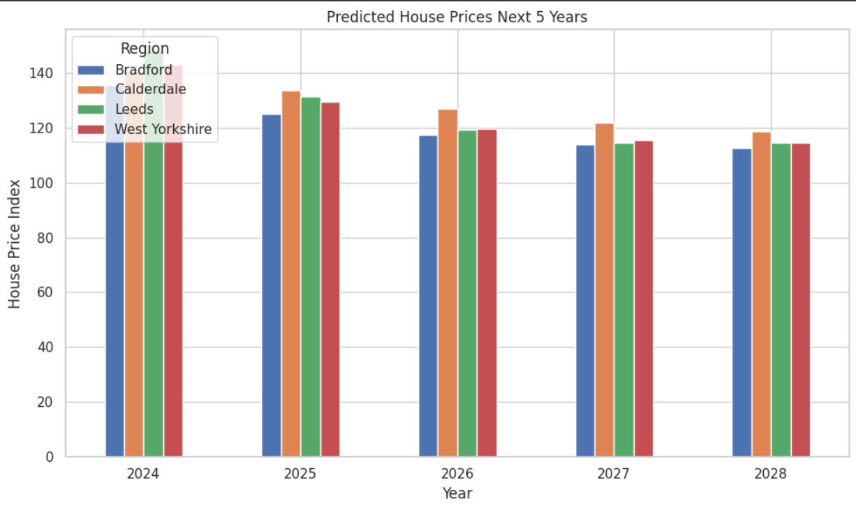

*Figure 72 Graphical representation of Prediction*

From these predictions it can be inferred that there is a gradual upward trend of the house price index in the next five years.

#### 5.4.2 Deep Learning

**Long Short-Term Memory (LSTM):** The ability of Long Short-Term Memory (LSTM) networks, a particular kind of Recurrent Neural Network (RNN), to handle and learn from sequential input makes them incredibly well-suited for housing price prediction. LSTMs are a great option because house prices are fundamentally tied to time and are impacted by past trends as well as cyclical market fluctuations. LSTMs use a special design with memory cells and gating mechanisms to preserve and take advantage of long-term dependencies, in contrast to regular RNNs, which frequently suffer with the vanishing gradient problem. They are able to retain information for longer because to this, which is essential for identifying long-term patterns in home pricing. LSTMs can detect seasonal and cyclical patterns, which improves their forecast accuracy. They are also skilled at modeling complex, non-linear interactions.

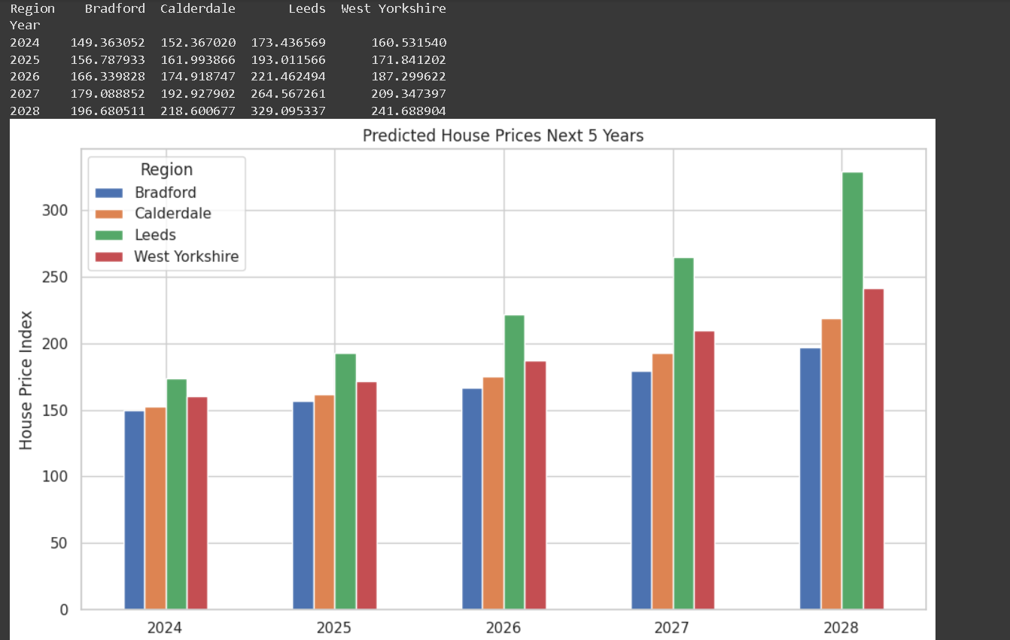

*Figure 73 LSTM Prediction*

Using an LSTM (Long Short-Term Memory) model, the code projects housing price indices over the following five years (2024–2028) across four different regions: Bradford, Calderdale, Leeds, and West Yorkshire. This model uses past home price data to forecast future trends, making it ideal for sequential data such as time series.  
  
The projection indicates a significant rise in housing costs in every area. The projected house price index for Bradford is expected to begin at 149.36 in 2024 and increase gradually to 196.68 by 2028. This illustrates the steadily rising but slow trend in real estate prices. Similar upward trends are shown in Calderdale, where the index started at 152.37 in 2024 and reached 218.60 in 2028, demonstrating a strong rise in home values over the course of the five-year period.

Out of all the regions, Leeds has the highest projected housing prices. The index rises from 173.44 in 2024 to 329.10 by 2028. This considerable expansion indicates that Leeds property values have increased significantly, pointing to a strong market or high demand in the area.  
  
From the year 2024, it was seen that the house price index rose to 160.53 and was expected to further rise to 241.69 in the year 2028. Hence, it can be stated that a notable growth is being reflected in West Yorkshire. Furthermore, it is estimated that the housing price for the climb will be established in the robust market of West Yorkshire.

A clear view is provided in the projection which is being stored in this CSV file and presented in a bar graph form reflecting the changes which are expected to take place in the housing price. For real estate professionals, investors, and legislators, these projections are essential because they provide insightful information about future market circumstances and support the formulation of strategic plans for real estate development and investment. The implementation of LSTM models intends to increase the prediction precision by identifying the patterns which are complex within the historical data. This tool utilisation is crucial as it helps to understand the market which is dynamic regarding the housing projecting.

**Gated Recurrent Units (GRUs):** The house price prediction can be done with the application of Gated Recurrent Units which is a type of Recurrent Neural Network that helps to excel the job requirement within the sequential input. This GUS is designed in such a way as to record the correlations which are temporal and find the pattern in time series data to forecast the trends in the prices of the property. The issues of disappearing can be avoided with the help of the gradient which is a traditional RNN encounter allowing to preservation of the information which is important while preventing being in lengthy sequence features. As a result, this ability will be beneficial to simulate the seasonal cycles accurately and in the pattern of long-term within the real estate data.

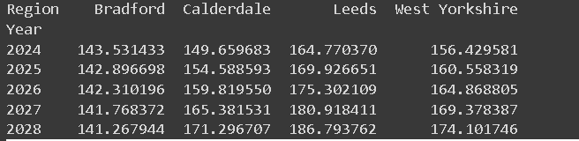

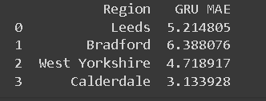

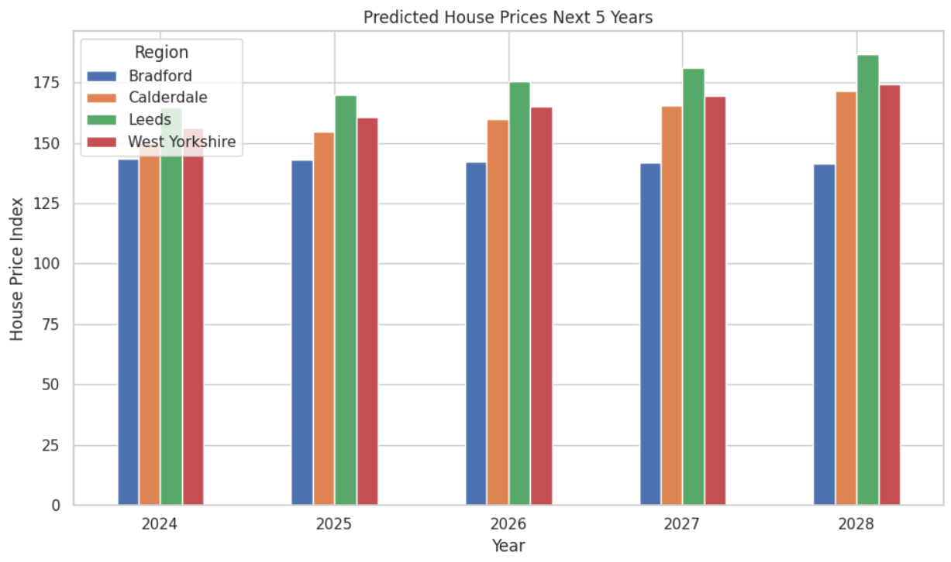

*Figure 74 GRU Prediction*

A detailed forecast is generated of the house price in indices for Leeds, Calderdale, Bradford and West Yorkshire for the next five years with the help of the Gated Recurrent Unit model. This helps to project the different patterns which are being observed within the four zones. A little decrease in the trend is being forecast in the house prices of Bradvors which is further going to decrease from the year 2024 which price is 143.53 to the year 2028 which pricing will be 141.27. Calderdale's home prices are expected to rise steadily from 149.66 in 2024 to 171.30 in 2028 due to a considerable increase in property values. Leeds exhibits a notable rising tendency; prices are expected to rise from 164.77 in 2024 to 186.79 by 2028, indicating a robust expansion of the market. Prices in West Yorkshire are likewise increasing steadily, going from 156.43 in 2024 to 174.10 in 2028.

The approach also calculates the Mean Absolute Error (MAE) for the GRU model's predictions. This measures the accuracy by quantifying the mean error between the predicted and actual numbers. These MAE statistics are saved in a CSV file for further research. The code also creates a bar graph so that you can have a visual comparison of the expected housing prices for each region over the course of the projected years. The previously mentioned visual assistance makes it easier to understand the data and sheds light on the relative trends and variations in house price estimates among different regions. Generally speaking, the GRU model's predictions and assessments offer relevant data regarding probable future housing industry trends, which can direct real estate investment strategies, policy decisions, and market research.

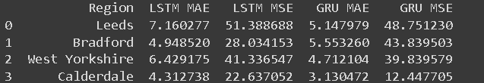

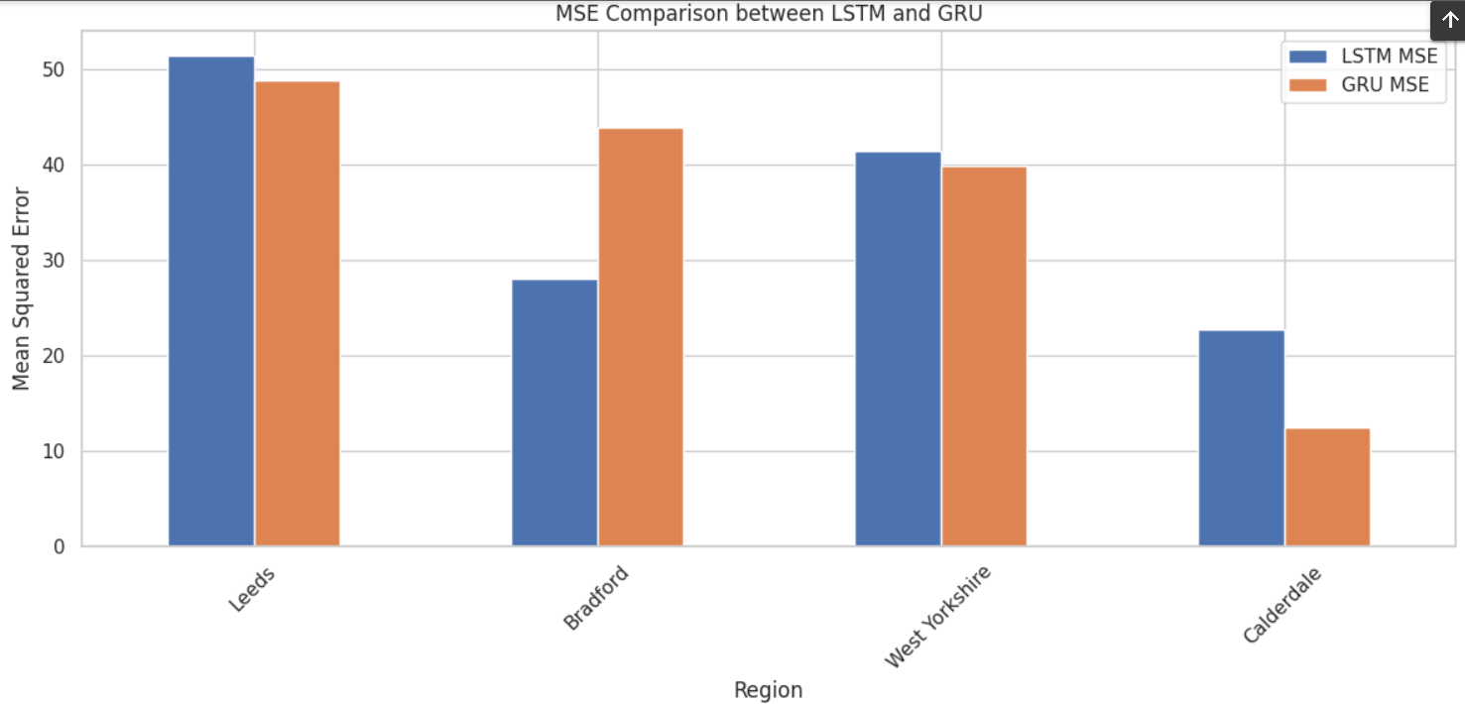 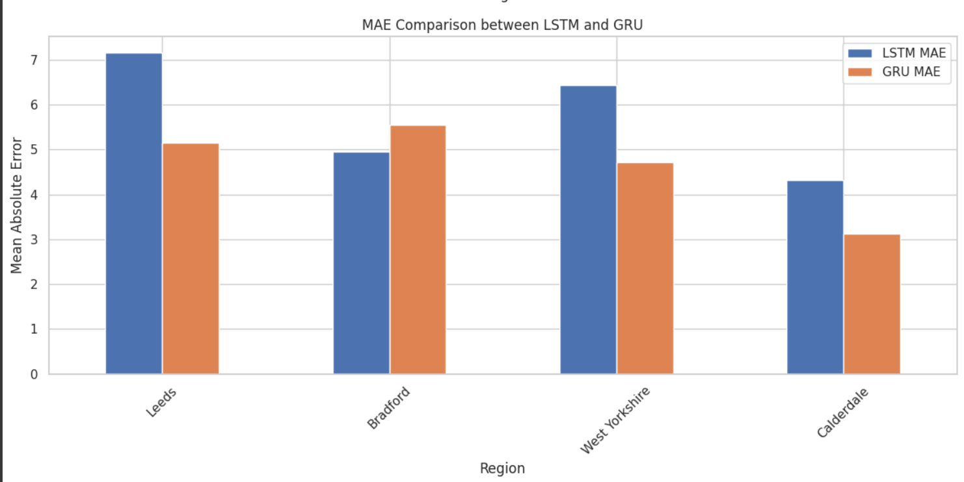

*Figure 75 Comparition between LSTM and GRU Predition*

In the four locations that are the subject of this study—Leeds, Bradford, West Yorkshire, and Calderdale—the Gated Recurrent Unit (GRU) model consistently outperforms the Long Short-Term Memory (LSTM) model in forecasting home price indexes. Specifically, the LSTM model records an MSE of 51.39 and an MAE of 7.16, whereas the GRU model for Leeds reveals a lower Mean Squared Error (MSE) of 48.75 and a lower Mean Absolute Error (MAE) of 5.15. This implies that the GRU model produces higher quality predictions and matches the test data more well. However, the implication of the LSTM model in the case of Brantford has slightly shown a superior MAE of 4.95 compared to the model GRU 5.55. Hence, it can be stated that the GRU model provides a better and more accurate MSE whose value is 43.84 compared to LSTM whose value is 28.03. As a result, it can be stated that the LSTM model needs to provide more accurate and precise terms whereas the GRU model can perform in terms of magnitude being error. In the case of West Yorkshire the GRU model shows a lower MAE of 4.75 and MSE of 39.84 whereas the LSTM model shows an MAE of 6.43 and MSE of 41.34. It can be stated that the GRU model has outperformed the LASTM model.

Hence, it is concluded that the predictions made by the GRU model are more accurate and reliable. In the case of Calderdale, the GRU does has outperformed the LSTM model by showing an MAE of 3.13 and MSE of 12.45 compared to the LSTM model which shows an MAE of 4.31 and MSE of 22.64. The prediction was improved and the error rates with the help of the GRU model which is being demonstrated here. In general, the GRU model is more successful at predicting house prices in this dataset as it consistently obtains lower MAE and MSE values across all regions. A clear visual picture of the GRU model's superior performance in house price prediction is provided by the comparative findings between the LSTM and GRU models, which are logged in a CSV file and displayed through bar charts.

### 5.5 Analysis and Visualization

Leeds has been found to have the highest forecasted house price index in 2024 (value of 148.32), based on the output that was provided. This suggests that, for that particular year, Leeds is expected to have the most expensive property market in all of West Yorkshire. But starting in 2025, Calderdale rises to the top of the home price index rankings every time; its values are 133.47 in 2025, 126.84 in 2026, 121.88 in 2027, and 118.69 in 2028. This pattern indicates a change in the dynamics of the housing market, with Calderdale overtaking Leeds and continuing to lead the house price index in the ensuing years. When compared to other West Yorkshire regions, Calderdale's consistently high home price index points to a possible rise in the area's appeal or demand for housing. Improved facilities, the state of the economy, or other characteristics of attractiveness may be making Calderdale a more desirable place to live in current days.

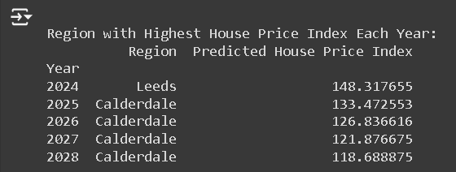

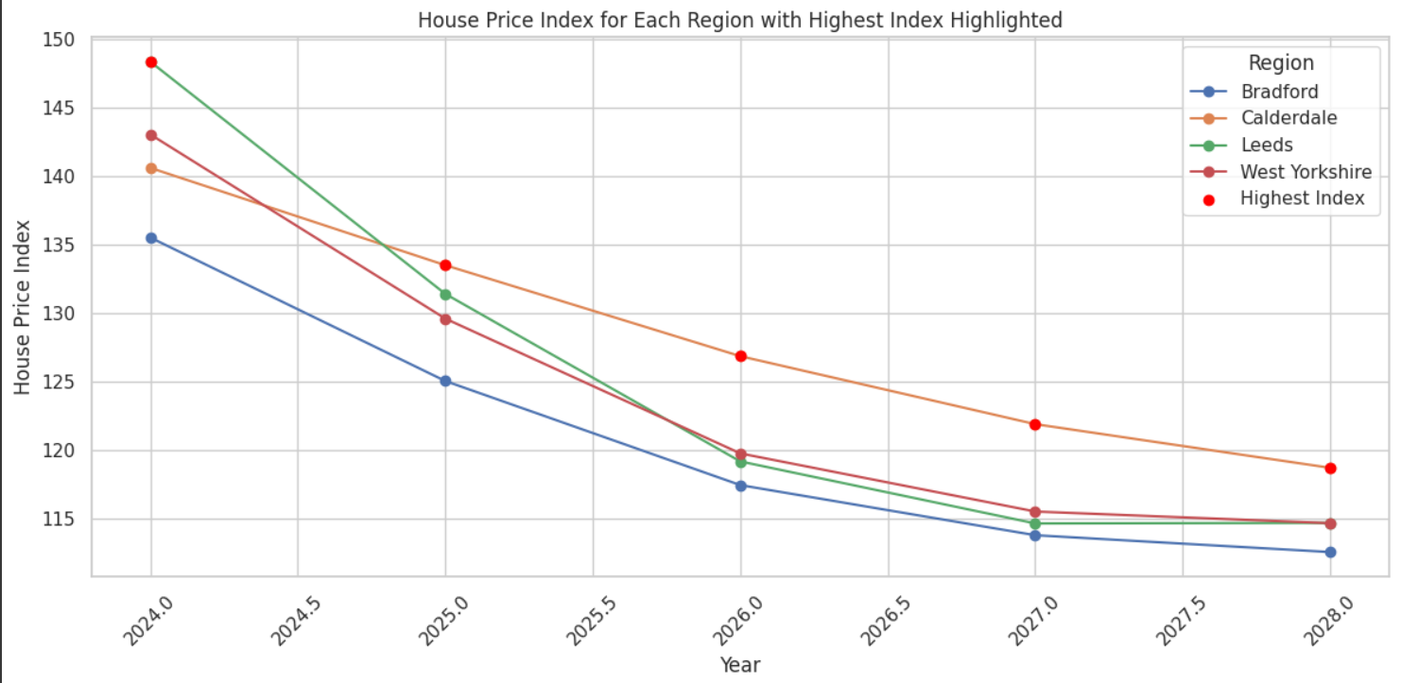

.

### 5.6 Implications for Real Estate Market Dynamics and Policy-Making

The results of this study therefore hold great importance to the investors in the real estate market, policy makers and prospective homeowners. The estimation of the house prices is quite significant as it aids in identifying the right investment opportunity and risks associates with the investment. To the policy makers the most important application of accurate forecasts of house prices is the formulation of housing policies as well as in formulation of regulating policies which are meant to help control the market, assist in the provision of affordable prices which also have to foster sustainable development.

The application of ML techniques for house price prediction can be viewed as a transition to more data-driven approaches in the real estate industry. Through volume of data and use of analytical tools, the stakeholders can improve on their understanding of the trends and factors that shape markets so that they can plan more effectively. Such an approach can result in optimal allocation of resources, increased efficiency in the allocation of resources in the markets, and consequently, improved economic stability.

It’s always useful information for potential homebuyers to have accurate price predictions to guide them when making the purchase. Information on future price movements can enable the buyers to make enlightened decisions such that they do not spend too much on the properties. It can also help in determining the ratios of expected appreciation on the property, and the stability of the market.

### 5.8 Conclusion

The findings of this research confirm the ability of employing the machine learning for the purpose of house price prediction. While the chosen SVM model offered a fair prognosis for future house prices, there is always a possibility for enhancement. The results show the need for the integration of more parameters and the use of sophisticated models for more accurate and effective estimations. It would be valuable for investors, policymakers, and other stakeholders in the real estate market to use the insights derived from this analysis to facilitate better decision making.

Possibilities for further research include overcoming the shortcomings stated herein and adding more features and/or employing more sophisticated techniques to create even better models for future housing market prediction. This will improve the reliability of the predictions and would be a plus to all the stakeholders involved in the real estate business to make it more efficient, stable, and sustainable.

# Chapter 06: Project Management

## 6.1 Introduction

This chapter presents the project management techniques together with the frameworks that guided the building of the house price prediction model using machine learning. Running such a task always involves a modeling of different aspects like time schedules, resources, stakeholders' expectation and risk factors.

|  |  |  |  |  |  |  |  |  |  |  |
| --- | --- | --- | --- | --- | --- | --- | --- | --- | --- | --- |
| **Task** | Month 1 | Month 2 | Month 3 | Month 4 | Month 5 | Month 6 | Month 7 | Month 8 reassesmant | Month 9 reassesmant | Month 10 reassesmant |
| **Introduction** |  |  |  |  |  |  |  |  |  |  |
| **Literature Review** |  |  |  |  |  |  |  |  |  |  |
| **Methodology** |  |  |  |  |  |  |  |  |  |  |
| **Data Collection** |  |  |  |  |  |  |  |  |  |  |
| **Data Analysis** |  |  |  |  |  |  |  |  |  |  |
| **Interpreting & Discussion** |  |  |  |  |  |  |  |  |  |  |
| **Recommendation & Conclusion** |  |  |  |  |  |  |  |  |  |  |

## 6.2 Project Planning and Scope

The project scope was set to consist of both the creation and the verification of a machine learning model which is able to provide precise predictions regarding the UK house prices. Project planning was carried out by defining the reasonable goals, deliverables and deadlines which were delivered to all the stakeholders to ensure proper alignment and commitment.

## 6.3 Resource Allocation

In order to complete the project successfully, resource management was extremely important. Such leading to being in charge of personnel placement, budgeting, and the utilization of technology systems. Decisions about resources allocation were made in accordance with the plan phases and their importance, namely, to guarantee each stage of the model development is properly supported.

## 6.4 Risk Management

The proactive approach of identifying risks at various stages of the project was the common way of dealing with risks. These risks have been associated with issues such as the privacy of data as well as the uncertainties of the technology. Strategies had been adopted to avoid these risks which included the use of data security audits on a regular basis and the fallback technologies.

## 6.5 Stakeholder Engagement

Strategic communication with the stakeholders was the center of the communication plan that contained regular updates and feedback sessions. This step was critical to keep the stakeholders updated on the progress of the project and to incorporate their feedback into the development process.

## 6.6 Quality Control

The quality control systems were set in place to leave the machine learning model unaltered. The process incorporates the thorough testing stages, peer reviews, and iterative validation steps to make sure the model complies with the assumptions and accuracy level.

## 6.7 Project Monitoring and Evaluation

The continuous monitoring was implemented to evaluate the progress of the project according to the schedule. The project activities were measured by the following performance metrics and were used to gauge their effectiveness. Adjustments were made whenever necessary so that the project can stay on the right track and be on time with their goals.

## 6.8 Change Management

The project was managed with great flexibility to address any changes that might be needed. A change management formal process was available to manage any modifications in the project schedule, resources, or timelines. This way setup was done to make sure that all modifications were recorded, tested and implemented in the project progress.

## 6.9 Project Closure and Review

The process of closing the project, after the model was delivered, documentation was provided, and a post-implementation review was carried out. The lessons learned were recorded to be used in future projects, and the successes were celebrated with the team and stakeholders.

## 6.10 Conclusion

The disciplined approach followed to project management proved to be a crucial factor in the timely delivery of a successful machine learning model for predicting house prices. The solutions and plans adopted allowed the project to be carried out successfully with reactive adaptation to contingencies and potential gains. This chapter focuses on the value of project management with structure for building and managing complex data-driven projects and with a view to the other projects in the domain of machine learning and real estate analytics, provides the template.

# Chapter 07: Conclusion

## 7.1 Introduction

The dissertation revealed that various ML methods can be used for prediction of house prices in the UK real estate market with desirable outcomes. One of the profit techniques in the house price prediction area is the use of various models such as Support Vector Machines, Random Forest Algorithm, Gradient Boosting Algorithms, Linear Regression, and Neural Networks to enhance the prediction accuracy. It is unimaginable how far state-of-the-art methods have come from conceptual methods that used to provide just simple answers to the direct questions and ignored possible influence of multiple variables in the market.

Among the research findings was the possibility that ML would help gain ample information for a variety of stakeholders including investors, policymakers, and property agents. Thanks to historical data and predictive analytics, investors now can make more insightful decisions that may result in investment strategies that would target optimized outcomes which in turn result in increased market stability.

## 7.2 Critical Reflection

### 7.2.1 Model Performance

The analysis using the Support Vactor Machine(SVM) model was rather successful in approximating the house price index of the each region. From the statistical point of view, the suggested model provides a reasonable approximation of what was found in the data, with certain reservations. For example, the low value of R² indicates that there might be other factors not incorporated in the model that equally affects the prices of houses.

### 7.2.2 Alignment with Research Objectives

The model fulfils the research objectives of presenting a sound technique to estimate the house prices in the each region. The assessment of the accuracy of the model has been conducted with the help of MAE, MSE, RMSE, and R².

One weakness of the current model is that it only uses historical data and year as the predictor variable. Although, this approach offered a clear way of making predictions, it failed to include other factors like the economic climate, population growth, new policies as well as other development plans within a particular region. Some of these variables may affect the price of houses and should be included in next models to enhance their precision.

Besides, it also has the disadvantage of exhausting the SVM assumption that lays between the year and the house price index, which does not take into account the many non-linearity patterns may exist in the housing market. Further research may include the introduction of other contributing factors like economic factors (e. g., interest rate level, employment rate), demography (e. g., population growth rate, income level) and other factors. Furthermore, applying higher levels of the Machine Learning approach like Random Forest, Gradient Boosting, or Neural networks could enrich the value of the model by identifying much more intricate structures and triggers within the data inputs.

The above can also be further enhanced using other method like cross-validation to ensure that the model does not over-fit on the training data. Cross-validation is very important it can help in checking the reliability of the model by testing the model on smaller sets of data in order to get more accurate results.

Another limitation of this study is that it looks at the spatial dimension only and does not take into account the temporal aspect of the housing market process. Methods like ARIMA or LSTM networks are more suitable to capture temporal dependencies and trends in the data. These methods are very useful when it comes to converting point forecast by using past data as a basis and may offer more precise values should be used for time series data

## 7.3 Limitations

Although the study was mostly successful, it had some obvious drawbacks that limited the level of detail and suitability to a certain extent. The data issue is primarily connected with the absence and the amount of the data. The precision of the predictions diminishes drastically if data is poor quality and lacks complete representation of the problem under study, for which they don't have access to complete or reliable datasets because of our data privacy or global data protection regulations like GDPR. This problem is especially acute in districts with different standards and data capture digitization which are unstable. Also, since the housing market is highly dynamic and it is determined by factors such as the economy, society, and politics, the implementation of machines learning model, which is the rigid one has high volatility and hence, it is difficult to train it. This constraint implies the fact that it is challenging to develop models which can appropriately react to highly dynamic market states in a very short period of time without significant lags of model updates or retraining.

Through their findings they demonstrated the suitability of ML applications for a future predictability of UK housing costs. The team applied a mixture of machine learning algorithms such as Support Vector Machines, Random Forest, Gradient Boosting Algorithms, Linear Regression, among others to real estate prediction, and has made huge steps in the accuracy of house price predictions. In recent years, the machine learning's algorithms have demonstrated its superiority over traditional methods, as they can provide a lot of data and capture the hidden interactions between variables which are characteristic for the real estate market.

Another barrier is market nimbleness, a descriptive characteristic. Economic, social and political factors are always in the forefront of the market constantly introducing volatility which makes it difficult for ML, particularly those models that lack versatility, to adjust accordingly. Such a limitation shows how hard it is developing models that can successfully address vastly changing markets where lean and fast updates are needed without losing much time on model retraining or updates. In order to cope with this, words of this research should concentrate upon the formation of adaptive models which reacts to the incoming data automatically without too much human intervention. Like solutions involving online learning and continuous model training, it is imperative to consider these as ways to keep a reliable prediction during an unstable market environment. Besides, a few more considerations, too are suggested that may facilitate the field of ML in the real estate price predictions. Initial and foremost the improvements should be performed for better data collecting and availability. A key research measure for future consideration should focus on collaborations between government agencies, real estate industry players, and other stakeholders to streamline data availability, standardization and quality for research. That's where adopting such strategies as partnerships to gather data that is both real-time and complete as the market goes around will be needed. The market needs models that can be created around ML systems that will be able to adjust fast in case the condition of the market is changing. This involves the application of recommendations including self-learning tools through which the models will routinely update and revise in line with newly acquired data. Besides that, on the go model training along the way should be considered so that the models do not lose the update and relevance. For the last, interdisciplinary methods should be also considered for the greater readability and dependability of the models. By combining economic theories such as monetary policy and macroeconomic indices, it would be possible for machine learning models to understand the factors underlying house-prices more comprehensively. The combination of the disciplines can result in real invaluable results and give us, and the market, as well, a more holistic point of view.

Ethical and regulatory compliance is not under any circumstances taken lightly. The necessity to maintain privacy of data will always go together with the development of artificial intelligence. Therefore, it is essential to guarantee that ML models comply with the corresponding laws and rules. Extensive data regulation models should be set in place to make sure the privacy of individuals is maintained and still trust among the stakeholders is observed. Ethical criteria also deserve to be incorporated while forming of ML models to tackle possible bias or influence and maintain a fair and even distribution while predictions. General public openness and transparency should be an assigned to most desire to enhance marketing of ML applications in real estate. Developing platforms that are user friendly with the provision of data analytic tools that promptly address stakeholders’ needs and desires to know the technique of predictive model creation help in clarifying the Moiré knowledge to the common consumer. Clarification in how each prediction is made, and the elements impacting these predictions, will lead to increased knowledge of the processes at play in turn giving parties confidence in the machine learning model predictions made. Adopting advancements in ML that will consider those obstacles and adopting my suggested recommendations, future studies can be capable to overcome challenges and improve the performance of ML in predicting UK real estate prices accordingly. The reactive development of policy measures would precipitate greater accuracy in decision-making, enhance market stability, and lend to the discovery of the underlying determinants of house prices. The underlying utility to the stakeholders is extended as everybody is able to access reliable information and make comparisons easily hence putting them in a position of making informed choices with confidence.

## 7.4 Future Recommendations

To address the identified limitations and enhance the utility of ML in real estate price prediction, several recommendations are proposed:

**1. Data Enhancement:** Future research should concentrate on the institution of cooperation with government and private institutions to increase accessibility to real time data learning systems and to more integrative and detailed collection systems. Fair practice must be adopted to integrate data collection and reporting system among different regions for better confidence of the feed data into predictive models.

**2. Model Adaptability:** Creating adaptive models able to dynamically process new data while automating processes reducing manual intervention is significant. The tools, among others, like online learning and continuous model training, could play vital roles in precision of the forecasts in a dynamic environment.

**3. Interdisciplinary Approaches:** By combining ML technology with the economic theory, it is reasonable to argue that the forecasting models could to some extent be more rational and reliable. The importance of the macroeconomic indicators and market analysis possibly can’t be ignored. The ML model with market analysis and macroeconomic indicators will be able to see the market trends better.

**4. Ethical and Regulatory Compliance:** The information privacy issue is only increasing in all the walks of lives day by day; therefore, it is imperative to check the data models’ compliance with all the existing national and global laws and regulations. Building up solid data governance and ethical frameworks will be essential for an ML application to remain credible and acceptable not only in the real estate industry but also others in future.

**5. Public Access and Transparency:** Information portals that present clear instructions and algorithmic designs to stakeholders can help build up trust and spread their applications. Demonstration of how the predictions are made and the factors that influence this process will make mysterious ML applications in real estate realistic entrepreneur models for an average user.

# Reference:

A. Varma et al., "House price prediction using machine learning and neural networks", 2018 Second International Conference on Inventive Communication and Computational Technologies (ICICCT), pp. 1936-1939, 2018.

Adetunji, A.B., Akande, O.N., Ajala, F.A., Oyewo, O., Akande, Y.F. and Oluwadara, G., 2022. House price prediction using random forest machine learning technique. Procedia Computer Science, 199, pp.806-813.

Ahmed, M., Ahmad, S., Raza, M.A., Kumar, U., Ansar, M., Shah, G.A., Parsons, D., Hoogenboom, G., Palosuo, T. and Seidel, S., 2020. Models calibration and evaluation. Systems modeling, pp.151-178.

Akinrinola, O., Addy, W.A., Ajayi-Nifise, A.O., Odeyemi, O. and Falaiye, T., 2024. Application of machine learning in tax prediction: A review with practical approaches. Global Journal of Engineering and Technology Advances, 18(02), pp.102-117.

Amershi, S., Begel, A., Bird, C., DeLine, R., Gall, H., Kamar, E., Nagappan, N., Nushi, B. and Zimmermann, T., 2019, May. Software engineering for machine learning: A case study. In **2019 IEEE/ACM 41st International Conference on Software Engineering: Software Engineering in Practice (ICSE-SEIP***)* (pp. 291-300). IEEE.

Chen, M., 2023. Spatially Explicit Machine Learning Approaches for House Price Models (Doctoral dissertation).

Duca, J.V., Muellbauer, J. and Murphy, A., 2021. What drives house price cycles? International experience and policy issues. Journal of Economic Literature, 59(3), pp.773-864.

Huang, T., Liu, T., Ai, Y., Ren, Z., Ou, J., Li, Y. and Xu, N., 2023. Modelling the interface bond strength of corroded reinforced concrete using hybrid machine learning algorithms. Journal of Building Engineering, 74, p.106862.

James, G., Witten, D., Hastie, T. and Tibshirani, R., 2013. *An introduction to statistical learning* (Vol. 112, p. 18). New York: springer.

Landers, R.N., Armstrong, M.B., Collmus, A.B., Mujcic, S. and Blaik, J., 2022. Theory-driven game-based assessment of general cognitive ability: Design theory, measurement, prediction of performance, and test fairness. Journal of Applied Psychology, 107(10), p.1655.

Laradji, I.H., Alshayeb, M. and Ghouti, L. (2015) Software defect prediction using ensemble learning on selected features. Information and Software Technology, 58, pp.388-402.

Mae, F. and Mac, F., 2017. Federal Housing Finance Agency. *Single-Family Guarantee Fees*.

Mohd, T., Jamil, N.S., Johari, N., Abdullah, L. and Masrom, S., 2020. An overview of real estate modelling techniques for house price prediction. In Charting a Sustainable Future of ASEAN in Business and Social Sciences: Proceedings of the 3ʳᵈ International Conference on the Future of ASEAN (ICoFA) 2019—Volume 1 (pp. 321-338). Springer Singapore.

Ragapriya, N., Kumar, T.A., Parthiban, R., Divya, P., Jayalakshmi, S. and Raman, D.R., 2023. Machine Learning Based House Price Prediction Using Modified Extreme Boosting. Asian Journal of Applied Science and Technology (AJAST), 7(1), pp.41-54.

Rawool, A.G., Rogye, D.V., Rane, S.G. and Bharadi, V.A., 2021. House price prediction using machine learning. Int. J. Res. Appl. Sci. Eng. Technol, 9, pp.686-692.

Riaz, S., Ahmed, R., Parkash, R. and Ahmad, M.J., 2020. Determinants of stock market investors’behavior in COVID-19: A study on the Pakistan Stock Exchange.

Robertson, C.B., 2023. Litigating Partial Autonomy. Case Legal Studies Research Paper, (4), p.109.

Ruipérez-Valiente, J.A., Jenner, M., Staubitz, T., Li, X., Rohloff, T., Halawa, S., Turro, C., Cheng, Y., Zhang, J., Despujol, I. and Reich, J., 2020, March. Macro MOOC learning analytics: exploring trends across global and regional providers. In Proceedings of the tenth international conference on learning analytics & knowledge (pp. 518-523).

Salam, M.A., Azar, A.T., Elgendy, M.S. and Fouad, K.M., 2021. The effect of different dimensionality reduction techniques on machine learning overfitting problem. Int. J. Adv. Comput. Sci. Appl, 12(4), pp.641-655.

Schröer, C., Kruse, F. and Gómez, J.M. (2021) A systematic literature review on applying CRISP-DM process model. Procedia Computer Science, 181, pp.526- 534

Seyedzadeh, S., Rahimian, F.P., Oliver, S., Rodriguez, S. and Glesk, I., 2020. Machine learning modelling for predicting non-domestic buildings energy performance: A model to support deep energy retrofit decision-making. Applied Energy, 279, p.115908.

Smith, A.O. and Track, D., 2022. The Necropolitics of TRIPS: Neoliberal Disease and Slow Death in a Pandemic.

Soltani, A., Heydari, M., Aghaei, F. and Pettit, C.J., 2022. Housing price prediction incorporating spatio-temporal dependency into machine learning algorithms. Cities, 131, p.103941.

Stojsin, R., Chen, X. and Zhao, Z., 2024. A Model-agnostic Computational Method for Discovering Gene-Phenotype Relationships and Inferring Gene Networks via in silico Gene Perturbation. medRxiv, pp.2024-02.

Utkarsh Gupta, Himadri Vaidya, Rahul Chauhan, Chandradeep Bhatt, "House Price Prediction Using Gradient Boosting and Linear Regression", 2023 International Conference on Sustainable Emerging Innovations in Engineering and Technology (ICSEIET), pp.829-832, 2023.

Wang, P.Y., Chen, C.T., Su, J.W., Wang, T.Y. and Huang, S.H., 2021. Deep learning model for house price prediction using heterogeneous data analysis along with joint self-attention mechanism. IEEE Access, 9, pp.55244-55259.

Zhao, J., Han, X., Ouyang, M. and Burke, A.F., 2023. Specialized deep neural networks for battery health prognostics: Opportunities and challenges. Journal of Energy Chemistry.

Zhang, J. and Yang, H., 2024. Bounded quantile loss for robust support vector machines-based classification and regression. *Expert Systems with Applications*, *242*, p.122759.

# Appendices:

Ethical considerations, such as privacy issues, could hinder data access, limiting the depth and breadth of the analysis. Hence, adherence to GDPR (General Data Protection and Regulation) is required for data collection with prior consent. Anonymization of data is done avoid user privacy. Additionally, time-based factors, like current events and marketing campaigns, can influence social media sentiment, which could be challenging to capture comprehensively in the study. Furthermore, given the diverse retail landscape, the sentiment analysis approach will likely vary across different retail subsectors. Finally, technology constraints could delay the competitiveness and relevance of the developed sentiment analysis tools. A diverse set of data must be used to avoid algorithmic biasing. Retrain the model from time to time to ensure fair outcome. Eventually, sustainable data practices must be followed to contribute positively to the society. However, this research provides productive insights into sentiment analysis in terms of promoting a discussion on enhancing accuracy in interpreting customer sentiments in the dynamically changing retail landscape in the UK

**1 Import required libraries**

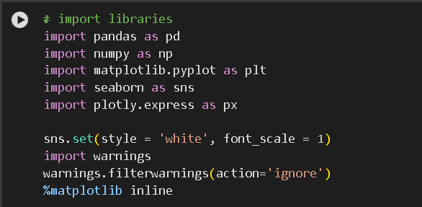

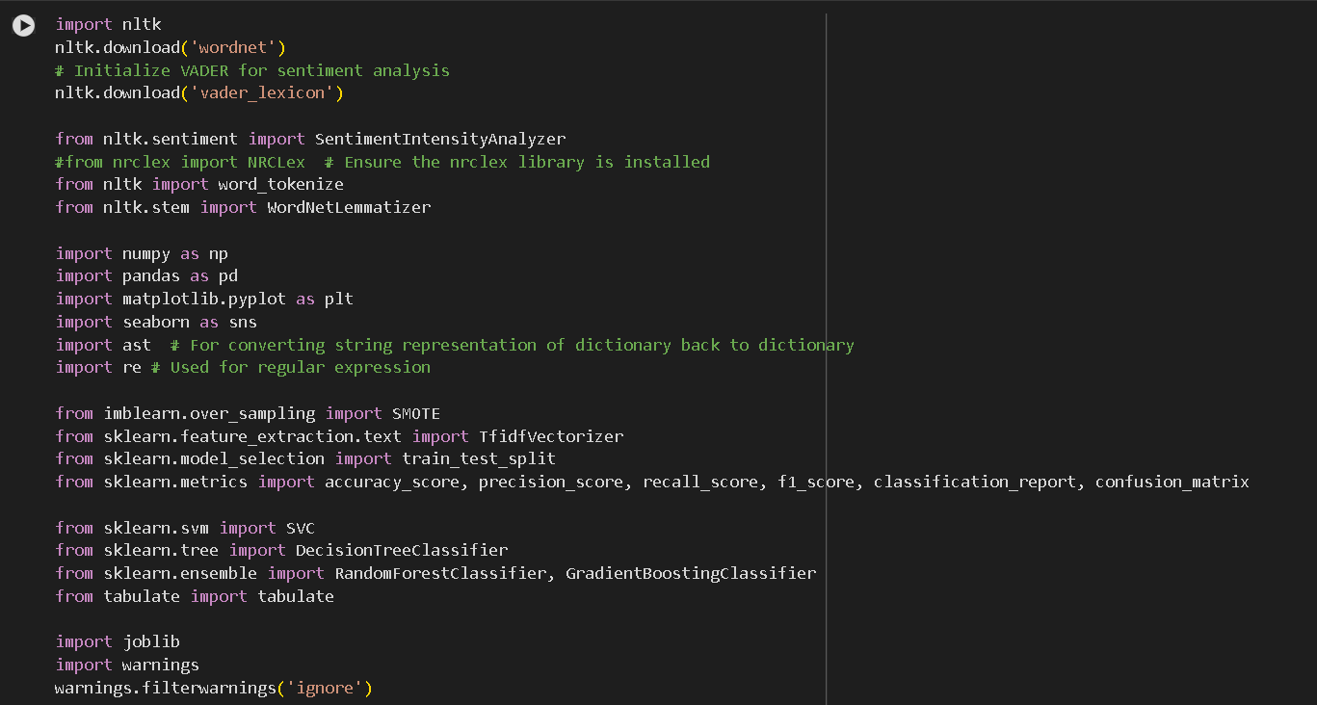 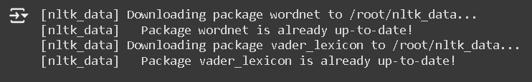

**2 Load the dataset**



**3 Display top 5 rows**

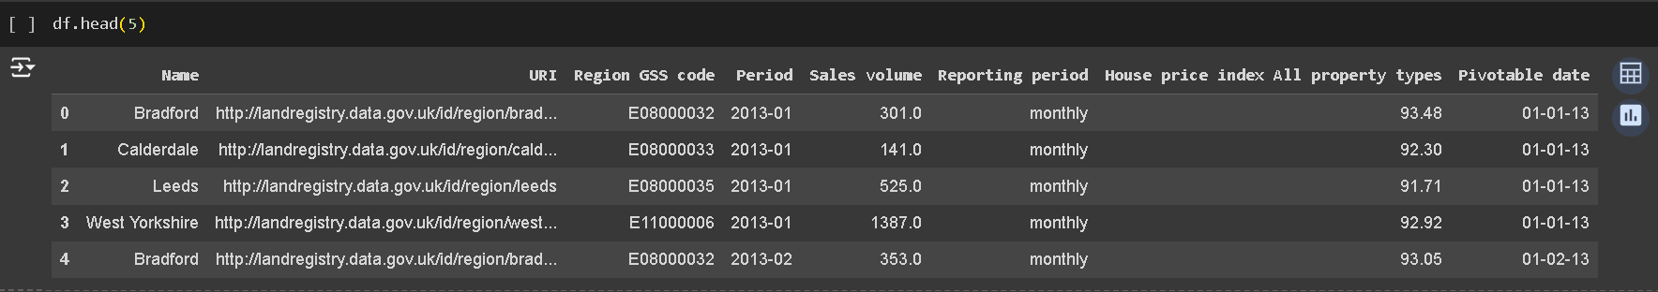

**4 Display last 5 rows**

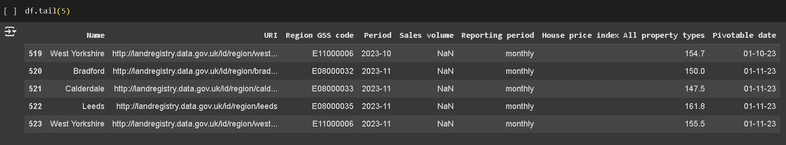

**5 Display shape of data**

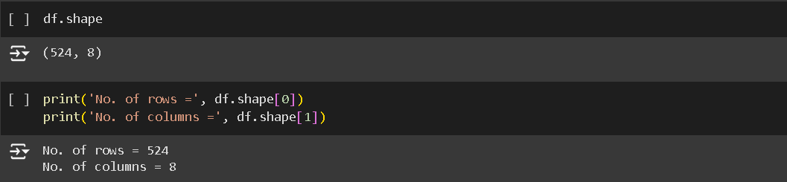

**6 Display information like total no. of rows, columns, data types of each column and memory requirement**

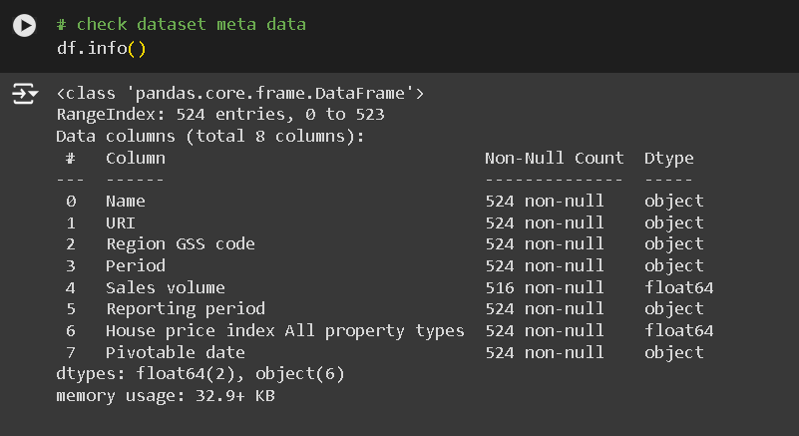

**7 Display statistics of the dataset**

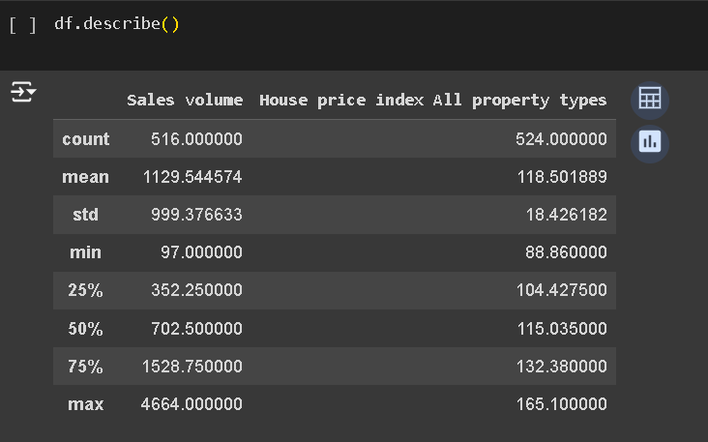

**8 Check for NULL values**

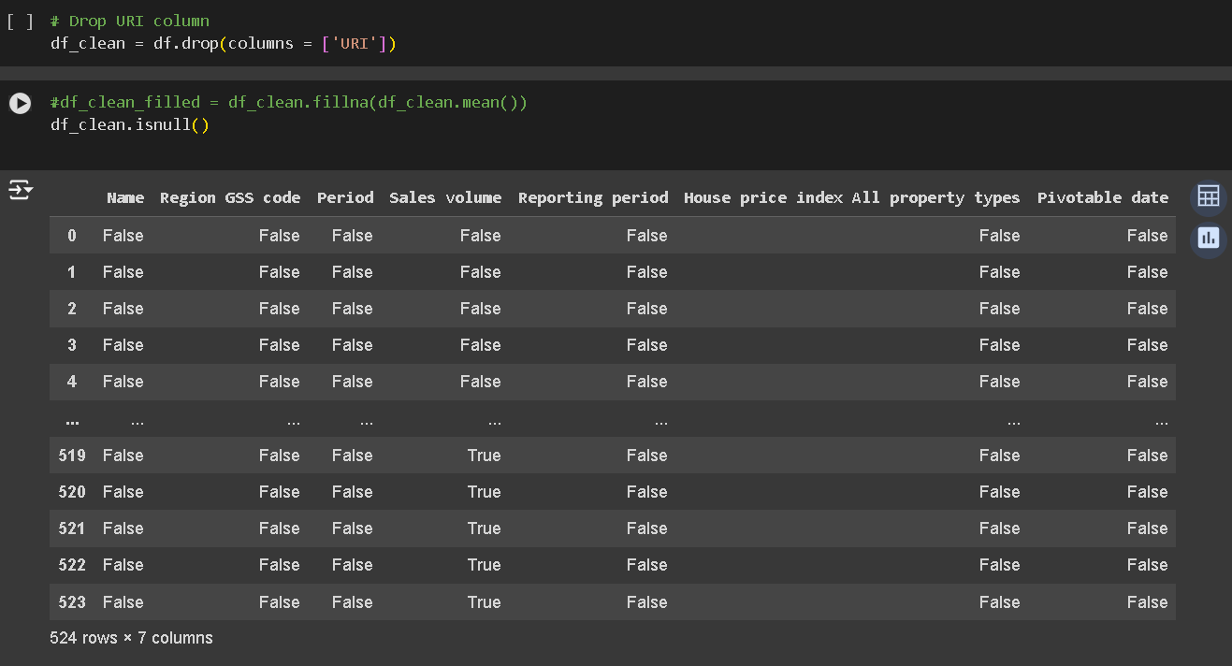 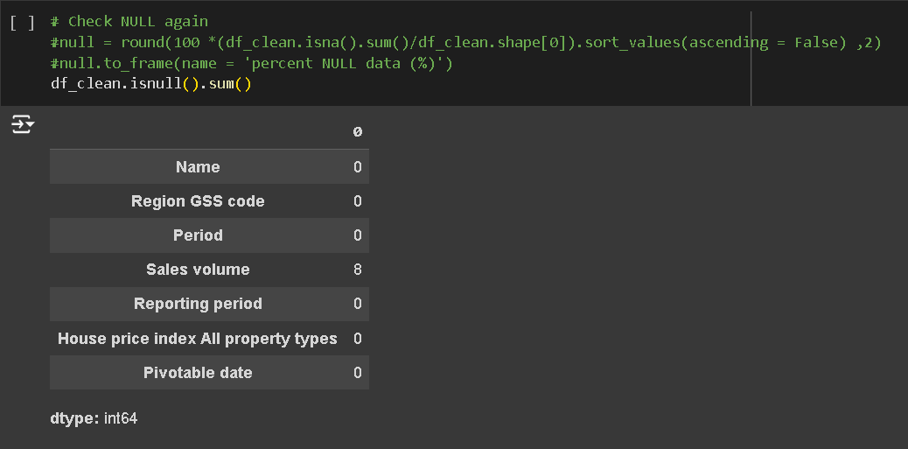

**9 Handle NULL value in ‘Sales Volum’ column**

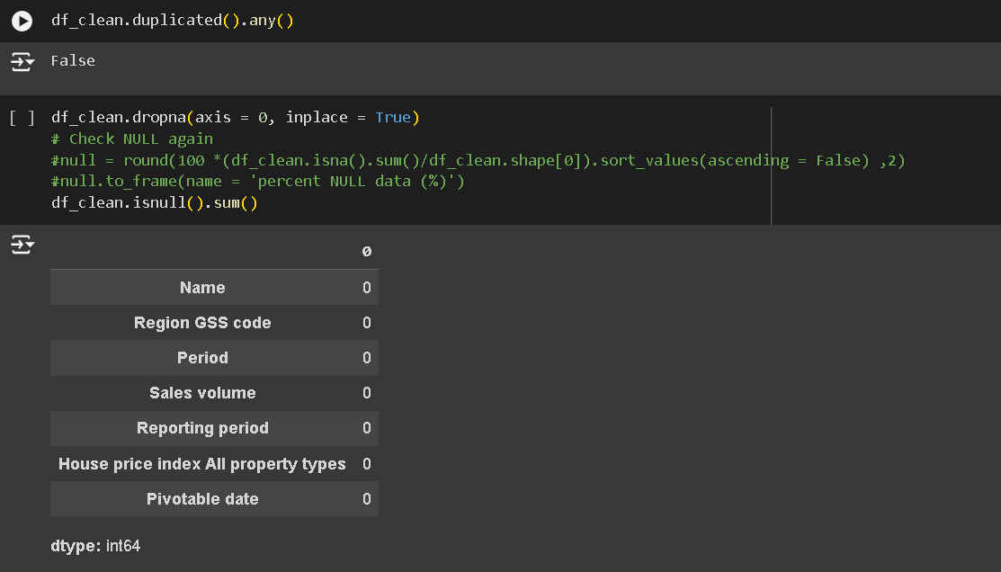

**10 Create a function for preprocessing**

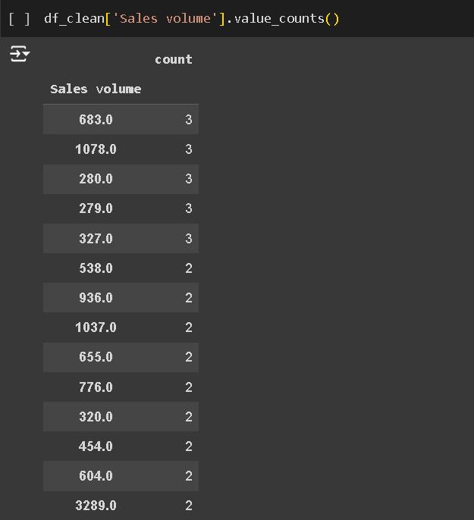

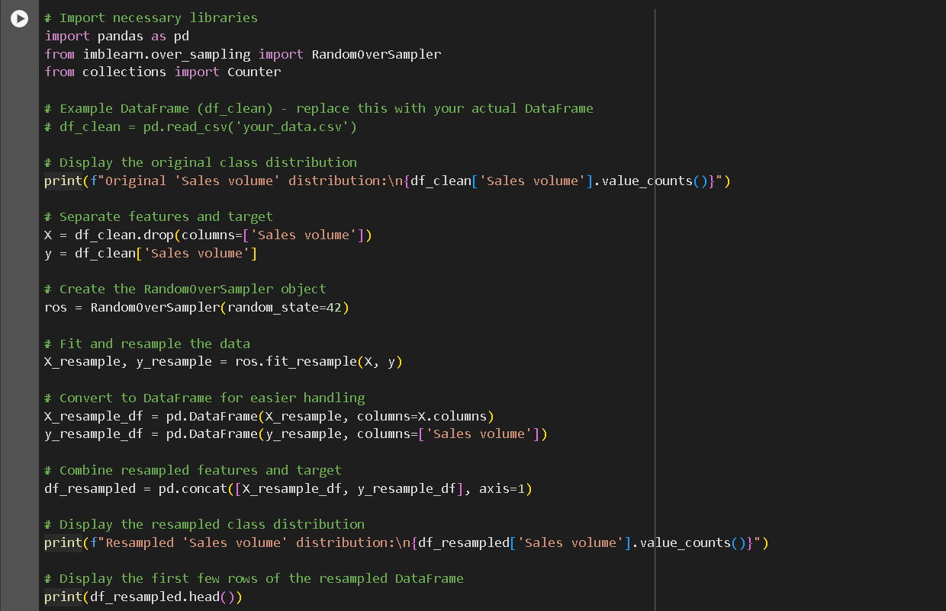 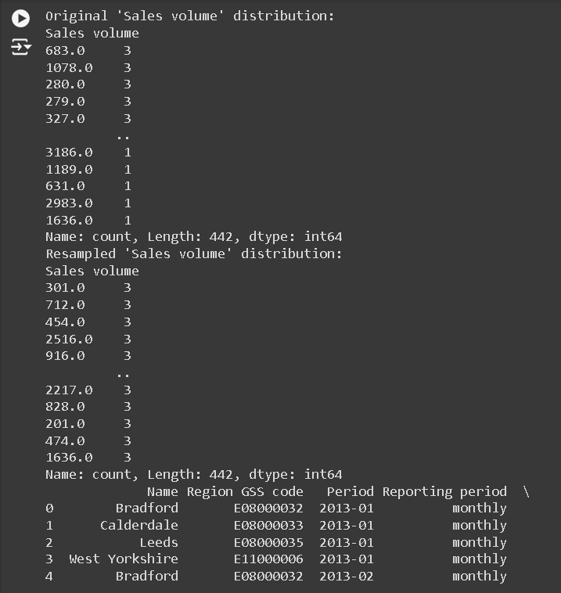

11. Box plot for Sales Volum

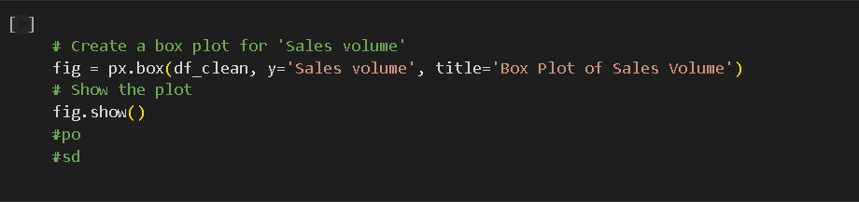 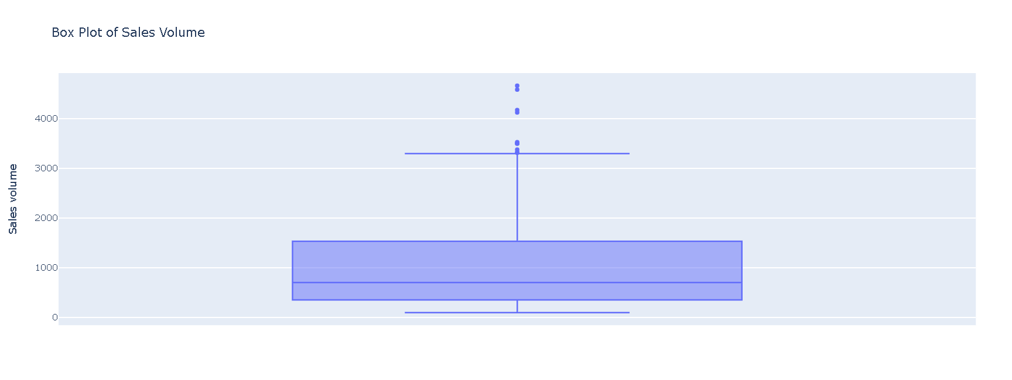

**12 Display histograms**

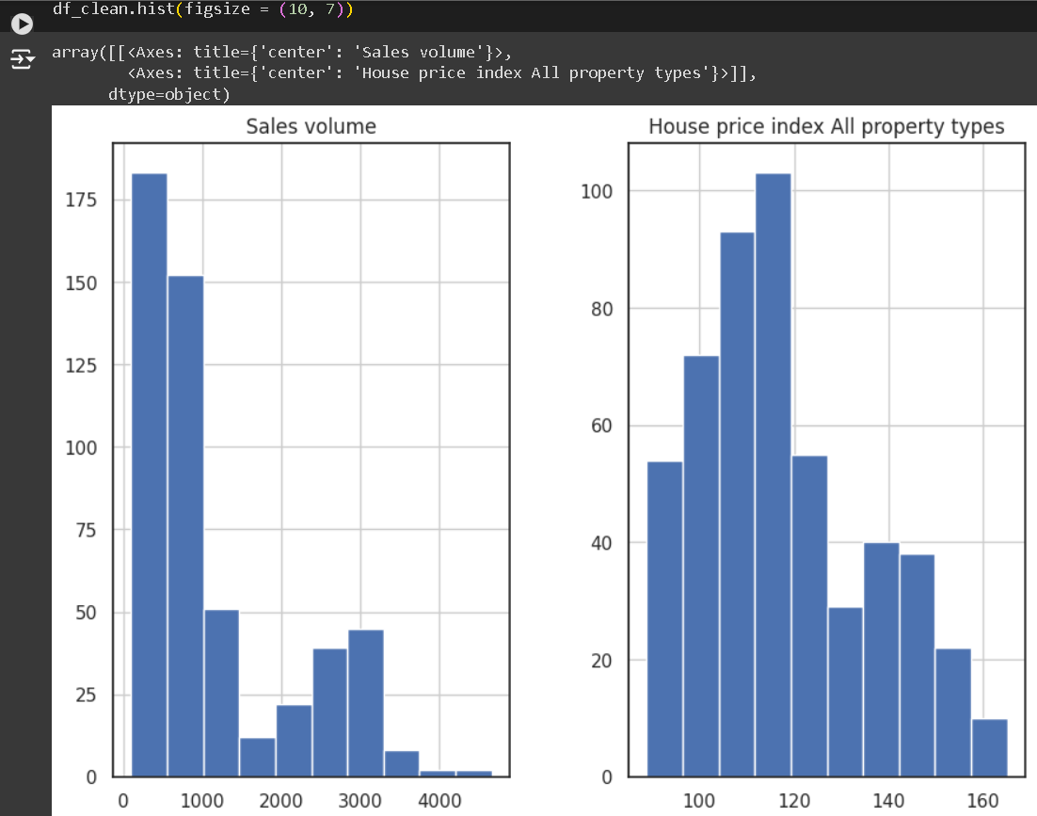 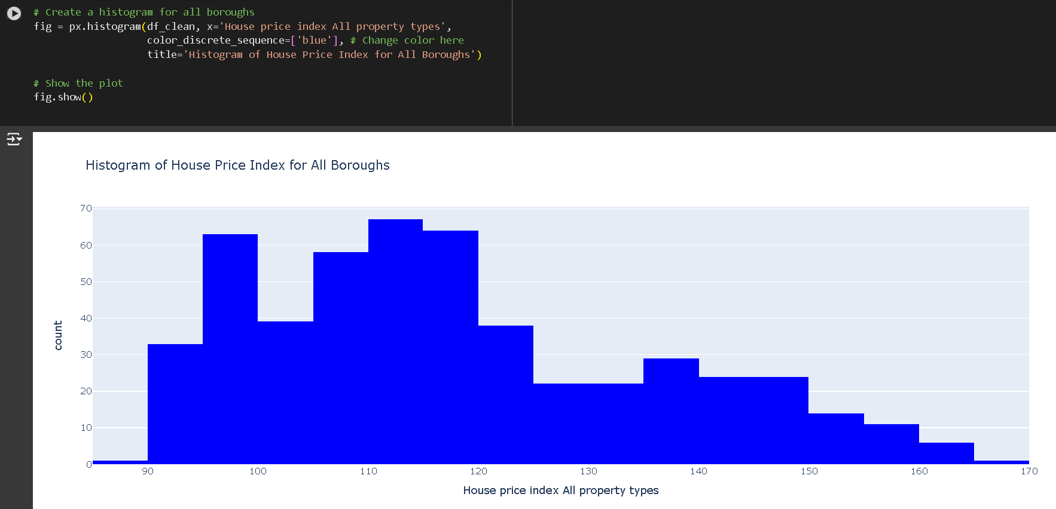

**13 Create a line plot for 'Period' and 'Sales volume'**

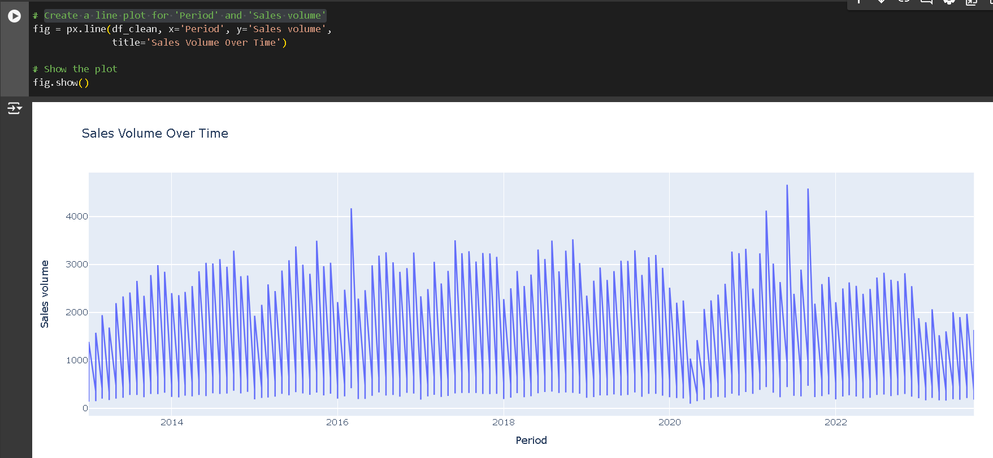

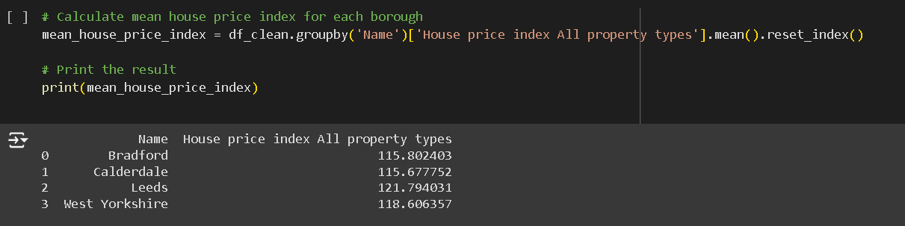 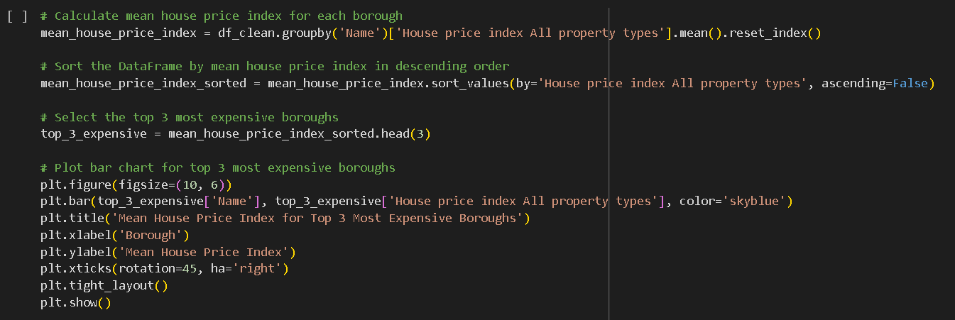 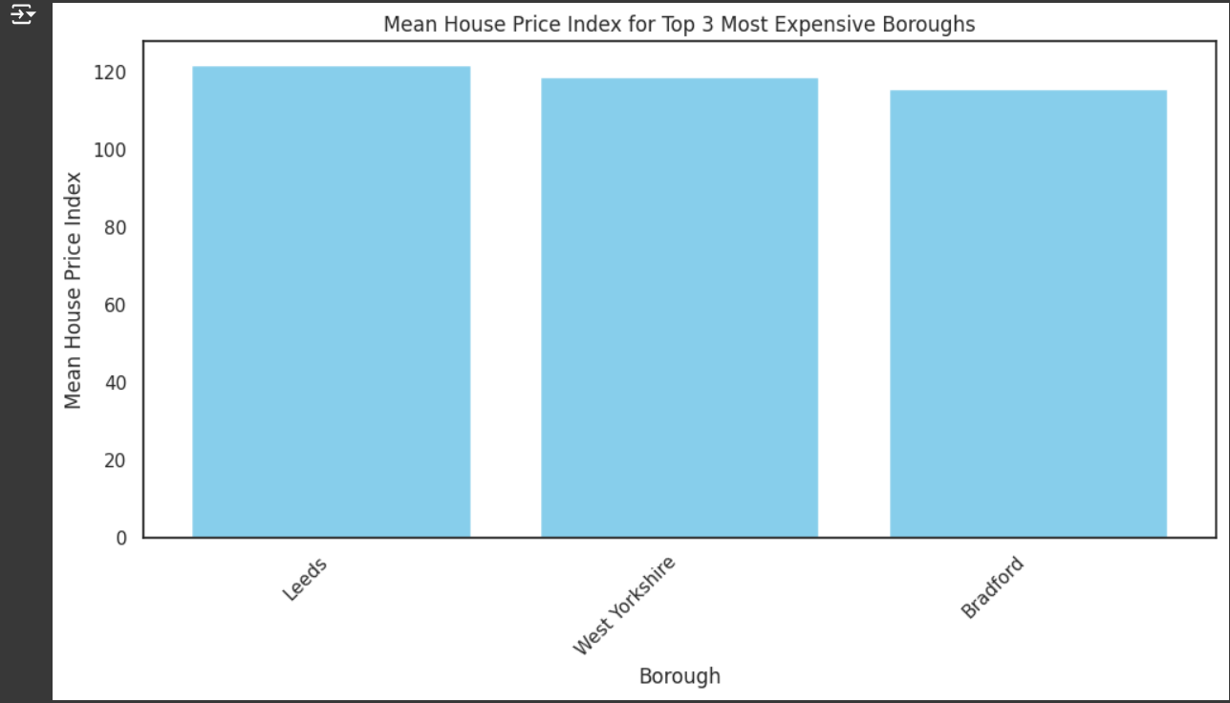

14 Feature Engineering

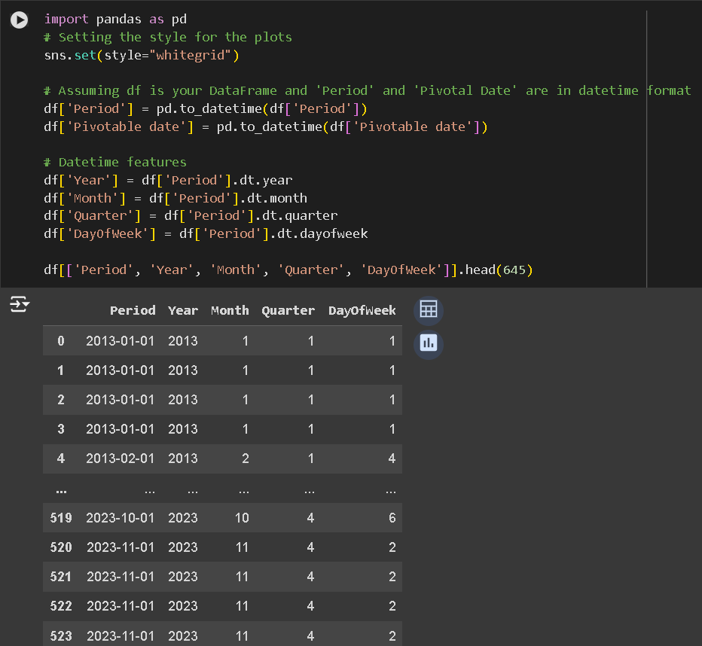

**15 Seasonal Features**

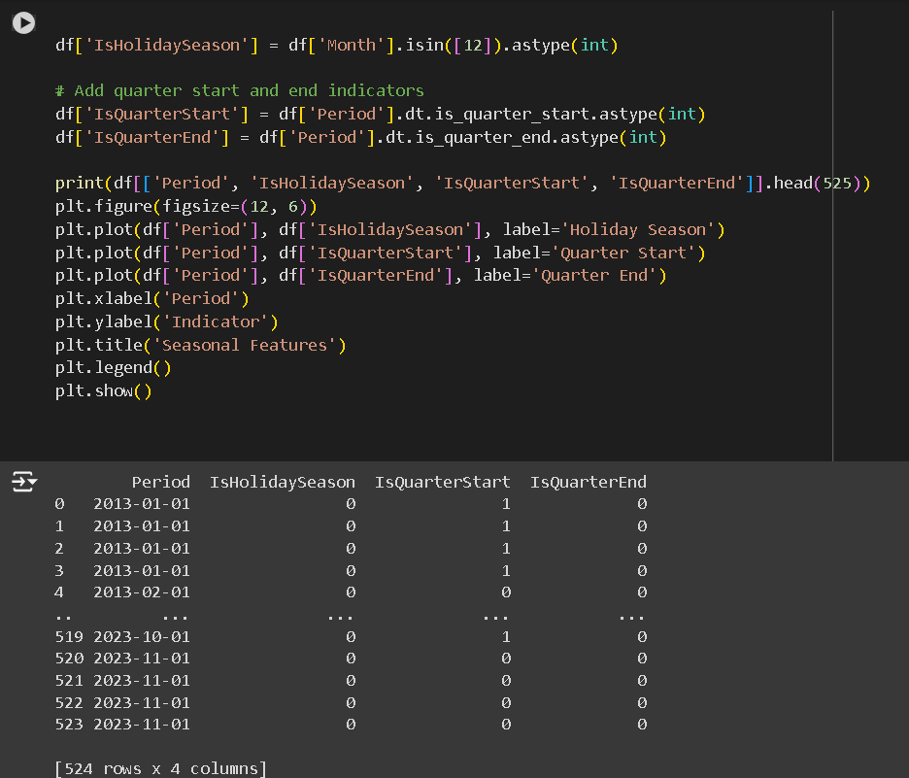

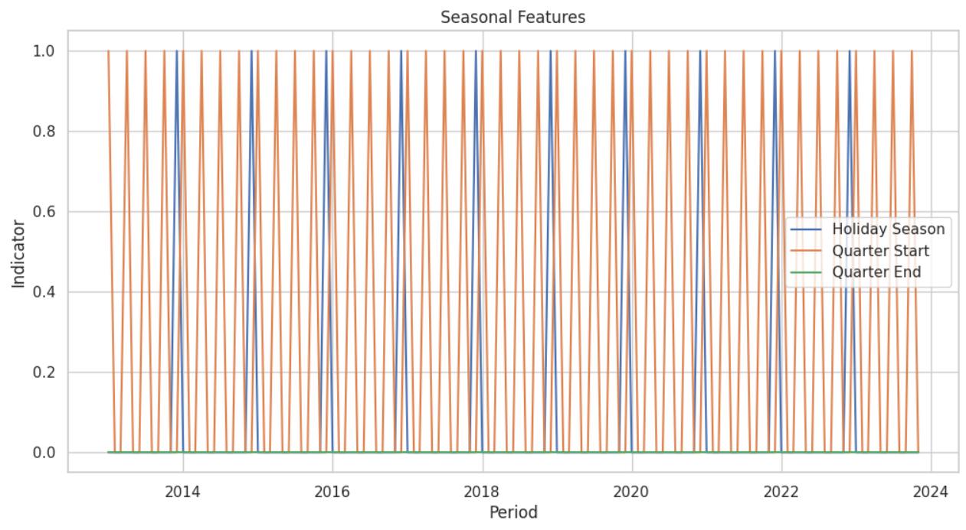

**16 Growth Rate Features**

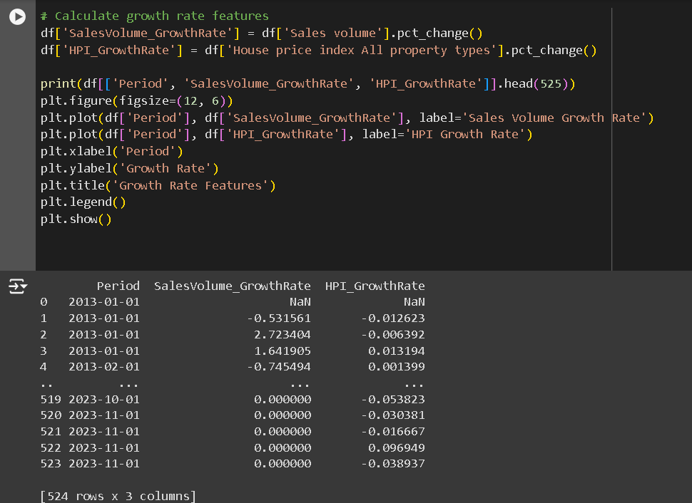 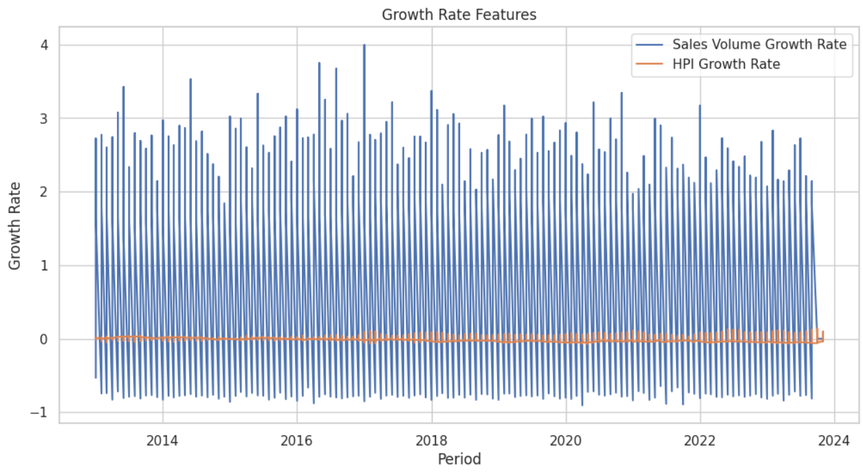

17 **Moving Average Convergence Divergence (MACD)**

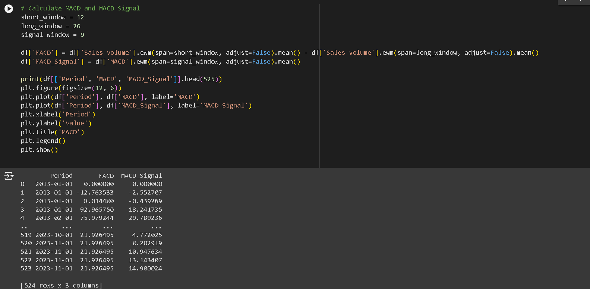 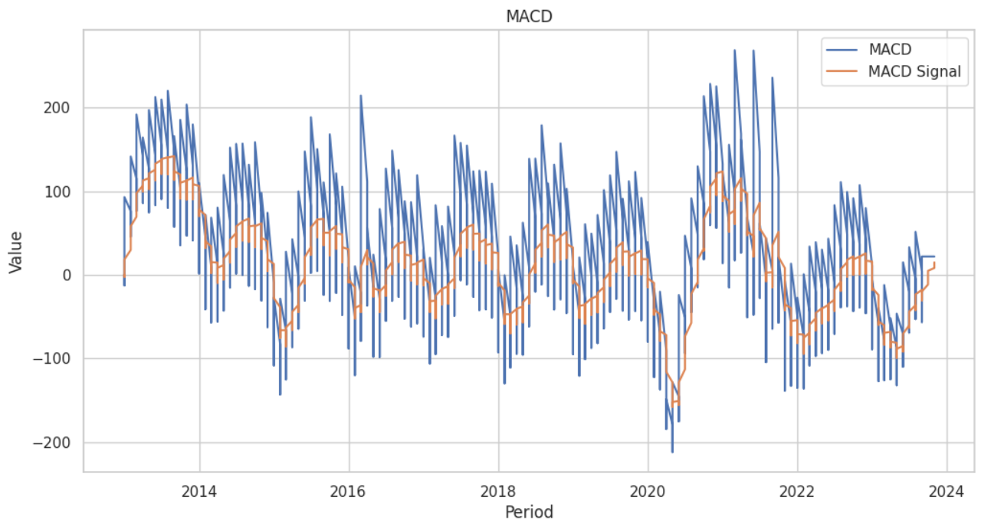

18 **Exponential Moving Average (EMA)**

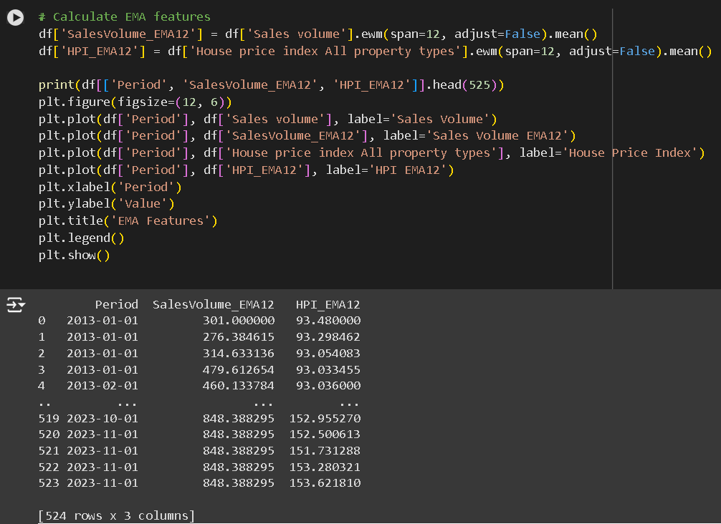 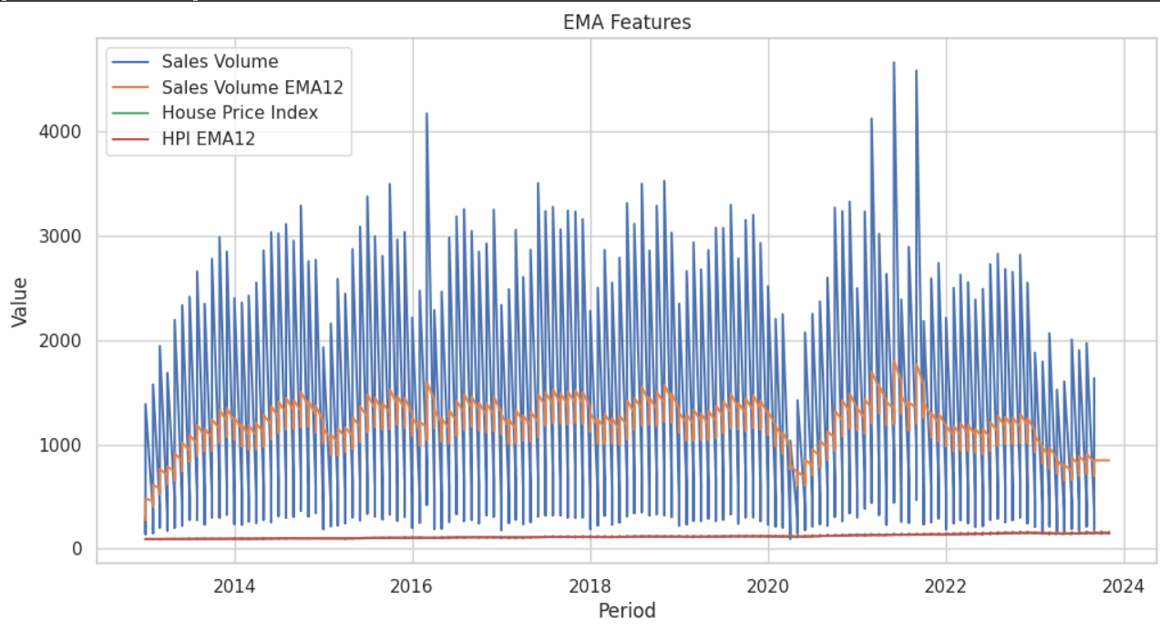

**19 Relative Strength Index (RSI)**

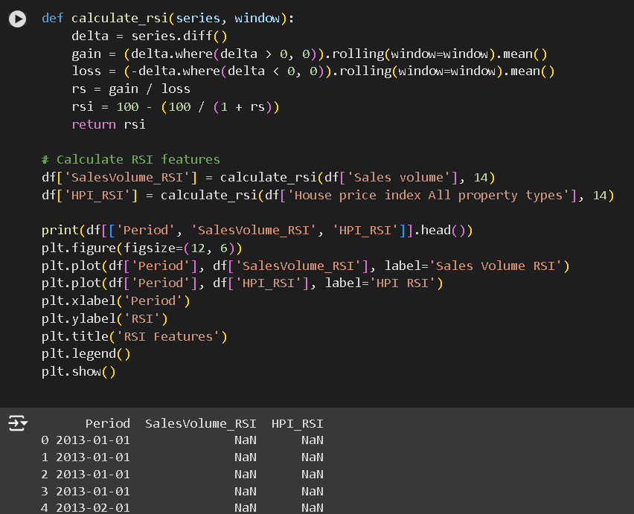 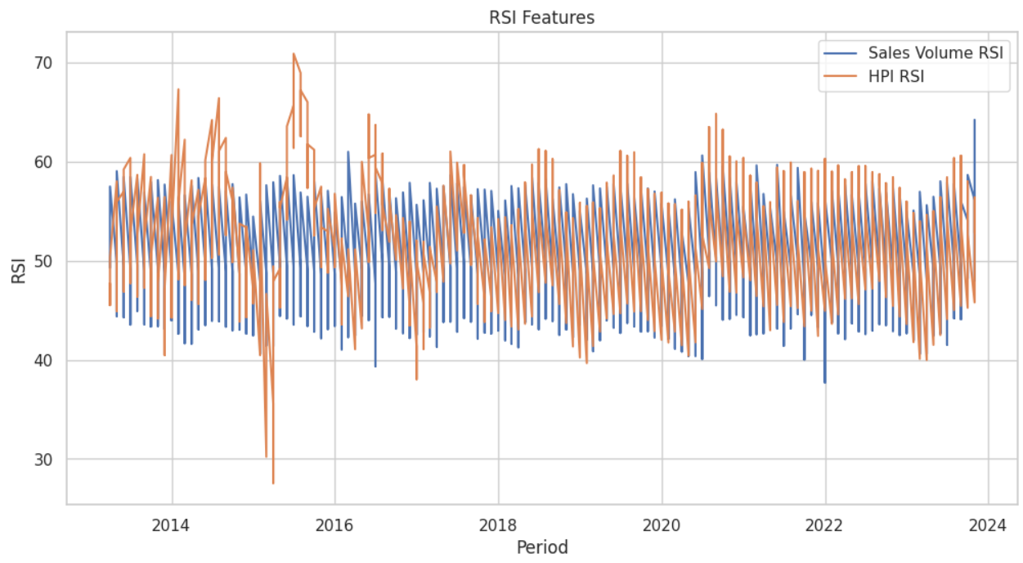

20 **Trend Features**

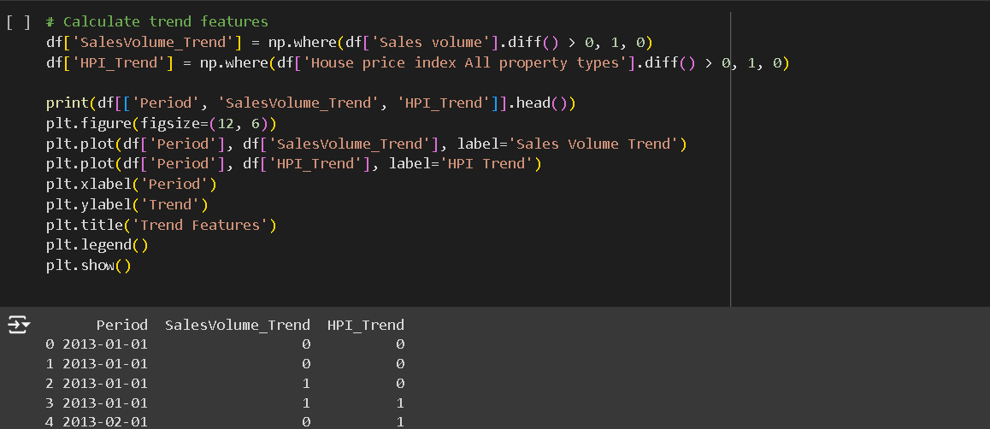 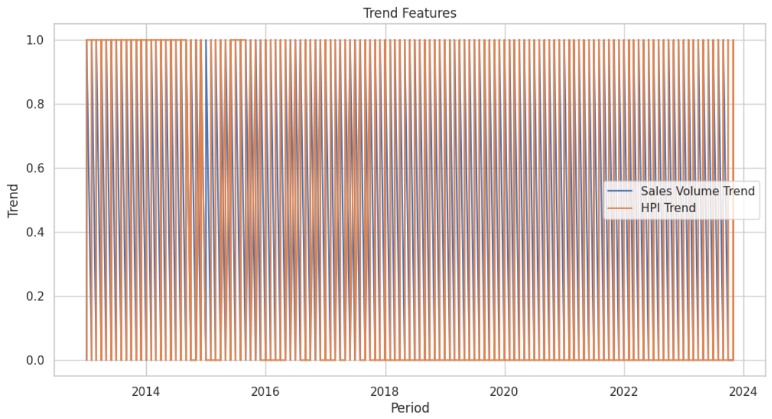

21 Gradient Boosting Classifier

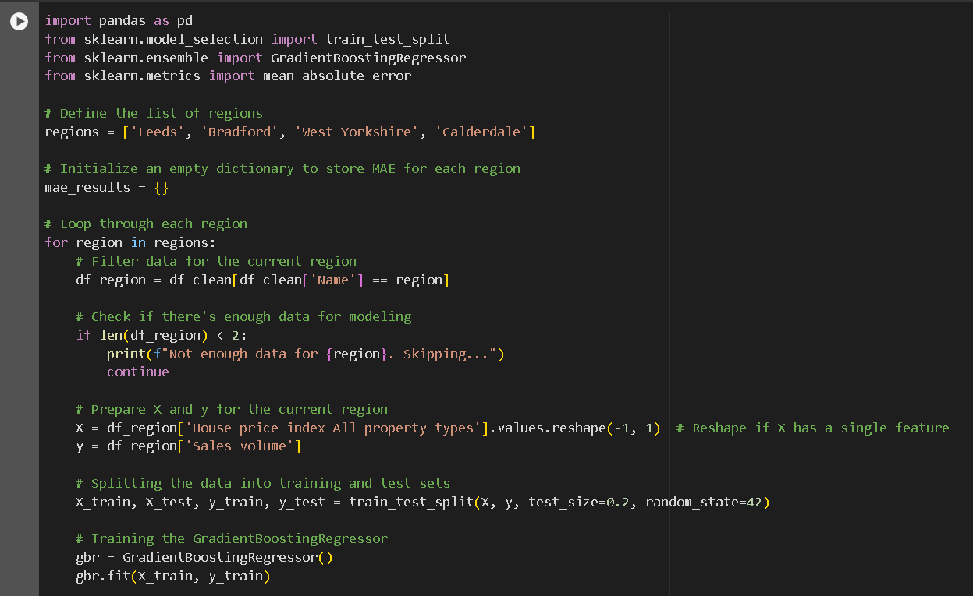 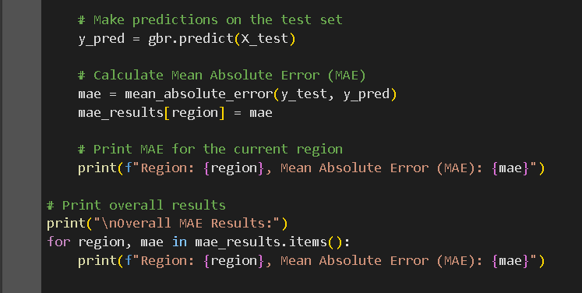 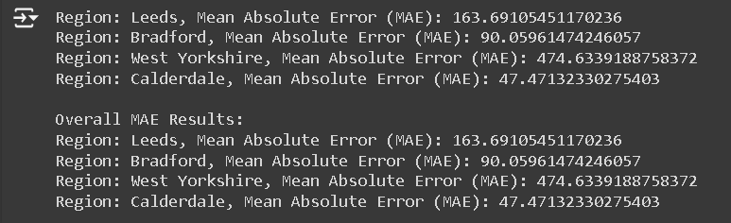 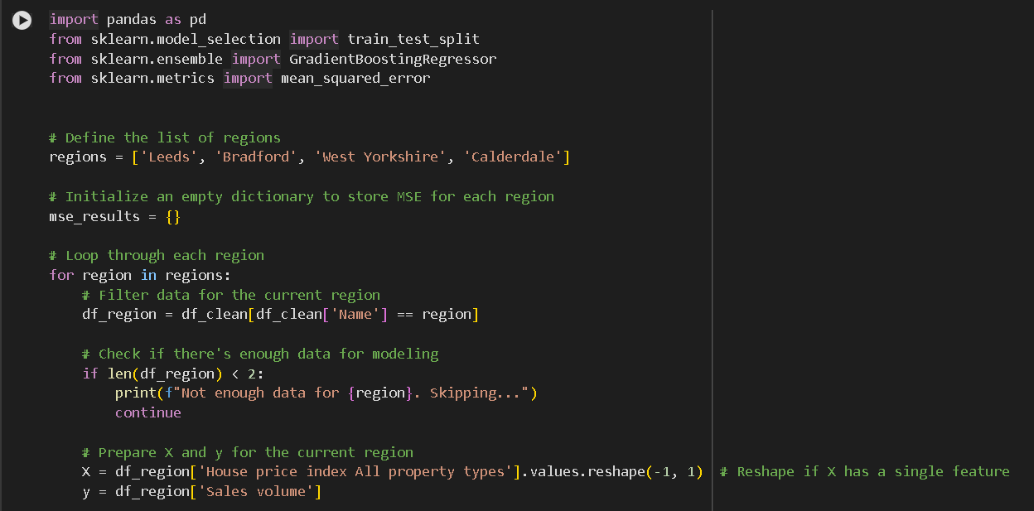 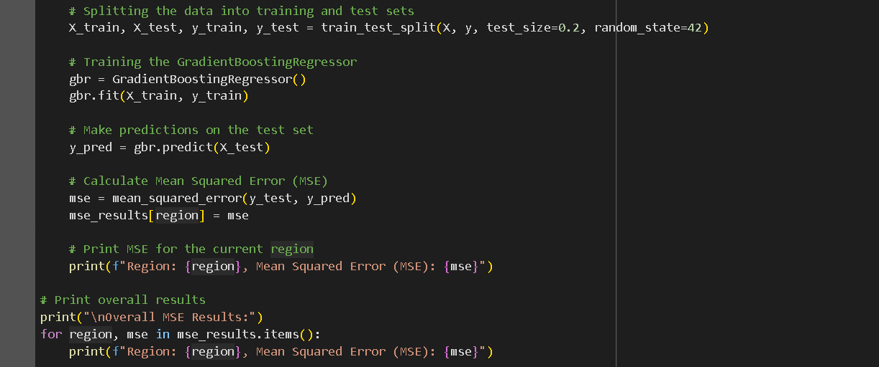 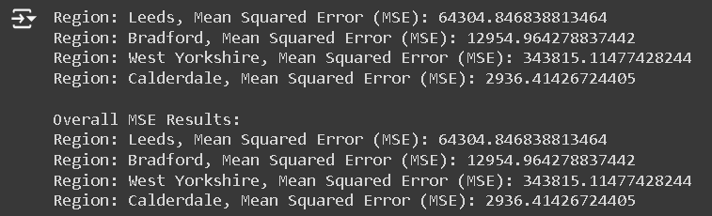 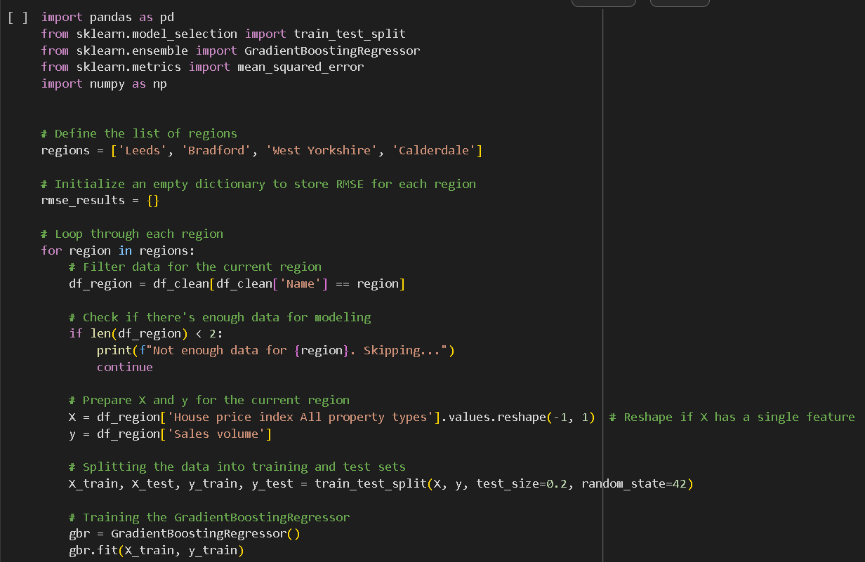 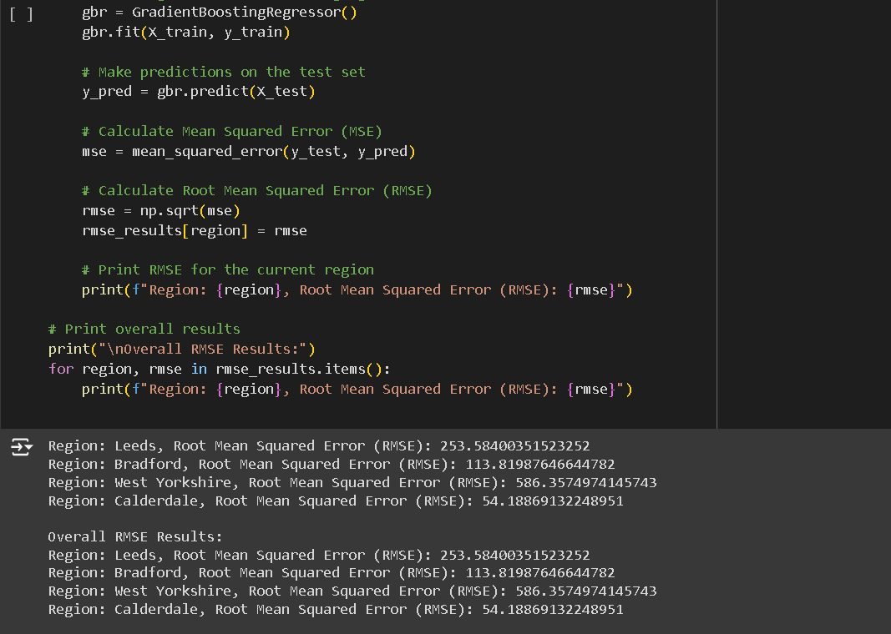

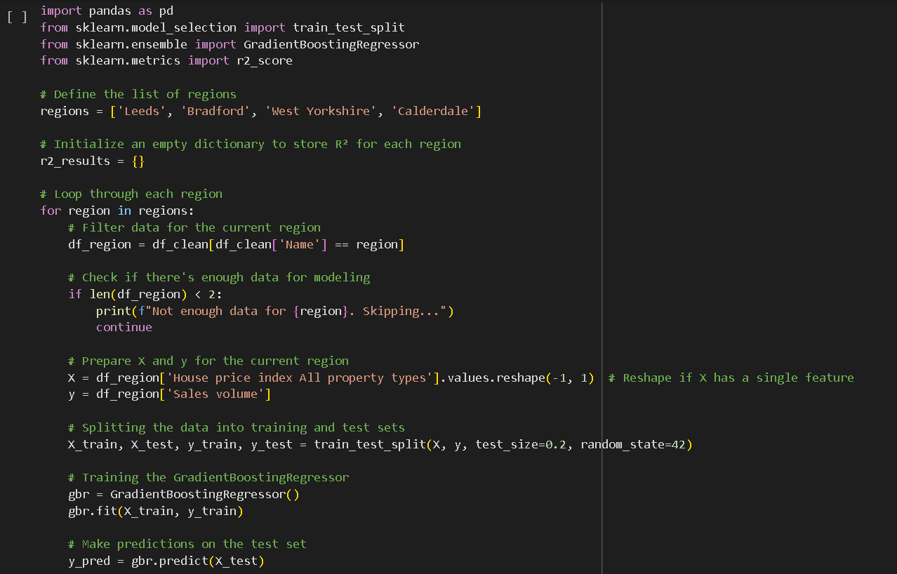 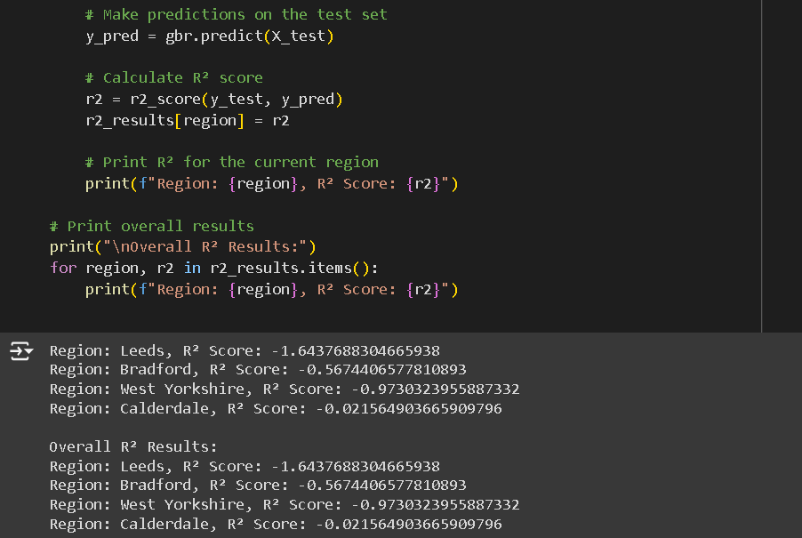

22 Linear Regression

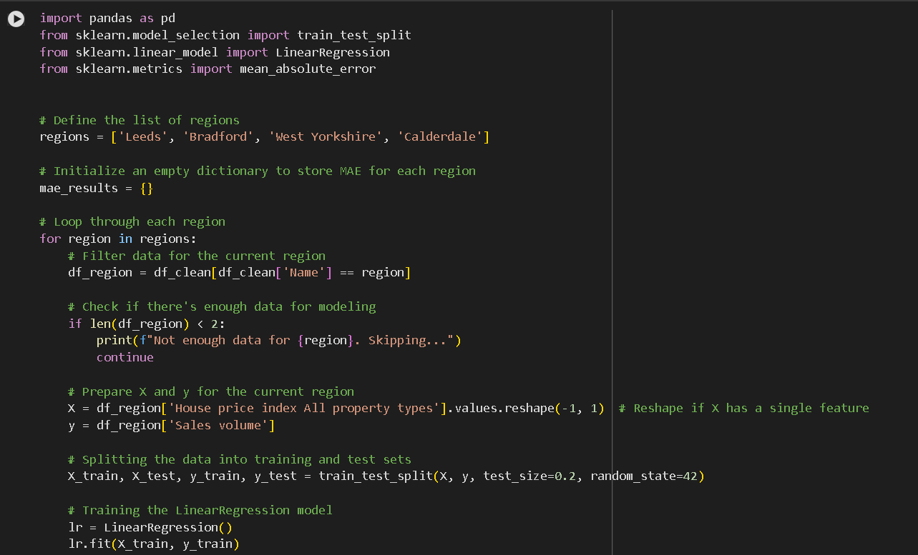 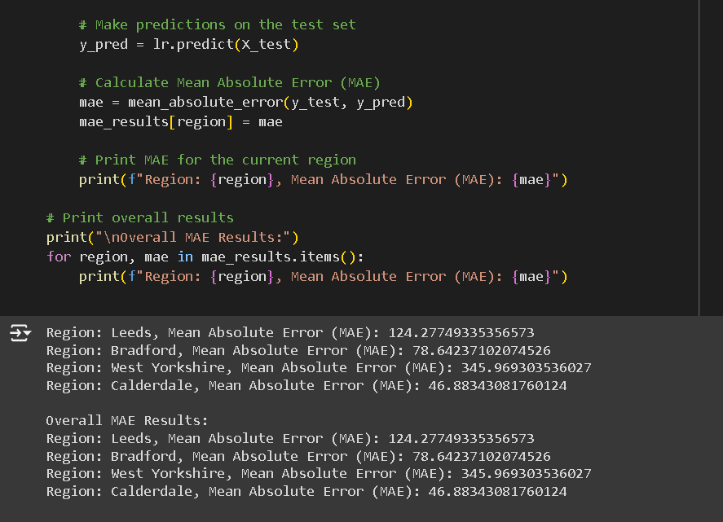 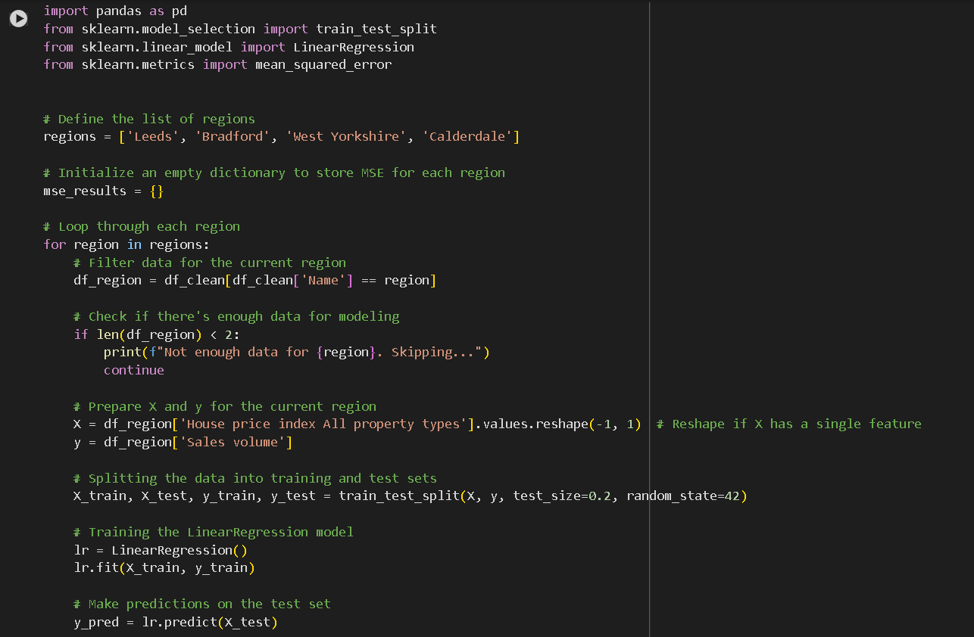 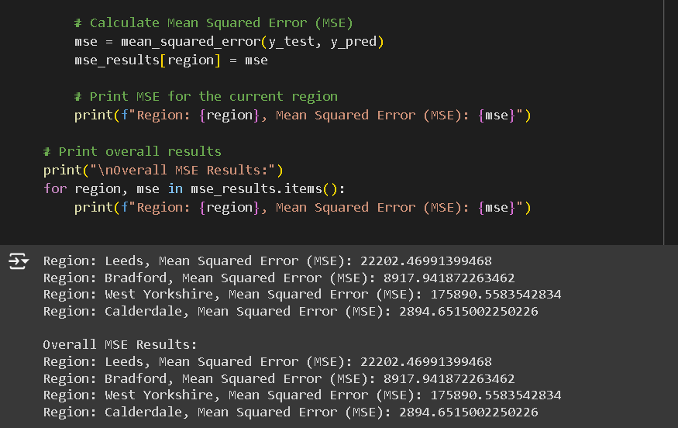

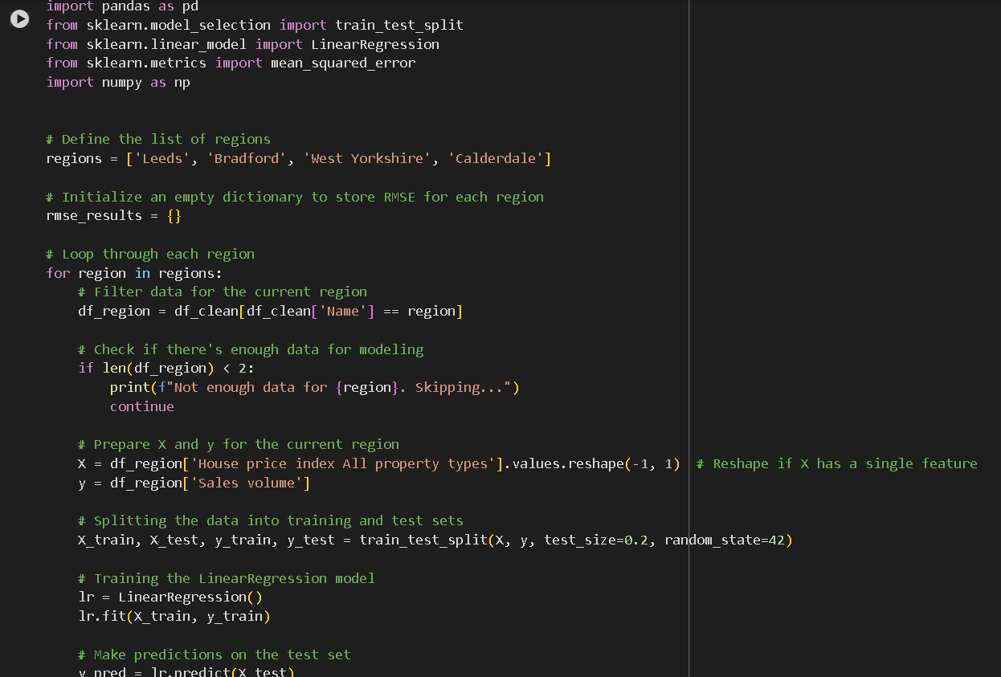 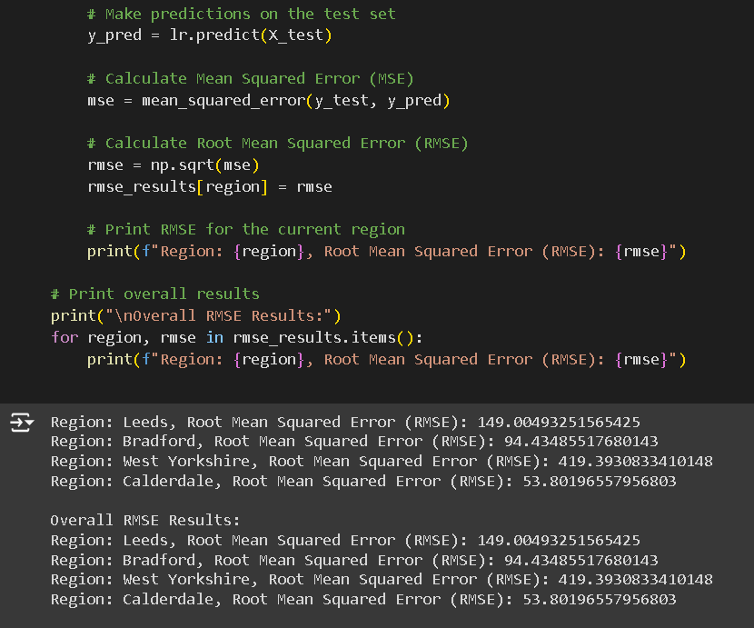 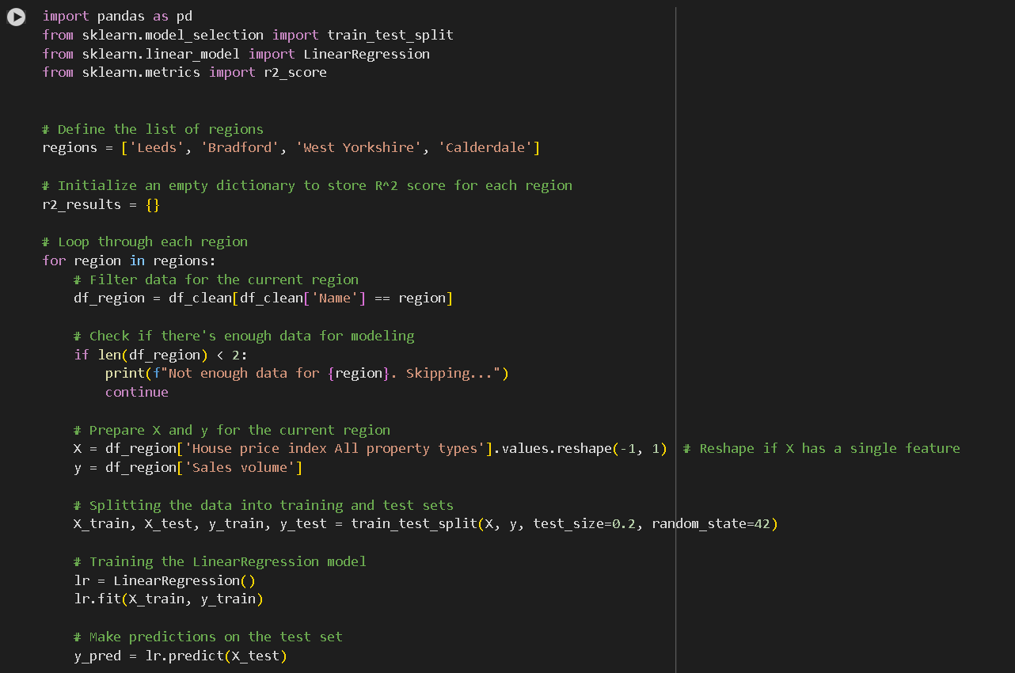 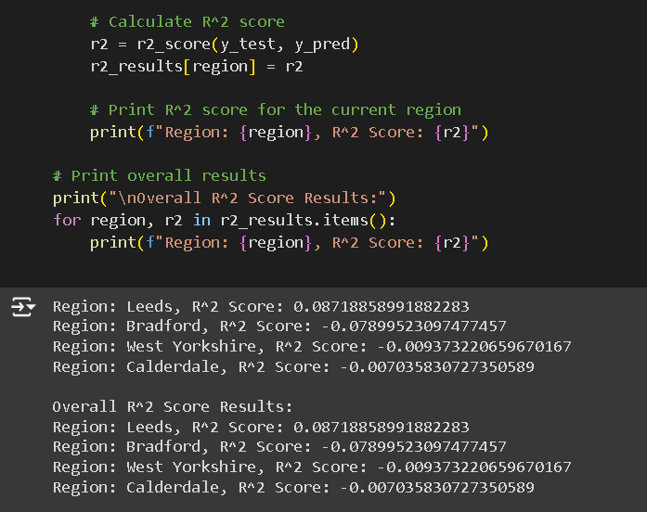

23 Support Vactor Machine(SVM)

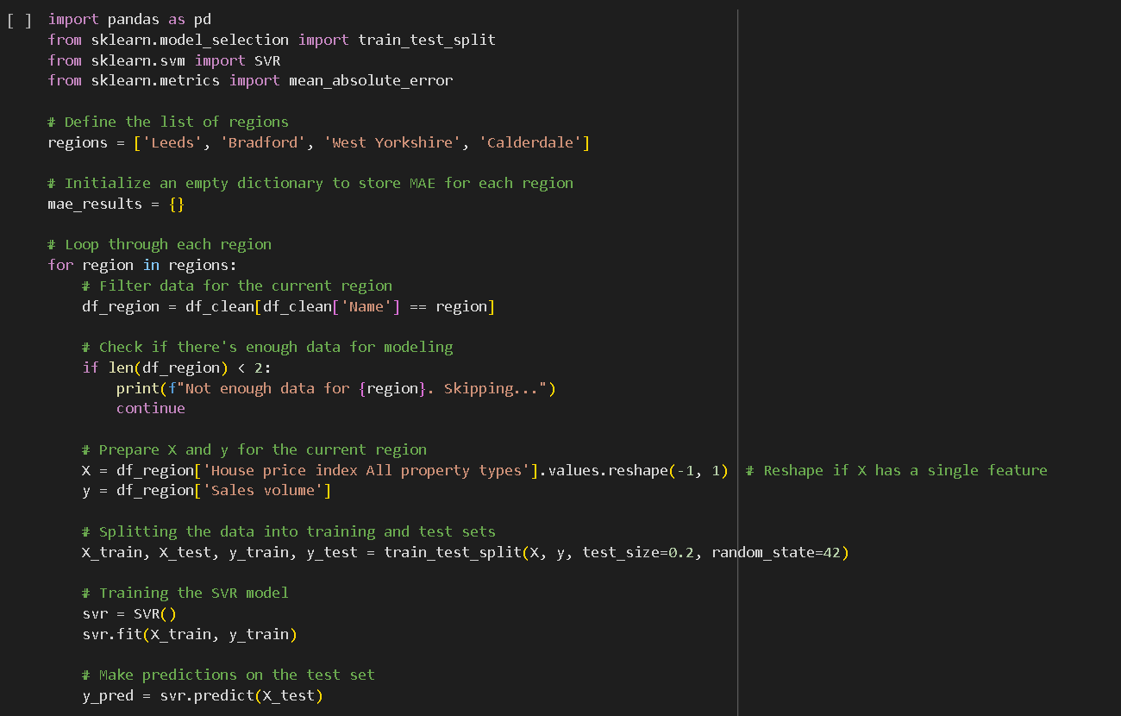 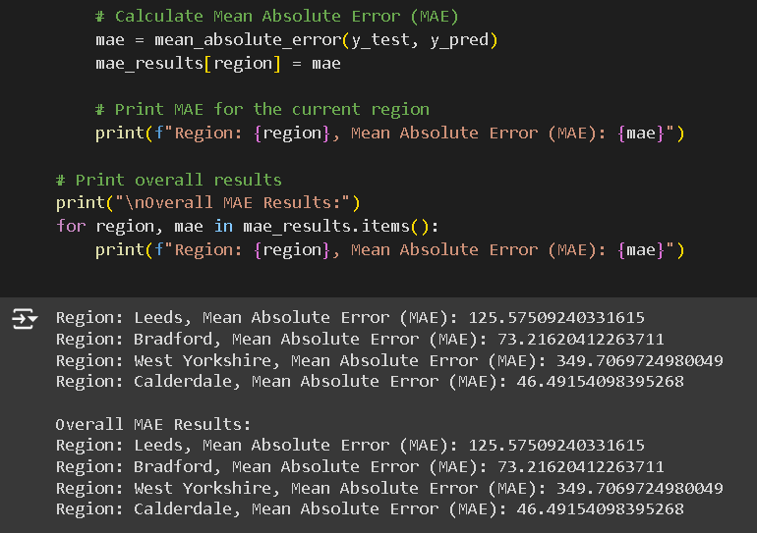 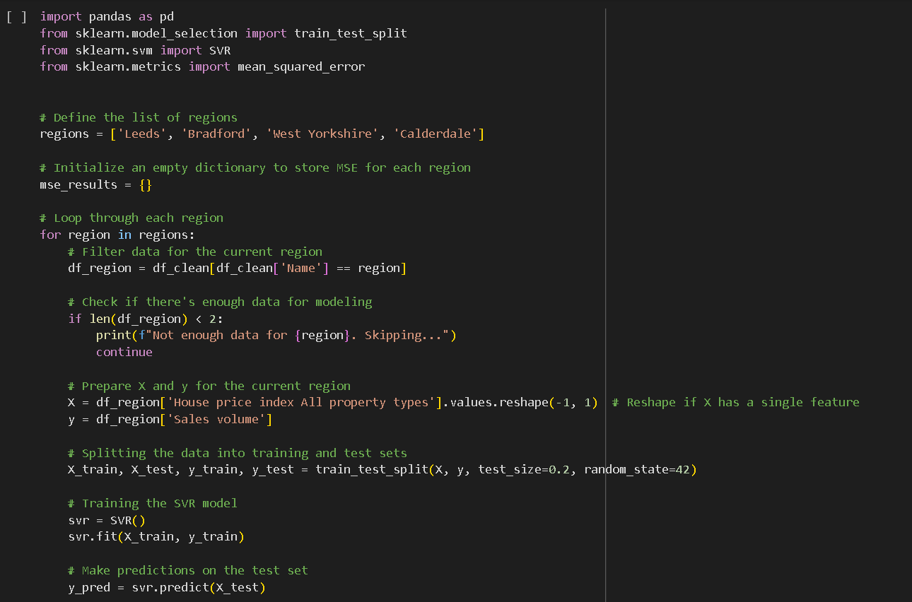 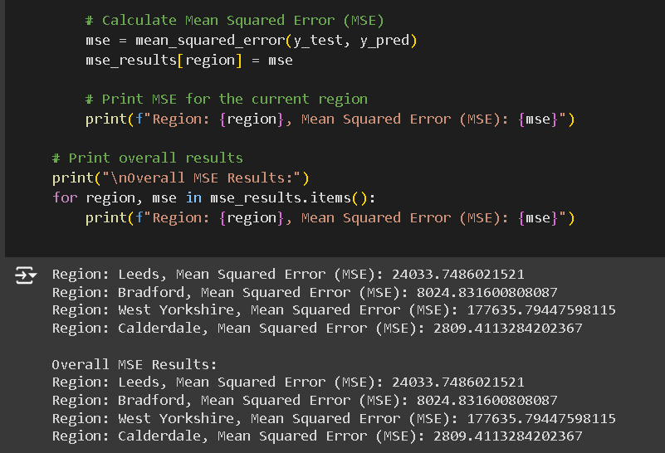 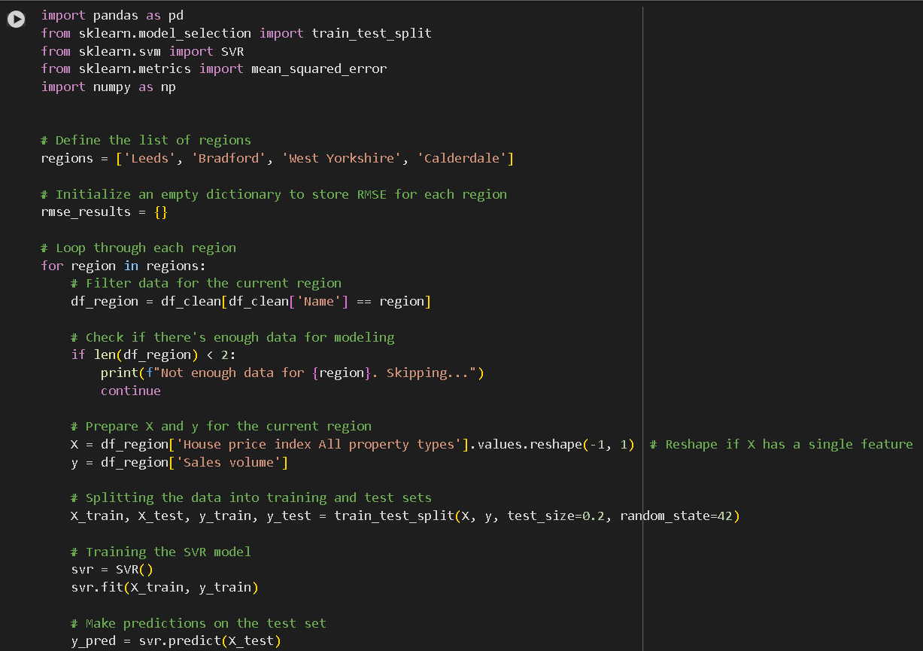 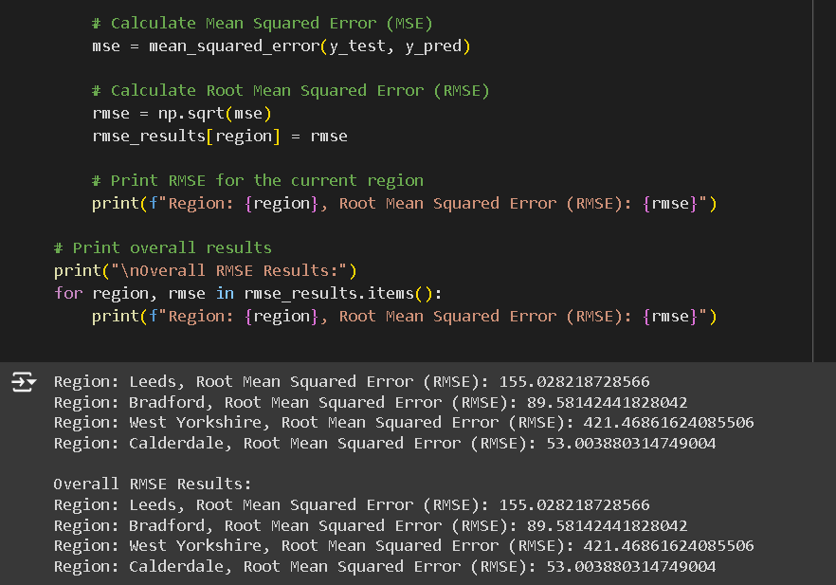 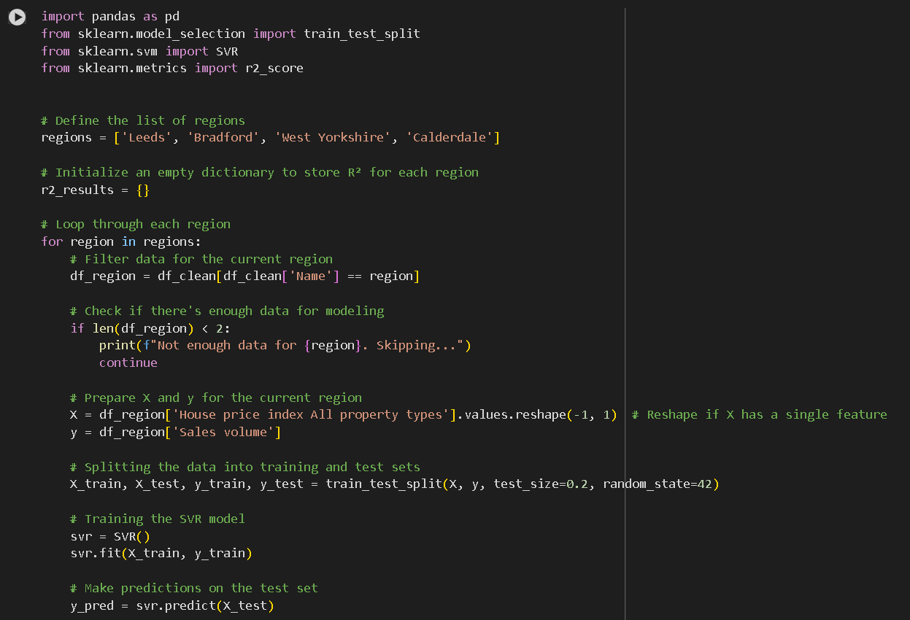 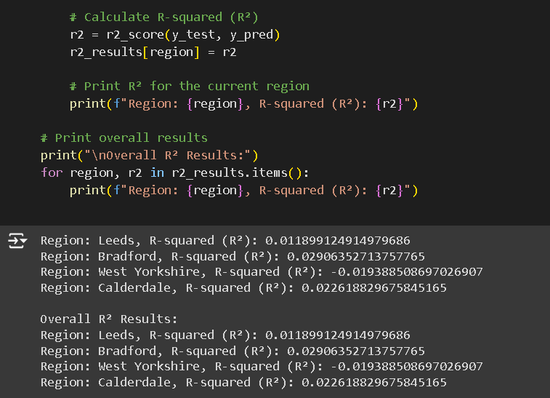

24. Random Forest Regression

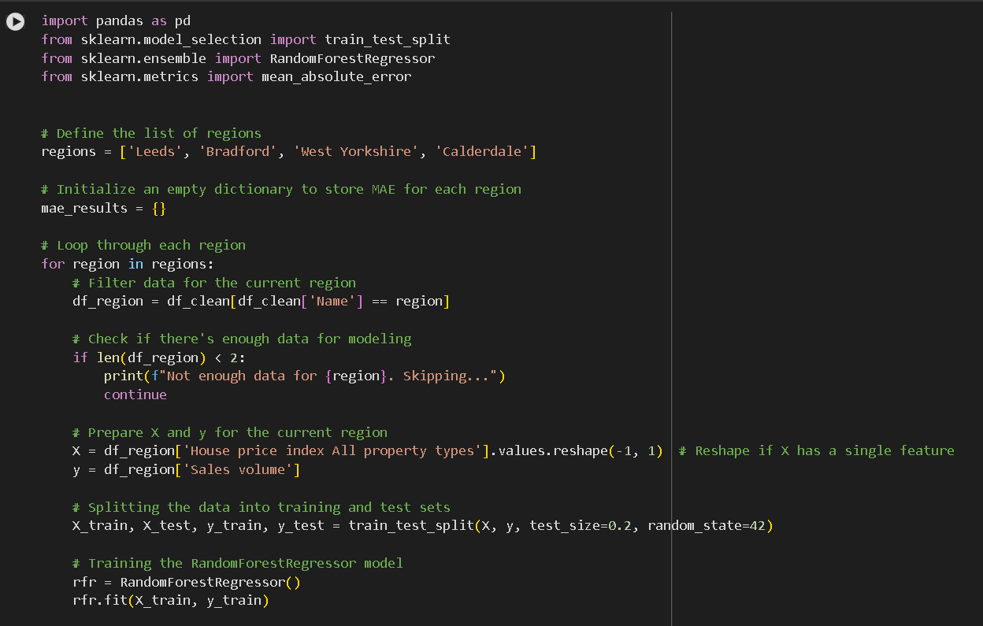 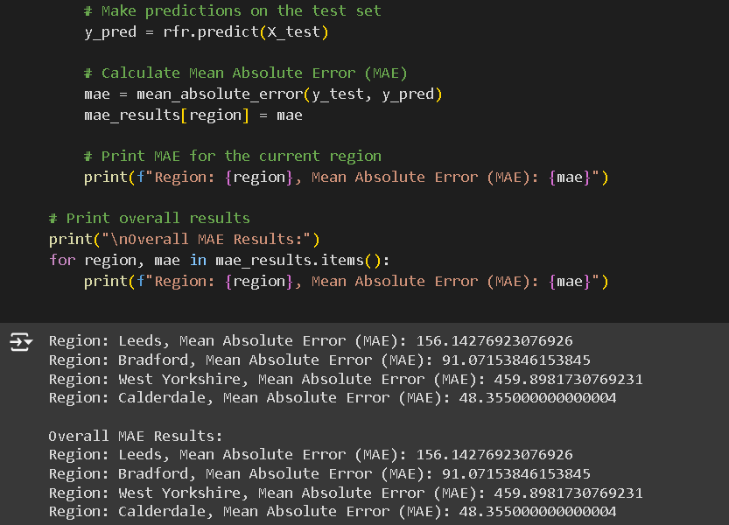 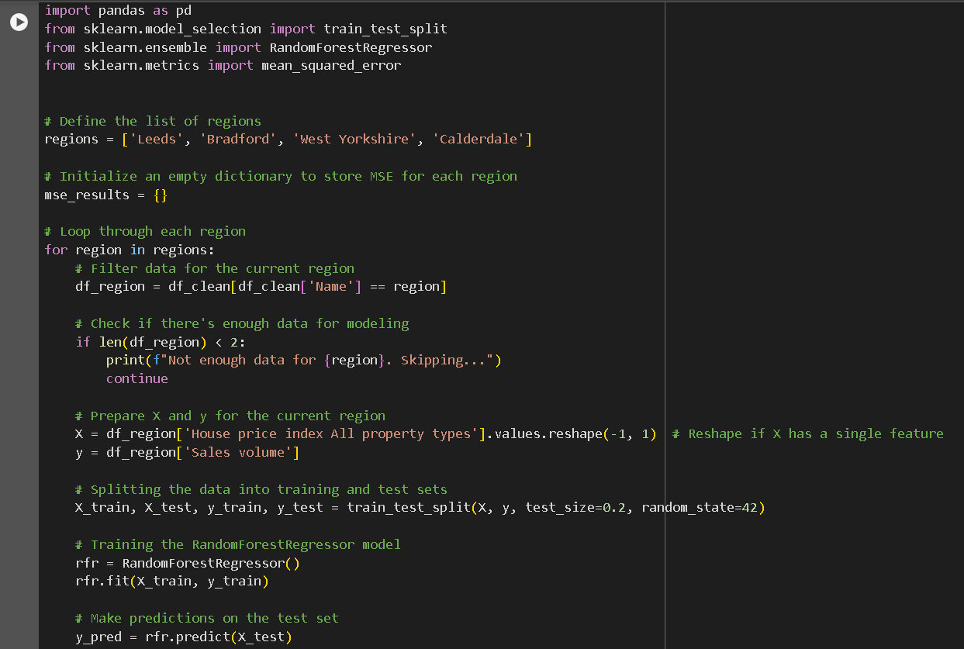 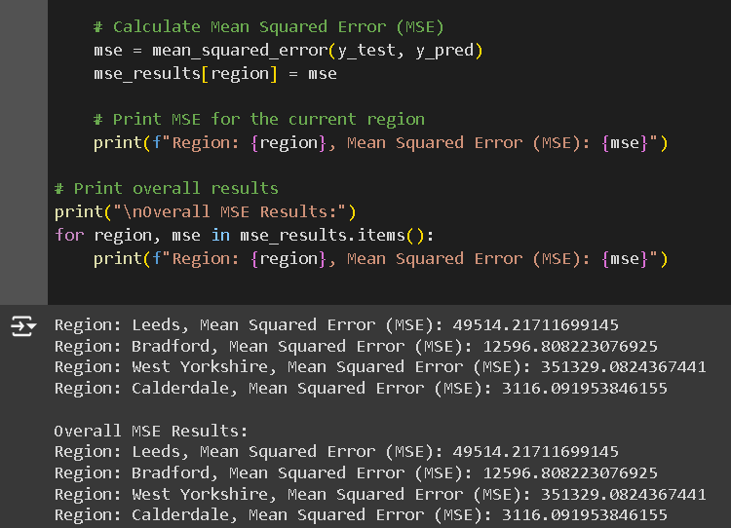 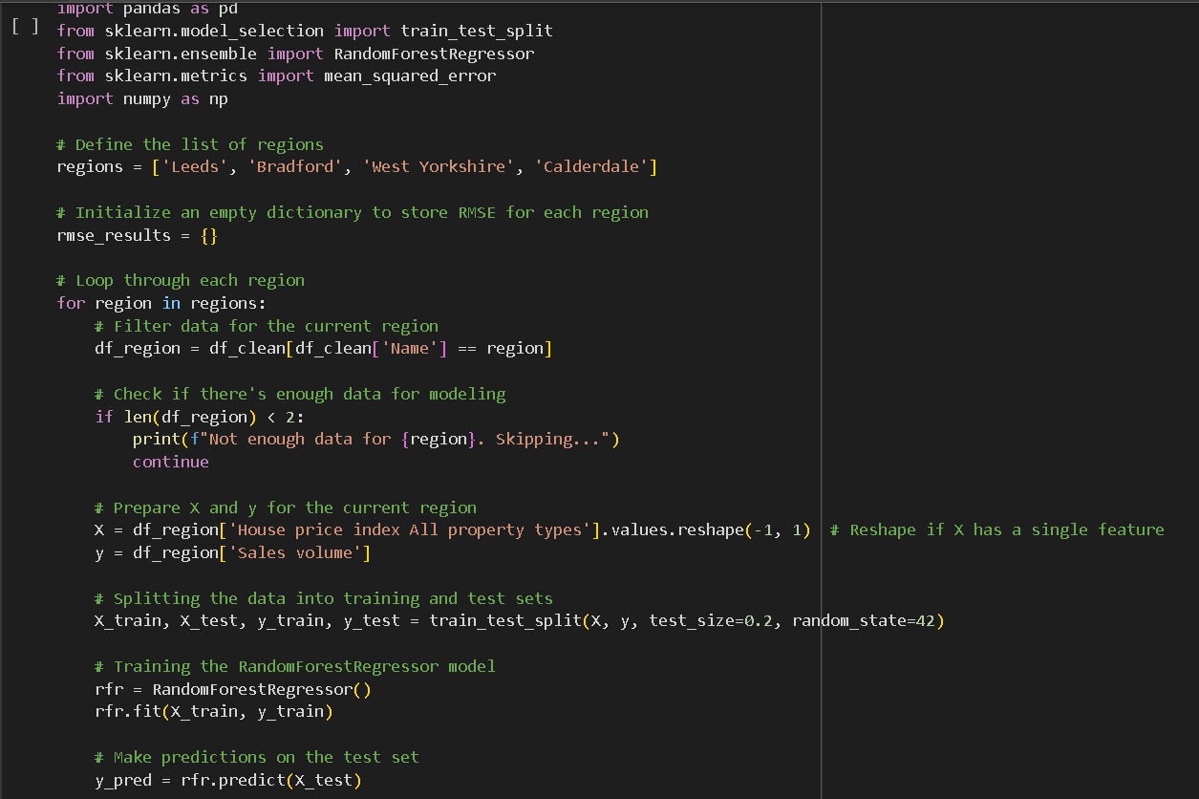 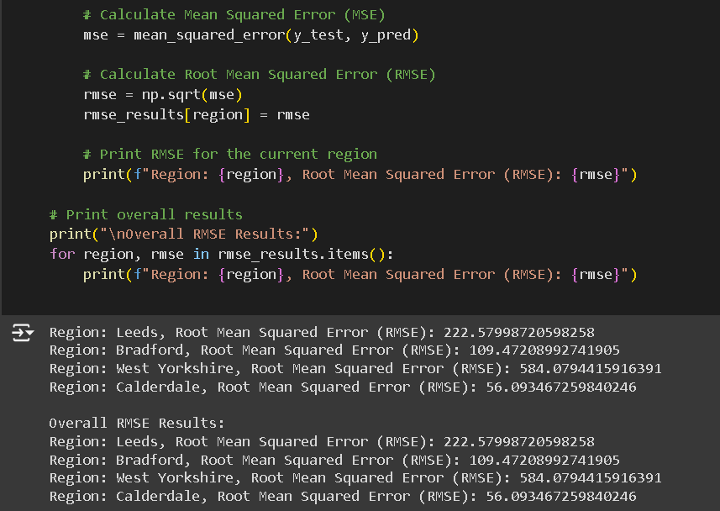 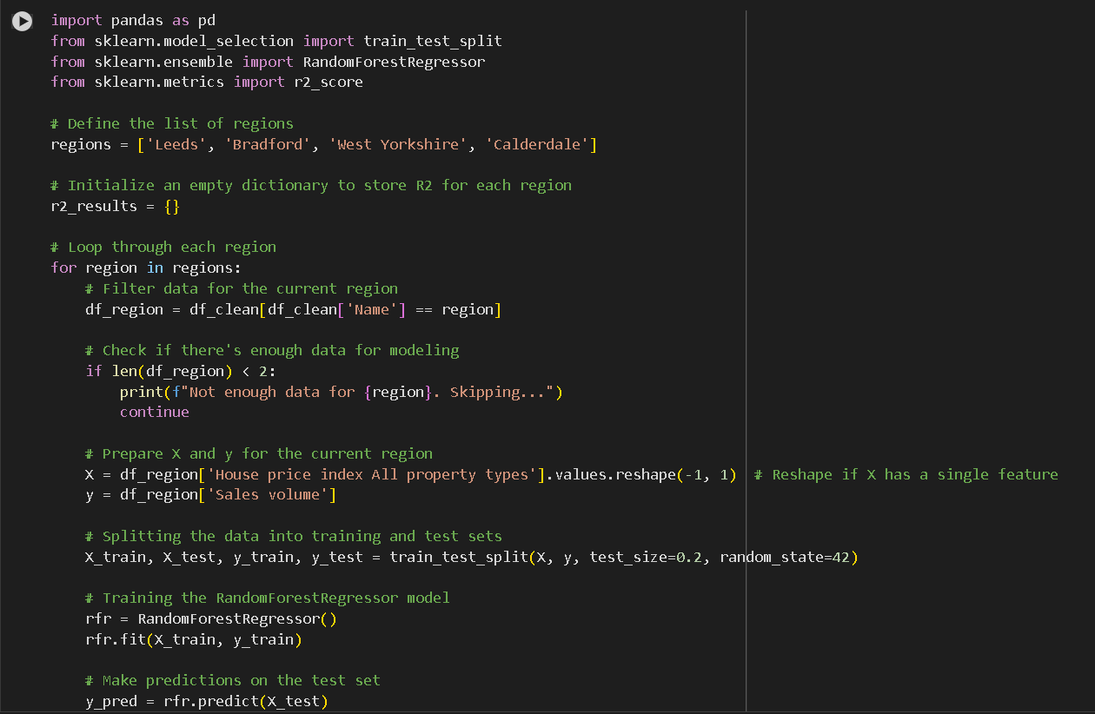 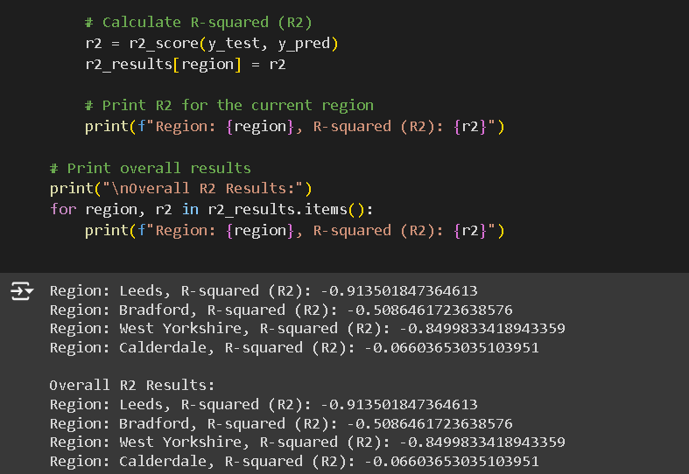 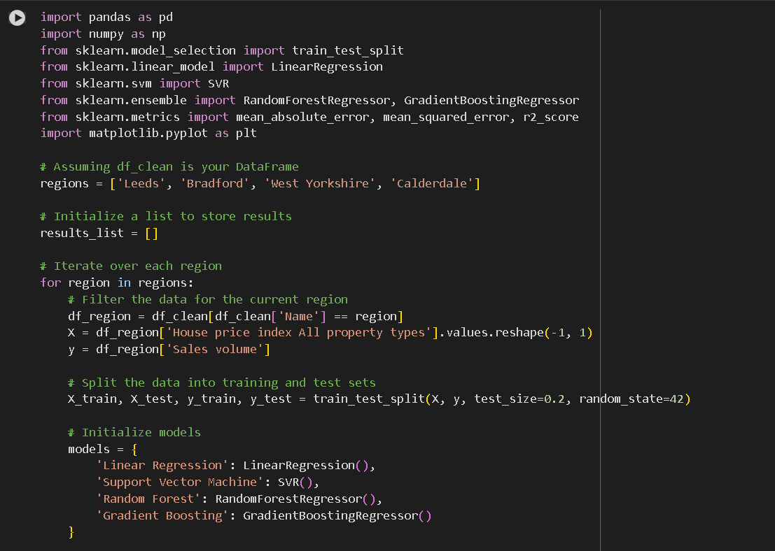 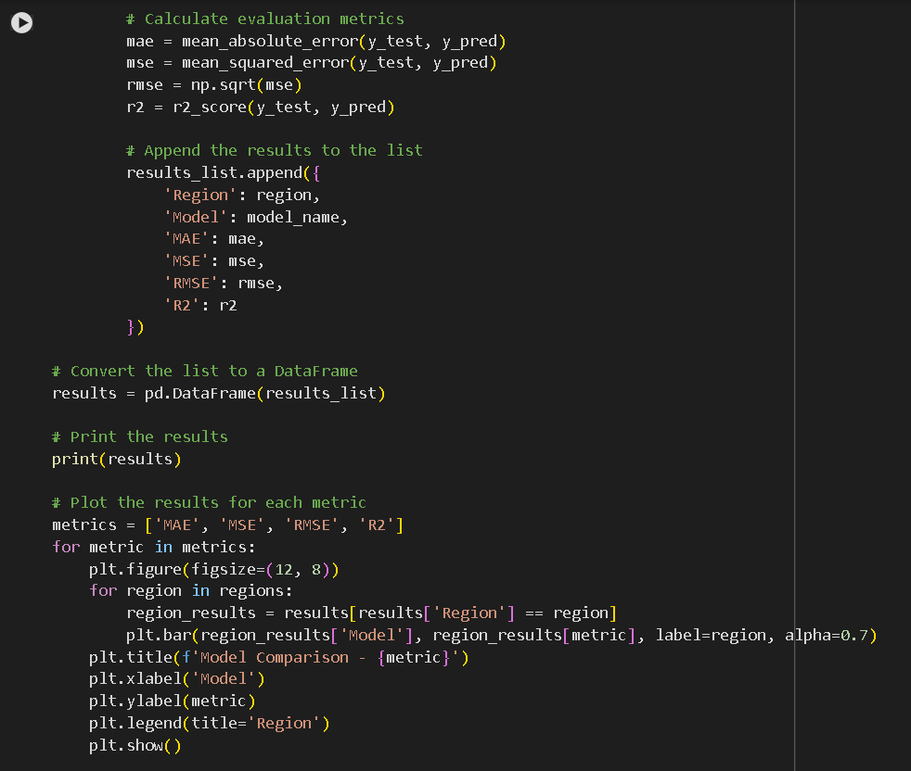 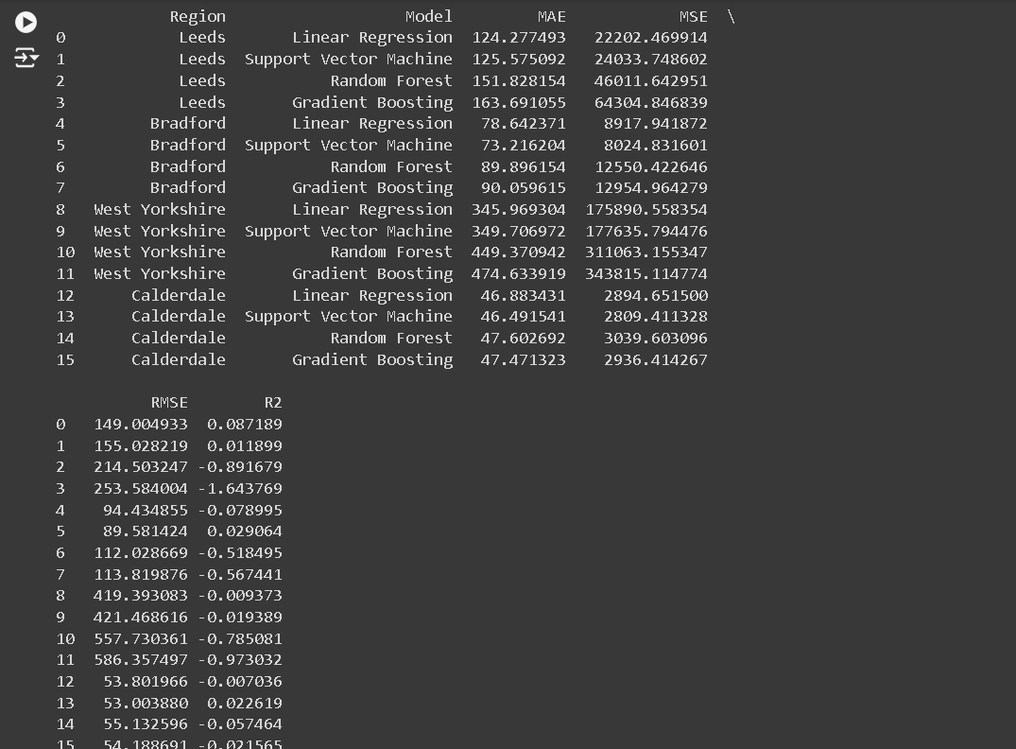 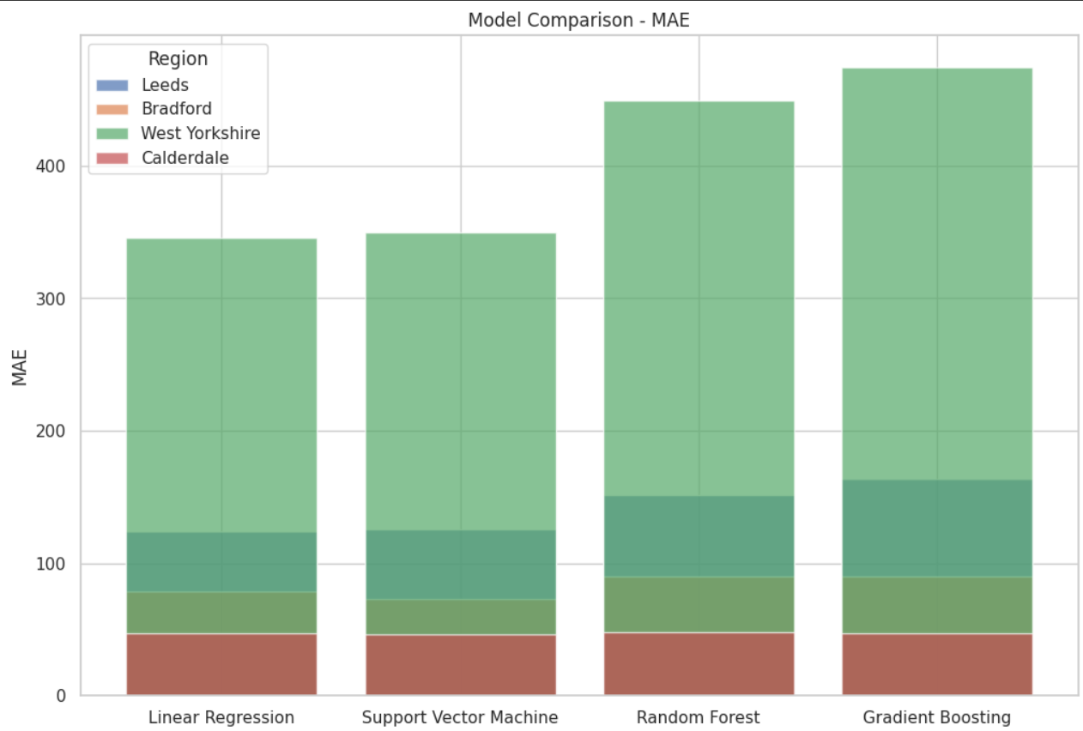 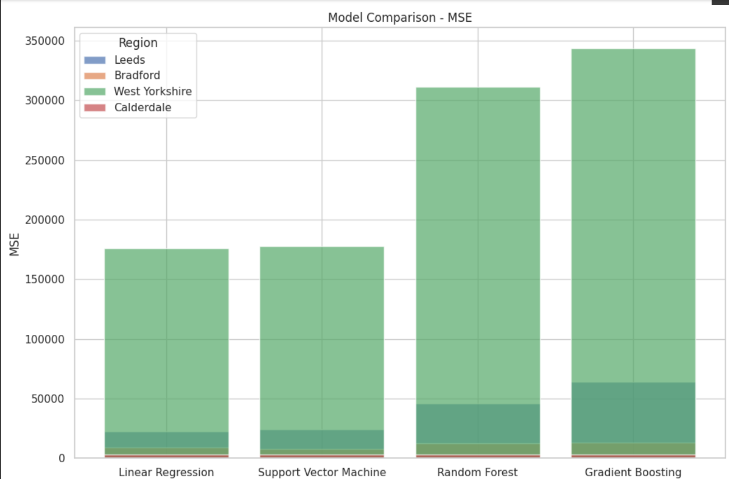

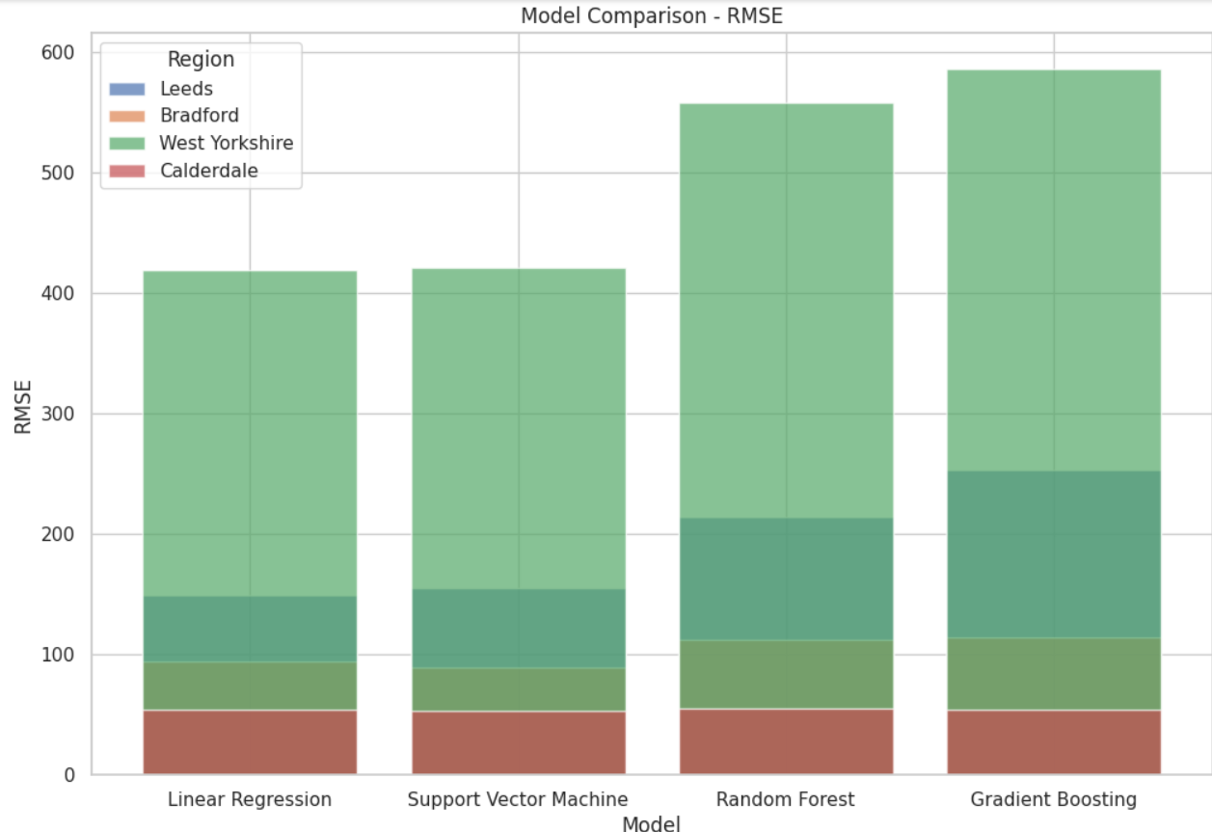 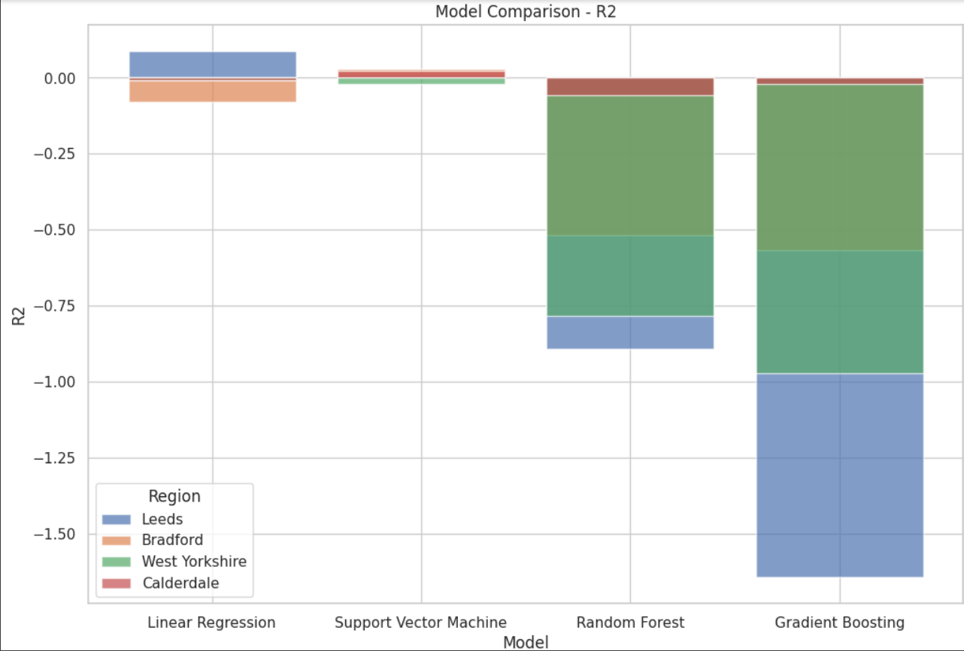

25 Predition 